

Syrian Private University
Faculty of Engineering
Department of Software
and Information Systems

Integrated Event & Activity Management Platform
A senior 2 project report- submitted to complete the requirements for obtaining a bachelor's degree in Informatics Engineering - Software Engineering and Information Systems

Prepared by:
Helpest Mohamad Mohamad Marwa Ghassan Aljaouni Hiba Ahmad Shawa

Supervised by:
Eng. Anas Abdulziz

2026


الجامعة السورية الخاصة
كلية هندسة الذكاء الاصطناعي
قسم البرمجيات و نظم المعلومات

منصة متكاملة لتخطيط الفعاليات
والأنشطة
مشروع تخرج 2 - قدم استكمالاً لمتطلبات الحصول على درجة البكالوريوس في هندسة المعلوماتية
هندسة البرمجيات ونظم المعلومات

إعداد:

هبه احمد شاوه مروة غسان الجاعوني هلبست محمد محمد

إشراف:
المهندس أنس عبد العزيز

2026

Abstract:

In the absence of a unified digital platform serving the events sector in the Syrian market, our platform has emerged to fill this gap with a comprehensive solution that brings together everyone involved in creating, attending, and serving events under one digital roof. The platform allows attendees to browse events, book tickets, and pay fees in a few simple steps, receiving an instant digital ticket with a QR code. Organizers, on the other hand, gain access to a professional dashboard displaying bookings, revenue, and real-time performance indicators, with the ability to export reports. The platform also includes an integrated marketplace for service providers in photography, hospitality, and decoration. Most notably, this project integrates three powerful artificial intelligence applications: an intelligent event planner that analyzes user needs and recommends the most suitable event; a virtual assistant that answers inquiries instantly; and a personalized recommendation system based on user behavior—all built on a state-of-the-art technological infrastructure that ensures performance and future expansion.

الملخص

في ظل غياب منصة رقمية موحّدة تخدم قطاع الفعاليات في السوق السوري، جاءت منصتنا لتملأ هذا الفراغ بحلٍّ متكامل يجمع تحت سقف رقمي واحد كلَّ من يصنع الفعالية ويحضرها ويخدمها. تتيح المنصة للحضور تصفّح الفعاليات وحجز تذاكرها ودفع رسومها في خطوات بسيطة مع استلام تذكرة رقمية بكود QR فورياً، بينما يحصل المنظمون على لوحة تحكم احترافية تعرض الحجوزات والإيرادات ومؤشرات الأداء لحظةً بلحظة مع إمكانية تصدير التقارير. وتمتد المنصة لتشمل سوقاً مدمجاً لمزودي الخدمات من تصوير وضيافة وديكور، والأبرز في هذا المشروع هو دمجه ثلاثة تطبيقات ذكاء اصطناعي حقيقية: مخطط فعاليات ذكي يحلل احتياجات المستخدم ويوصي بالفعالية الأنسب، ومساعد افتراضي يجيب على الاستفسارات فورياً، ونظام توصيات شخصية مبني على سلوك المستخدم — كل ذلك مبني على بنية تقنية حديثة تضمن الأداء والتوسع المستقبلي

List Of Content:
Abstract: 3
Chapter 1: 9
General Introduction 9
1-1 Project Overview and Background 10
1-2 Problem Statement and Its Practical and Academic Importance 10
problem 10
Current situation in Syria 10
impact 10
Special Syrian Gaps 10
Practical Importance 11
Academic Importance 11
1-3 Project Objectives (Main and Sub Objectives) 11
Main Objective 11
Sub Objectives 11
1-4 Project Scope, Constraints, and Assumptions 12
Project Scope 12
Constraints 12
Assumptions 12
1-5 Project Contribution to Knowledge and Industry 12
1-6 Research Methodology and Scientific Approaches 13
Supporting Methods 13
1-7 Organizational Structure of the Thesis 13
1-8 Definitions and Key Concepts 14
Chapter 2 : 15
Project Development & Management Methodology 15
2-1 selected development methodology and justification 16
2-2 Project Schedule and Timeline 16
2-3 Risk Management 17
2-4 Team Structure and Role Distribution 17
2-5 Quality Management 18
Code Quality Standards 18
Testing Strategy 18
Version Control and Code Review 19
2-6 Project Management Tools 19
2-7 Monitoring and Continuous Evaluation 19
2-8 Software Configuration Management 20
Chapter 3: 21
Literature Review & Previous Studies 21
3-1 Review of Existing Event Management Systems: 22
1. Bizzabo: 22
2.Splash: 23
3. Luma: 24
5.Faaliyeh App_ Syria: 26
2-3 Technologies and Modern Frameworks in the Field: 27
3-3 Comparative Analysis: 28
3-4 Research Gap and Proposed Innovation: 29
3-5 Theoretical Framework: 30
3-6 Emerging Trends in the Field: 31
Chapter 4: 33
Requirements Modeling and Analysis 33
4-1 Feasibility Study 34
Technical Feasibility 34
Economic Feasibility 34
4-2 Requirements Gathering 34
4-3 Stakeholder Analysis 35
End Users (Attendees) 35
Organizers 35
Suppliers 35
Developers/Maintainers 35
4-4 Functional Requirements 36
1. User Account Management 36
2. Event Discovery 36
4. Event Management for Organizers 37
5. Dashboard and Booking Management 37
6. Service Providers 38
7. Ratings and Reviews 38
8. Notification System 38
9. Reports and Analytics 39
4-5 Non-Functional Requirements 40
4-6 Prioritization of Requirements (MoSCoW) 41
Must Have 41
Should Have 41
Could Have 41
Won't Have 41
4-7 UML Diagrams 41
4-7-1 Main Use Case Diagrams 41
4.7.2 use case Descriptions: 49
4-7-3 Activity Diagrams 60
4-7-4 Sequence Diagrams 69
4-8 Agile Modeling and Methodology Implementation 93
4-8-1 Story Mapping 93
4-8-2 Product Backlog 96
4-8-3 User Stories 99
Chapter 5: 129
System Architecture Design 129
5-1- High-Level Design: 130
5-1-1- System Block Diagram: 131
5-1-2- Architectural Design Pattern Used: 132
5-1-3- System Architecture Design: 132
5-2- Database Design: 134
5-2-1- ER Diagram: 136
5-2-2- Collections& Documents: 136
5-2-3-Constraints and Keys: 138
5-3- Designing external interfaces (APIs): 139
5-4- Security & Access Control Design: 140
Chapter 6 : 141
Implementation Environment & Tools 141
6-1 Programming Languages and Frameworks 142
6-2 Development Environment and Project Structure 143
6-3 Libraries and Dependencies 144
6-4 Database System 145
6-5 External Service Integrations 146
6-7 Build Process and Deployment 147
6-8 Testing Environment 148
6-9 Security Considerations 149
6-10 Performance Considerations 150
6-11 Lessons Learned and Future Enhancements 150
Chapter 7: 152
Software Implementation 152
7-1 Project File Structure 153
7-2 Modules Implementation 154
7-3 API Implementation 155
7-4 Data Access Layer Implementation 155
7-5 Business Logic Layer Implementation 156
7-6 UI Implementation 156
7-7 Smart Algorithms and ML Implementation 169
Chapter 8: 170
Testing & Evaluation 170
8-1 Test Plan 171
8-1-1 Testing Objectives 171
8-1-2 Scope of Testing 171
8-1-3 Testing Environment 172
8-2 Types of Tests 173
8-2-1 Unit Testing 173
8-2-2 Integration Testing 173
8-2-3 System Testing 174
8-2-4 Acceptance Testing 174
8-2-5 Performance Testing 174
8-2-6 Security Testing 175
8-2-7 Usability Testing 175
8-3 Test Cases and Results 176
8-3-1 Test Case Structure 176
8-3-2 Test Results Summary 177
8-4 Test Results and Analysis 178
8-5 Quality Metrics 178
8-6 Usability Evaluation 179
Chapter 9: 181
Results and Analysis 181
9-1- Results of implementing the system: 182
9-2 Comparative Analysis with Existing Systems: 183
9-3 Objectives Achievement: 183
9-4 Strengths and Weaknesses Analysis 184
9-5 Key Performance Indicators (KPIs): 185
Chapter 10: 186
Conclusion & Recommendations 186
10-1 Project Summary and Main Achievements: 187
10-2 Challenges and Difficulties: 188
10-3 Future Development Suggestions: 188
10-4 Recommendations: 189

List Of Table

Table (1): Problem Statement and Its Practical and Academic Importance 13
Table (2): Project Contribution to Knowledge and Industry 16
Table (3): Risk Management 20
Table (4): Bizzabo 25
Table (5): splash 26
Table (6): Luma 27
Table (7): Hopin 28
Table (8): Faaliyeh App_ Syria 29
Table (9): Technologies and Modern Frameworks in the Field 30
Table (10): Comparative Analysis 32
Table (11): Research Gap and Proposed Innovation 32
Table (12): Theoretical Framework 33
Table (13): Emerging Trends in the Field 34
Table (14): Non-Functional Requirements 43
Table (15): Use Case Specification 1 51
Table (16): Use Case Specification 2 52
Table (17): Use Case Specification 3 52
Table (18): Use Case Specification 4 53
Table (19): Use Case Specification 5 53
Table (20): Use Case Specification 6 54
Table (21): Use Case Specification 7 54
Table (22): Use Case Specification 8 55
Table (23): Use Case Specification 9 55
Table (24): Use Case Specification 10 56
Table (25): Use Case Specification 11 56
Table (26): Use Case Specification 12 56
Table (27): Use Case Specification 13 56
Table (28): Use Case Specification 14 57
Table (29): Use Case Specification 15 57
Table (30): Use Case Specification 16 57
Table (31): Use Case Specification 17 58
Table (32): Use Case Specification 18 58
Table (33): Use Case Specification 19 58
Table (34): Use Case Specification 20 59
Table (35): Use Case Specification 21 59
Table (36): Use Case Specification 22 60
Table (37): Use Case Specification 23 61
Table (38): Use Case Specification 24 61
Table (39): Use Case Specification 25 61
Table (40): Use Case Specification 26 62
Table (41): Use Case Specification 27 62
Table (42): Use Case Specification 28 62
Table (43): User Personas 91
Table (44): Backbone Activities 92
Table (45): MVP Release Planning 93
Table (46): Product Backlog Summary 96
Table (47): Backlog Statistics 97
Table (48): Detailed User Stories 1 99
Table (49): Detailed User Stories 2 99
Table (50): Detailed User Stories 3 100
Table (51): Detailed User Stories 4 101
Table (52): Detailed User Stories 5 102
Table (53): Detailed User Stories 6 103
Table (54): Detailed User Stories 7 103
Table (55): Detailed User Stories 8 104
Table (56): Detailed User Stories 9 105
Table (57): Detailed User Stories 10 106
Table (58): Detailed User Stories 11 107
Table (59): Detailed User Stories 12 107
Table (60): Detailed User Stories 13 108
Table (61): Detailed User Stories 14 109
Table (62): Detailed User Stories 15 110
Table (63): Detailed User Stories 16 110
Table (64): Detailed User Stories 17 111
Table (65): Detailed User Stories 18 112
Table (66): Detailed User Stories 19 113
Table (67): Detailed User Stories 20 113
Table (68): User Story Format Reference 114
Table (69): User Story Format Reference 2 121
Table (70): Test Case 126
Table (71): Constraints and Keys 136
Table (72): APIs 137
Table (73): Security & Access Control Design 138
Table (74): Development Tools 141
Table (76): frontend Project Structure 142
Table (77): Backend Dependencies 143
Table (78): frontend Dependencies 143
Table (79): Firestore vs Relational Databases 144
Table (80): Layer and Tools 147
Table (81): Modules Implementation 152
Table (82): Testing Environment 170
Table (83): Performance Testing 173
Table (84): Test Case Structure 175
Table (85): Test Results Summary 175
Table (86): Quality Metrics 176
Table (87): Comparative Analysis with Existing Systems 181
Table (88): Objectives Achievement 182
Table (89): KPIs 183

List Of Figure

Figure 1:project schedule and timeline 22
Figure 2:project schedule and timeline2 22
Figure 3:use case Event Management Module 49
Figure 4:Use Case Booking Management System 50
Figure 5:use case Booking Management System 51
Figure 6:Use Case AI Integration Module 51
Figure 7:Use Case Supplier& Servier Management Module 52
Figure 8:Use Case Analytics & Reporting Module 53
Figure 9:Use Case Notification System Module 53
Figure 10:Use Case Review System Module 54
Figure 11:Activity 1 68
Figure 12:Activity 2 69
Figure 13:Activity 3 70
Figure 14:Activity 4 71
Figure 15:Activity 5 72
Figure 16: Activity For Service Management System 73
Figure 17:Activity For Provider Management System 74
Figure 18:Sequence For AI Powered Event Planning 75
Figure 19:Sequence For Create Event 76
Figure 20:Sequence For Update Event With Notifications 77
Figure 21:Sequence For Create Booking 78
Figure 22:Sequence For Cancel Booking 80
Figure 23:Sequence For View User Bookings 81
Figure 24:Sequence For Register as Supplier 82
Figure 25:Sequence For Add Service 83
Figure 26:Sequence For Update Service Status 84
Figure 27:Sequence For Browse Available Service 85
Figure 28:Sequence For Submit Review 86
Figure 29:Sequence For View Event Reviews 87
Figure 30:Sequence For Delete Review 88
Figure 31:Sequence For Chat With AI Assistant 89
Figure 32:Sequence For Get Smart Recommendations 90
Figure 33:Sequence For Send Attendee Notification 91
Figure 34:Sequence For Automated Event Reminder 92
Figure 35:Sequence For Update Notification Preferences 93
Figure 36:Sequence For Export Dashboard Report 94
Figure 37:Sequence For View Organization Dashboard 95
Figure 38:System Architecture Design 136
Figure 39:ER Diagram 139
Figure 40:Collections& Documents 140
Figure 41:Discover Events1 161
Figure 42:Discover Events2 162
Figure 43:Discover Events3 162
Figure 44:Discover Events4 163
Figure 45:Discover Events5 163
Figure 46:Discover Events6 164
Figure 47:Discover Events7 164
Figure 48:Discover Events8 165
Figure 49:My Bookings 165
Figure 50:My Booking 2 Interface 166
Figure 51:Provider Directory Interface 166
Figure 52:Welcome To EventMarketPLace Interface 167
Figure 53:Dashboard Organizer Panel Interface 167
Figure 54: Recent Bookings Interface 168
Figure 55: Manage Events Organizer Panel Interface 168
Figure 56:Bookings Management Organizer Panel Interface 169
Figure 57:Provider Directory Interface2 169
Figure 58:Provider Directory Interface3 170
Figure 59:Dashboard Report Interface 170
Figure 60:Provider Panel Interface 171
Figure 61:EventMarketPlace Assistant Interface 171
Figure 62:Add New Service Interface 171
Figure 63:AI Event Planner Interface 172

Chapter 1:

General Introduction

1-1 Project Overview and Background
In recent years, the world has experienced rapid digital transformation, which has influenced many sectors, including event and activity management such as concerts, conferences, and weddings. As the number of these events continues to grow, the need for digital systems that simplify organization and coordination between attendees, organizers, and service providers has become increasingly important.
This led to the idea of the Integrated Event and Activity Management Platform, which aims to provide a unified system for managing events from discovery and booking to performance tracking.
The platform is specifically designed for the Syrian environment by offering a simple and effective digital solution that fits local needs, uses free technologies, works under limited internet conditions, and connects attendees, organizers, and service providers within one system.

1-2 Problem Statement and Its Practical and Academic Importance
Despite noticeable technological progress, the event management industry still suffers from major gaps that reduce efficiency and weaken user experience. In Syria, these challenges are more severe.

problem | Current situation in Syria | impact
Fragmented systems | WhatsApp, Facebook, printed ads | Time loss ,errors, difficult tracking
Lack of smart discovery | Manual searching for hours | Missed opportunities, unmet needs
Weak analytics | Manual Excel sheets | Poor decisions, lost revenue
Table (1): Problem Statement and Its Practical and Academic Importance

Special Syrian Gaps
- Lack of digital infrastructure: There is no unified event platform covering Damascus, Aleppo, Latakia, and Homs.
- Economic challenges: There is a need for low-cost, high-impact solutions suitable for local capabilities.
- Missed opportunities: Syrian youth (around 60% under the age of 30) are interested in concerts, celebrations, and workshops, but no smart system currently connects them to these opportunities.
For these reasons, this project aims to close these gaps.

Practical Importance
- Saves organizers time and effort.
- Helps users find suitable events easily.
- Opens direct channels for local service providers.

Academic Importance
This project represents a unique case study of integrating Artificial Intelligence with event management in an emerging economy.

1-3 Project Objectives (Main and Sub Objectives)

Main Objective
To develop a smart event platform designed for the Syrian market that combines event management with selected Artificial Intelligence technologies, serving attendees, organizers, and service providers in one integrated system.

Sub Objectives
- Develop a complete booking system that allows users to browse events and reserve tickets easily using QR electronic tickets.
- Design a dashboard that helps organizers manage events and monitor bookings clearly.
- Create a marketplace for local service providers and connect them with organizers.
- Provide initial event recommendations based on user interests.
- Offer a simple chatbot system to support users and answer inquiries.
- Display indicators that help measure event performance such as attendance and cancellation rate.
- Apply essential security measures such as role-based access control and data protection.

1-4 Project Scope, Constraints, and Assumptions

Project Scope
The project includes developing a responsive web application that provides core event management functions such as:
- User management
- Event organization
- Booking system
- Communication between stakeholders
It also includes basic AI-related features such as event recommendations and a virtual assistant for answering common questions.
The project focuses on local Syrian events such as concerts, social occasions, and workshops.

Constraints
- Development must be completed within one academic semester by a small team.
- Experimental data will be used instead of real production data.
- Dependence on free tools and services may create performance limitations.
- Payment processing will be simulated only.
- The system relies on cloud infrastructure without local servers.

Assumptions
- Users have basic knowledge of internet usage and digital platforms.
- Acceptable internet connectivity is available.
- Organizers enter accurate event information.
- A mobile application is not required at the current stage because a responsive web app is sufficient.
- Service providers update their profiles regularly.

1-5 Project Contribution to Knowledge and Industry
This project aims to become the first AI-powered event platform in Syria through the following contributions:
contribution | Current situation in Syria | Proposed project
AI integration | Not available | Recommendations + Chatbot
Unified platform | Multiple separate tools | Three user groups in one system
Local technology | Expensive solutions | Free tools + slow internet support
QR Tickets | Paper-based | Secure digital tickets
Service Marketplace | middlemen | Direct connection with providers
Table (2): Project Contribution to Knowledge and Industry
The project also introduces a new economic model by connecting local services directly with customers and organizers. It can serve as a global case study for applying AI in an emerging economy.

1-6 Research Methodology and Scientific Approaches
This thesis adopts the Engineering Design Methodology as the main framework for organizing the research and documentation. It includes the following stages:
- Problem Analysis: Studying the Syrian event management environment and identifying existing gaps.
- Solution Design: Defining system requirements and architectural structure.
- Practical Implementation: Building the prototype and integrating AI technologies.
- Evaluation and Analysis: Testing performance and measuring quantitative and qualitative results.

Supporting Methods
- Descriptive Analytical Method: Used for reviewing literature and studying available solutions.
- Experimental Method: Used for evaluating AI features such as accuracy, speed, and effectiveness.
This mixed approach ensures comprehensive research coverage and logical connection between chapters, beginning with the problem and ending with the proposed and evaluated solution.

1-7 Organizational Structure of the Thesis
- Chapter One: General Introduction
- Chapter Two: Project Development and Management Methodology
- Chapter Three: Literature Review and Previous Studies
- Chapter Four: Requirements Modeling and Analysis
- Chapter Five: System Architecture Design
- Chapter Six: Implementation Environment and Tools
- Chapter Seven: Software Implementation
- Chapter Eight: Testing and Evaluation
- Chapter Nine: Results and Analysis
- Chapter Ten: Conclusion and Recommendations

1-8 Definitions and Key Concepts
- Firebase Firestore: Cloud-based NoSQL database for real-time data.
- KPI: Key Performance Indicators such as attendance and revenue.
- LLM: Large Language Model used in AI systems.
- OpenRouter API: Free gateway for accessing AI models.
- Prompt Engineering: Designing effective AI prompts and instructions.
- QR Code: Verification code used for electronic tickets.
- RBAC: Role-Based Access Control.
- React: Frontend library for interactive user interfaces.
- REST API: Communication architecture between frontend and backend systems.
- Spring Boot: Java framework for backend application development.

Chapter 2 :

Project Development & Management Methodology

2-1 selected development methodology and justification
The EventMarketPlace project employed a hybrid Agile methodology combining Scrum and Kanban frameworks. This approach was chosen due to the system’s multi-component architecture, which required both iterative development and continuous workflow management. Scrum was used to organize and plan complex features such as the AI chatbot system, ensuring structured sprint-based development. On the other hand, Kanban boards were used to visualize workflow across frontend and backend development, limit work-in-progress, and support continuous delivery. This hybrid approach was well-suited for coordinating the Spring Boot backend, React frontend, and external integrations such as Firebase and AI services, allowing the system to evolve flexibly while maintaining development structure

2-2 Project Schedule and Timeline
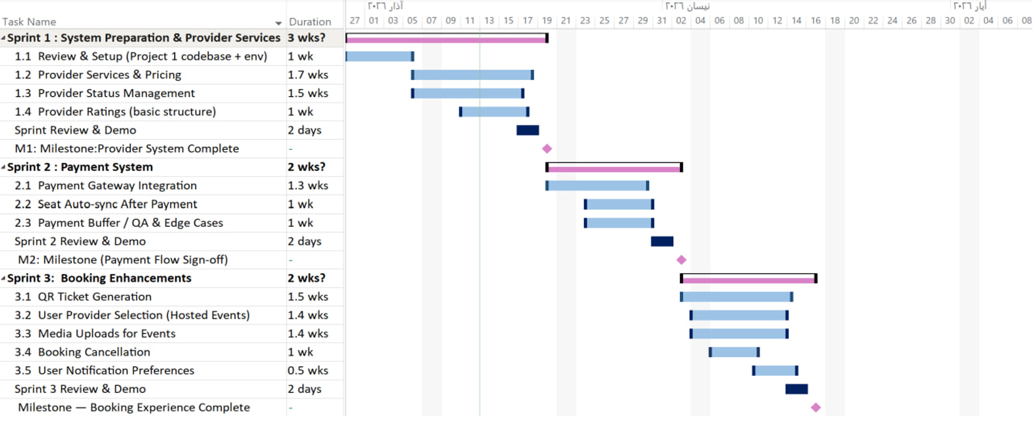
Figure 1:project schedule and timeline
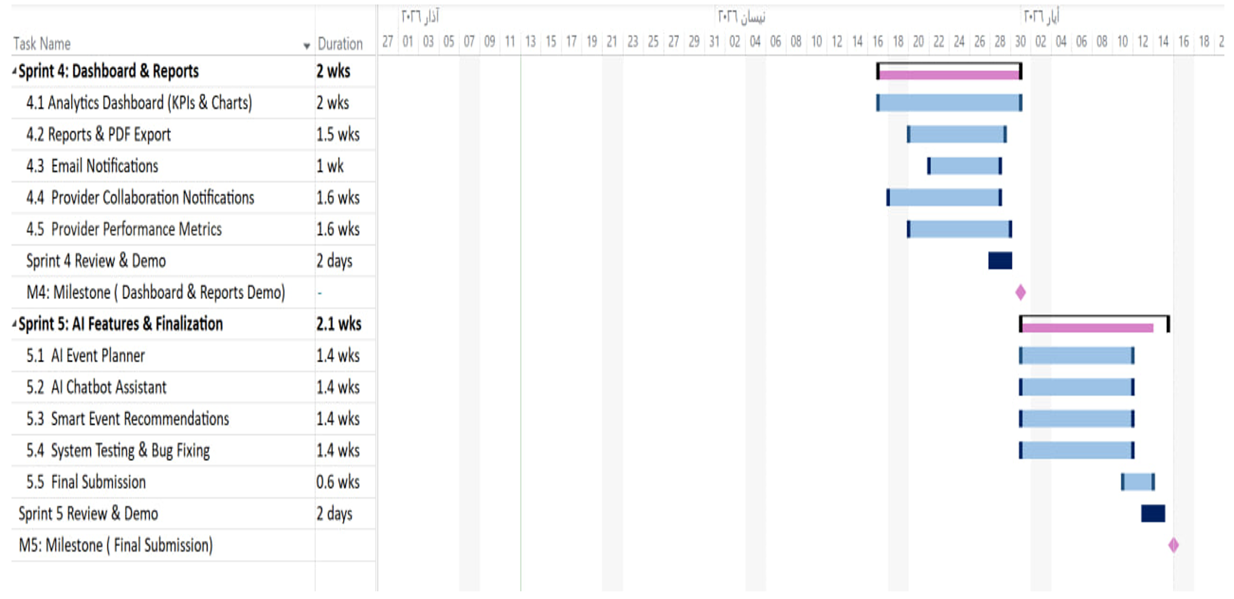
Figure 2:project schedule and timeline2

2-3 Risk Management
The risks were continuously reviewed throughout development, not only at the beginning of the project. At the end of each sprint, they were reassessed and mitigation strategies were adjusted when needed. This helped reduce unexpected technical issues, especially with Firebase and AI integrations.
Risk | Probability | Impact | Mitigation Strategy
Firebase service unavailability or downtime | Medium | High | Use local caching and fallback authentication to ensure core functionality during outages
AI API rate limit exhaustion | High | Medium | Implement request queuing, response caching, and graceful degradation when limits are reached
Cross-browser and cross-device compatibility issues | Medium | Medium | Perform systematic testing across major browsers (Chrome, Firefox, Safari) and multiple devices
Data security vulnerabilities or unauthorized access | Low | High | Apply strict Firebase security rules, server-side validation, and role-based access control
Dependency version conflicts between project components | Medium | low | Use Maven and npm lock files to maintain consistent and stable dependency versions
Table (3): Risk Management

2-4 Team Structure and Role Distribution
The project was executed by a four-member team with clearly defined responsibilities:
Leadership Roles:
- Anas Abdulaziz (Product Owner): Managed product backlog, defined acceptance criteria, and prioritized features based on business value
- Hiba (Scrum Master): Facilitated Agile ceremonies, removed impediments, and ensured adherence to Scrum-Kanban principles

Development Team:
- Hiba (Frontend Developer): Developed React components, implemented UI/UX using PrimeReact, and managed client-side Firebase integration
- Helpest (Backend Developer): Implemented Spring Boot REST APIs, data models, and Firebase Admin SDK integration
- Marwa (Backend Developer): Developed service layer components, repository patterns, and API endpoints
The frontend-backend collaboration was managed through daily synchronization meetings and shared Kanban boards, ensuring API compatibility and feature integration throughout the development lifecycle.

2-5 Quality Management
Quality assurance was embedded throughout the development lifecycle to ensure the reliability, maintainability, and consistency of the EventMarketPlace system. Rather than being treated as a final phase, quality was continuously enforced across all development stages.

Code Quality Standards
The project followed structured coding practices to maintain clean and scalable code:
- A Generic Repository Pattern was implemented to ensure consistent and reusable data access across all entities.
- Lombok annotations were used to reduce boilerplate code and improve readability of backend classes.
- A unified exception handling mechanism and logging strategy were applied across all system layers to improve debugging and system reliability.

Testing Strategy
A multi-level testing approach was adopted to ensure system correctness and stability:
- JUnit was used for backend unit testing to validate core application logic and service behaviour.
- React Testing Library was applied for frontend component testing to ensure correct UI rendering and interaction handling.
- Integration testing was conducted for REST API endpoints and database operations to verify end-to-end system functionality.

Version Control and Code Review
Software quality was further ensured through disciplined version control practices:
- Git was used with a feature-branch workflow to isolate development work and maintain a stable main codebase.
- All pull requests were subject to peer code review to ensure code correctness, consistency, and adherence to standards.
- Maven Wrapper was used to guarantee consistent build environments across different machines, ensuring reproducible builds and reducing environment-related issues.

2-6 Project Management Tools
The development workflow of the EventMarketPlace project utilized several industry-standard tools to support implementation, testing, and deployment:
- GitHub: Version control, issue tracking, and pull request management.
- VS Code: Primary development environment for backend and frontend development.
- Maven: Backend dependency management and build automation.
- npm: Frontend dependency management and build scripts.
- Firebase Console: Database management, authentication, and backend services monitoring.
- Postman: REST API testing and validation.
- OpenRouter: External AI service integration used to support chatbot and recommendation features.

2-7 Monitoring and Continuous Evaluation
Progress was monitored through Agile practices combined with regular meetings with the project supervisor to ensure alignment with academic and technical requirements. Sprint planning and daily stand-ups were used to track progress and identify issues, while sprint reviews and retrospectives helped evaluate completed work and improve future development cycles.
Quality was assessed through code testing (JUnit and React Testing Library), API performance checks, and user feedback during testing phases. Continuous improvement was achieved through regular code refactoring, supervisor feedback integration, and tracking project progress using velocity and burndown charts.

2-8 Software Configuration Management
The project used Git as the main version control system with a structured branching strategy to support organized and continuous development.
The branching model included:
- main: stable and production-ready code
- develop: integration branch for completed features
- feature/*: separate branches for developing new features
- hotfix/*: urgent fixes applied to the production version
The system was divided into two main parts: a Spring Boot backend using Maven and a React frontend using npm. This separation helped keep the codebase clean and allowed both layers to be developed independently.
The project also followed semantic versioning, clear commit messages, and pull requests to ensure proper code review before merging changes. Maven Wrapper was used to maintain consistent build environments across all machines.
Overall, this approach helped maintain code stability, improve collaboration, and support a well-organized development process aligned with Agile practices.

Chapter 3:

Literature Review & Previous Studies

3-1 Review of Existing Event Management Systems:
This section reviews five event management platforms selected for their relevance to the scope of this project — either due to their recent development activity or their operation in similar target markets. Each platform is evaluated on its core capabilities and limitations, with particular focus on AI integration, local market suitability, and dual-booking support.

1. Bizzabo:
Description: Bizzabo focuses on enhancing attendee experience and engagement in professional events. It provides solutions for registration management and event marketing (virtual or in-person) while offering detailed reports to measure ROI and event impact.

Disadvantages | Advantages
1. High subscription cost. | 1. Well-designed and user-friendly interface.
2. Not suitable for small or local events. | 2. Advanced analytics and reporting tools.
3. Requires time to learn advanced features | 3. Strong support for hybrid and virtual events.
4. It does not support artificial intelligence or collaboration with suppliers. | 4. Effective networking features for attendees.
Table (4): Bizzabo

2.Splash:
Description: Splash is a platform specialized in designing visually appealing event pages and promoting them as part of marketing campaigns. It is used by major companies to organize brand events and manage invitations and marketing analytics.

Disadvantages | Advantages
1. No ticketing or booking system. | 1. Easy creation of visually attractive event pages.
2. Limited analytics for event management. | 2. Strong marketing and audience segmentation tools.
3. Not suitable for non-marketing events. | 3. Automated invitation management.
4. Paid features can be expensive and Limited operational features. | 4. Integration with tools like CRM systems.

Table (5): splash

3. Luma:
Description: Luma is a modern, simple platform designed for quick event creation, especially for communities and startups.

Disadvantages | Advantages
1. Limited customization options. | 1. Very simple and intuitive interface.
2. No supplier integration. | 2. Fast event creation process.
3. Basic analytics only. | 3. Useful community management tools.
4. No AI features. | 4. Supports recurring events and Free for free events.

Table (6): Luma

4.Hopin:
Description: Hopin is a platform specializing in organizing large virtual events using advanced online environments..

Disadvantages | Advantages
1. High pricing and technically complex. | 1. Comprehensive virtual event environment.
2. Not suitable for small events. | 2. Strong networking features.
3. No supplier integration. | 3. Integration with external tools.
4. No AI features. | 4. Detailed analytics.

Table (7): Hopin

5.Faaliyeh App_ Syria:
Description: it is the official platform in Syria for organizing and managing exhibitions, projects, and events
It aims to support economic and cultural activities by bringing together government entities, organizers, and companies on a single digital platform.
It allows users to explore local events, register, and officially participate, while enabling organizers to manage requests and schedule exhibitions electronically, thus contributing to the digitization of the events sector and enhancing communication between participants and visitors.

Disadvantages | Advantages
1. No ticketing or payment system. | 1. Simple and accessible Arabic interface.
2. No user-generated events and No review or rating system. | 2. Covers a wide range of event types.
3. Limited analytics capabilities. | 3. Simplifies application processes for exhibitions.
4. No AI integration. | 4. Supports visibility of local initiatives.

Table (8): Faaliyeh App_ Syria

2-3 Technologies and Modern Frameworks in the Field:
The platform is built on a unified technology stack designed to support real-time data access, scalable AI integration, and clear separation of concerns between components.

Technology | Layer / Role | Function in the Project
Spring Boot | Backend | Handles API requests, builds AI prompts, and communicates with OpenRouter API.
React | Frontend | Renders recommendation cards, ChatBot UI, and real-time AI responses.
Firebase Firestore | Database | Stores and serves event/booking data in real time, feeding live data to AI features.
OpenRouter API | AI Gateway | Routes requests from the backend to large language models (LLMs).
LLMs | AI Engine | Processes natural language and generates context-aware responses and recommendations.
REST Architecture | API Design | Structures frontend-backend communication via defined endpoints (e.g., /api/events/plan).
Prompt Engineering | AI Integration | Combines user inputs with live Firestore data into structured prompts before calling the model.

Table (9): Technologies and Modern Frameworks in the Field

3-3 Comparative Analysis:
The table below evaluates all five reviewed platforms alongside the proposed system across eleven features spanning core event management functionality, local market suitability, and AI capabilities.

Feature | Bizzabo | Splash | Faaliyeh | Luma | Hopin | Our System
User-friendly interface | ✓ | ✓ | ✓ | ✓ | ✓ | ✓
Ticket sales & confirmations | ✓ | ✗ | ✗ | ✓ | ✓ | ✓
Customizable hosting packages | ✗ | ✗ | ✗ | ✗ | ✗ | ✓
Private event creation | ✗ | ✗ | ✗ | ✓ | ✓ | ✓
Suitable for small/local events | ✗ | ✓ | ✓ | ✓ | ✗ | ✓
Commercial event support | ✓ | ✓ | ✗ | ✗ | ✓ | ✓
Organizer dashboard | ✓ | ✓ | ✗ | ✓ | ✓ | ✓
Supplier directory | ✗ | ✗ | ✗ | ✗ | ✗ | ✓
AI Event Planner | ✗ | ✗ | ✗ | ✗ | ✗ | ✓
AI ChatBot (live data) | ✗ | ✗ | ✗ | ✗ | ✗ | ✓
Smart Recommendations | ✗ | ✗ | ✗ | ✗ | ✗ | ✓
Table (10): Comparative Analysis

3-4 Research Gap and Proposed Innovation:
After reviewing the five platforms, it is clear that each one covers only one aspect of event management, and none of them uses AI to meet individual user needs. This project fills that gap by combining three things no existing platform offers together: private event hosting with flexible packages, a supplier directory, and AI tools that

.
AI Feature | Technical Flow | Gap Addressed
AI Event Planner | User enters their needs → system searches the database → AI shows the best matching events. | No platform could find the right event based on all the user's needs at once.
AI ChatBot Assistant | User asks a question → system gets live event data → AI replies in the chat.. | No platform had a chatbot that reads live data and remembers the conversation.
Smart Recommendations (Planned) | System checks the user's past bookings → AI suggests events that match their interests. | No platform showed each user a personalized list based on their own activity.

Table (11): Research Gap and Proposed Innovation

3-5 Theoretical Framework:
The AI features of this platform are grounded in the following well-established computational concepts, each having a direct and identifiable role in system functionality.

Concept / The | Application in This Project
REST Architecture | A standard way for the frontend and backend to talk to each other using fixed web addresses.
Large Language Models (LLMs) | AI programs that understand normal language and give useful answers — used here through OpenRouter API.
Prompt Engineering | Before calling the AI, the backend builds a message that combines the user's input with live event data.
Real-Time Databases | Firebase Firestore updates data instantly, so the AI always works with the latest events..
Context-Aware Computing | The ChatBot sends the full conversation history with every request so its replies always make sense..
Personalization Systems | Smart Recommendations checks the user's past bookings and suggests events that match their interests.

Table (12): Theoretical Framework

3-6 Emerging Trends in the Field:
Event management platforms are moving toward systems that understand users, adapt to their needs, and handle repetitive tasks automatically. The table below shows how this project relates to the key trends shaping the field.

Trend | Status in This Project | Details
Large Language Models (LLMs) | Implemented | The AI Event Planner and ChatBot are fully working and connected to live data through OpenRouter API.
MLOps | Future Plan | As more users join, the team will need tools to monitor and update the AI models to keep results accurate.
Edge AI | Future Plan | Running parts of the AI on the user's own device instead of a remote server — this would make responses faster.
Personalization at Scale | In Development | Smart Recommendations will show every user a different homepage based on their own activity in the system.

Table (13): Emerging Trends in the Field

Chapter 4:

Requirements Modeling and Analysis

4-1 Feasibility Study

Technical Feasibility
The EventMarketPlace system demonstrates strong technical feasibility through the use of modern and well-integrated technologies. The backend is built using Spring Boot with Java, providing a solid and scalable foundation for developing RESTful APIs. The system also integrates Firebase for authentication and database services, which simplifies user management and data handling while ensuring reliability.
On the frontend, the system uses React with PrimeReact components to build a responsive single-page application. Role-based routing is implemented to control access based on user roles, ensuring proper navigation and security within the system.
In addition, the system incorporates artificial intelligence features through integration with an external AI service via OpenRouter, enabling intelligent chatbot functionality and enhanced user interaction.

Economic Feasibility
The project is economically feasible for a student-level implementation due to its reliance on free or open-source technologies. Firebase provides a free tier suitable for development and testing, while AI services used in the system operate under cost-efficient or free usage plans.Furthermore, the use of open-source frameworks such as Spring Boot and React eliminates licensing costs entirely. This significantly reduces overall development expenses, making the system affordable and practical to implement without requiring additional financial resources

4-2 Requirements Gathering
Requirements were gathered using a combination of analytical and semi-structured approaches. The process included informal interviews and discussions to understand user expectations and system needs at a high level. In addition, feedback and observations were considered during the design and development phases to refine the system requirements.
Alongside this, a detailed analysis of the system’s implementation was conducted by reviewing backend services, frontend components, and overall system architecture. This helped in identifying functional requirements, user interactions, and business logic more accurately.
The combination of informal user feedback and technical system analysis ensured that the final requirements reflected both user needs and actual system capabilities.

4-3 Stakeholder Analysis

End Users (Attendees)
Needs: Browse events, make bookings, manage personal profiles, receive notifications
Expectations: Intuitive interface, secure payments, timely confirmations
Role: Primary consumers who book events and interact with the platform through public routes and protected user dashboards

Organizers
Needs: Create and manage events, track bookings and revenue, communicate with attendees
Expectations: Comprehensive analytics, easy event management tools, reliable booking system
Role: Content creators who utilize the organizer dashboard and event management

Suppliers
Needs: List services, manage service offerings, track service bookings
Expectations: Visibility to organizers, easy service management, booking notifications
Role: Service providers who offer add-on services for events, managed through the supplier dashboard and service endpoints

Developers/Maintainers
Needs: Modular codebase, clear documentation, scalable architecture
Expectations: Clean code patterns, comprehensive testing, version control
Role: Technical team responsible for system maintenance and enhancement, supported by the modular repository pattern

4-4 Functional Requirements
The following functional requirements represent the complete scope of the system developed throughout both phases of the Graduation Project (Graduation Project 1 & Graduation Project 2). They include the core system requirements in addition to the advanced features and enhancements implemented during the second phase, such as artificial intelligence features, smart recommendations, and the virtual assistant.

1. User Account Management
FR1: The system shall allow users to create a new account using their name, email address, password, and phone number.
FR2: The system shall allow users to log in using their registered email and password.
FR3: The system shall allow users to log out of their accounts at any time.
FR4: The system shall allow users to recover their passwords through email verification.
FR5: The system shall allow users to edit their account information, including name, email, phone number, and profile picture.
FR6: The system shall allow users to delete their accounts if they choose to do so.
FR7: The system shall manage different user roles and permissions, including users, organizers, and service providers.

2. Event Discovery
FR8: The system shall allow users to browse all available events on the platform.
FR9: The system shall allow users to view full event details, including description, location, date, and price.
FR10: The system shall provide an easy-to-use event search feature.
FR11: The system shall allow users to filter events by date.
FR12: The system shall allow users to filter events by location.
FR13: The system shall allow users to filter events by price.
FR14: The system shall allow users to filter events by type, such as public events or host packages.

3. Booking and Payment
FR15: The system shall allow users to book tickets for public events.
FR16: The system shall allow users to book ready-made host packages provided by organizers.
FR17: The system shall generate a unique reference number for each successful booking.
FR18: The system shall support online payment for bookings.
FR19: The system shall automatically update the number of available seats after payment confirmation.
FR20: The system shall prevent users from booking events when the maximum event capacity has been reached.
FR21: The system shall issue a digital ticket containing a QR code and booking information.
FR22: The system shall allow users to view their current and previous bookings.
FR23: The system shall allow users to cancel bookings before the event date.
FR24: The system shall send a confirmation email after a successful booking.

4. Event Management for Organizers
FR25: The system shall allow organizers to create new events on the platform.
FR26: The system shall allow organizers to edit their event details.
FR27: The system shall allow organizers to delete their events.
FR28: The system shall support two types of events: public events and host packages.
FR29: The system shall allow organizers to enter all event details, including title, description, location, date, time, capacity, price, images, and videos.
FR30: The system shall support different event statuses such as active, canceled, and completed.
FR31: The system shall allow organizers to enable or disable bookings for any event.

5. Dashboard and Booking Management
FR32: The system shall provide organizers with a dashboard to monitor the performance of their events.
FR33: The dashboard shall display the number of bookings for each event.
FR34: The dashboard shall display the number of remaining seats.
FR35: The dashboard shall display the total revenue generated from events.
FR36: The dashboard shall display attendance and cancellation rates.
FR37: The system shall allow organizers to view all bookings related to their events.
FR38: The system shall allow organizers to view attendee lists for each event.
FR39: The system shall allow organizers to monitor payment statuses for bookings.

6. Service Providers
FR40: The system shall allow service providers to create accounts and public profiles containing their basic information.
FR41: The system shall allow service providers to add their services.
FR42: The system shall allow service providers to edit their services.
FR43: The system shall allow service providers to delete their services.
FR44: The system shall support different service statuses such as in progress, completed, and canceled.
FR45: The system shall allow service providers to view customer ratings and feedback.
FR46: The system shall allow users and organizers to search for service providers by service type or city.

7. Ratings and Reviews
FR47: The system shall allow users to rate events they have attended.
FR48: The system shall allow users to submit ratings and reviews only for events they have attended.
FR49: The system shall allow users to write reviews or comments about events.
FR50: The system shall allow users to rate service providers.
FR51: The system shall display ratings and reviews publicly for all users.

8. Notification System
FR52: The system shall allow users to enable or disable email notifications.
FR53: The system shall send a welcome email after successful account registration.
FR54: The system shall send a notification when a booking is confirmed.
FR55: The system shall send a notification when a booking is canceled.
FR56: The system shall send notifications whenever an event is updated.
FR57: The system shall send notifications when an event is canceled.
FR58: The system shall send notifications related to collaboration requests with service providers.
FR59: The system shall send notifications when a service status changes.

9. Reports and Analytics
FR60: The system shall provide organizers with interactive reports and dashboards.
FR61: The system shall display ticket sales statistics for each event.
FR62: The system shall display reports showing revenue growth.
FR63: The system shall display information about service provider performance.
FR64: The system shall display the most popular events among users.
FR65: The system shall display the most requested and frequently used services.
FR66: The system shall allow organizers to export reports in PDF format.

10. Artificial Intelligence Features
FR67: The system shall allow users to enter event preferences in order to receive suitable recommendations.
FR68: The system shall analyze event data using artificial intelligence techniques to provide the best recommendations.
FR69: The system shall display personalized event recommendations based on user interests and preferences.
FR70: The system shall provide an AI-powered assistant (ChatBot) to answer user questions related to events and services.
FR71: The system shall allow users to communicate with the AI assistant using natural language.
FR72: The AI assistant shall rely on real event data stored within the system.
FR73: The system shall display AI recommendations in interactive cards containing event details and direct booking links.
FR74: The system shall analyze users’ booking history to provide future personalized recommendations.
FR75: The system shall display a “Recommended for You” section based on user interests and previous bookings.

4-5 Non-Functional Requirements
Category | Requirement
Performance | API response times under 2 seconds for standard operations
Security | Firebase Authentication with role-based authorization
Usability | Responsive React UI with PrimeReact components for consistent user experience
Reliability | Comprehensive error handling with try-catch blocks and user-friendly error messages
Maintainability | Generic repository pattern for consistent data access across all entities
Scalability | Cloud-based Firebase backend supporting horizontal scaling and real-time updates
Integration | RESTful API architecture enabling seamless frontend-backend communication

Table (14): Non-Functional Requirements

4-6 Prioritization of Requirements (MoSCoW)

Must Have
Core authentication system, event creation and booking functionality, and basic dashboard analytics were classified as Must Have requirements. These form the foundation of the platform and were implemented first, evidenced by the comprehensive AuthService and BookingService implementations.

Should Have
AI chatbot integration, smart recommendations, and email notifications were categorized as Should Have. These features enhance user experience but are not critical for basic platform operation. The AI integration was implemented after core functionality, using the OpenRouter API.

Could Have
Advanced analytics with PDF export, video uploads for events, and supplier management features were classified as Could Have. These provide additional value but have lower priority. The PDF export functionality using iText was implemented as an enhancement to the dashboard.

Won't Have
Real-time chat between users, advanced payment gateway integration, and mobile applications were excluded from the current scope. The payment system uses a stub implementation, deferring real payment processing to future iterations.
This prioritization influenced development decisions by ensuring core functionality was delivered first, with advanced features added incrementally based on the hybrid Scrum-Kanban methodology. The modular architecture facilitated this approach by allowing features to be developed and integrated independently.

4-7 UML Diagrams
UML diagrams are used to visually represent the system structure, user interactions, and workflow processes. They help simplify the analysis and design of the system by providing a clear understanding of its functionalities and component relationships before implementation.

4-7-1 Main Use Case Diagrams
Main Use Case Diagrams illustrate the core functionalities and services provided by the system, as well as the relationships between different users and the system itself. These diagrams provide an overall view of the primary operations that can be performed within the platform, such as event management, booking, payment, and interaction with AI-powered features.
Use Case Diagram:
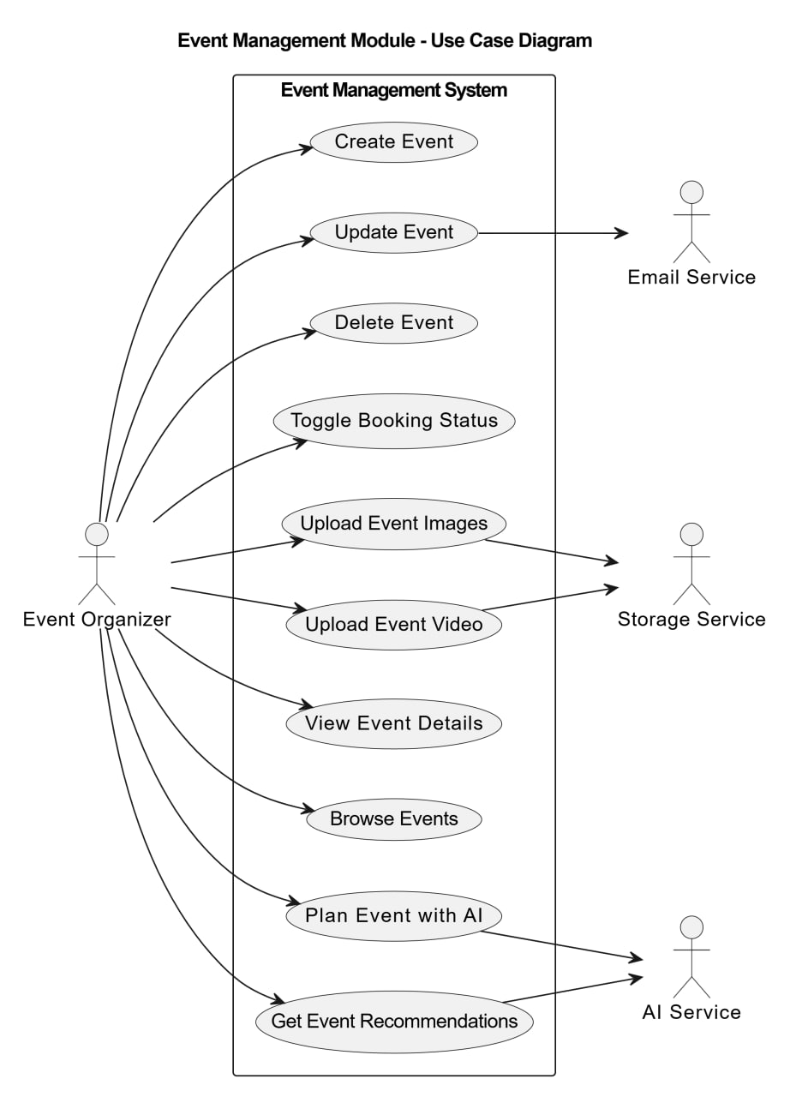
Figure 3:use case Event Management Module

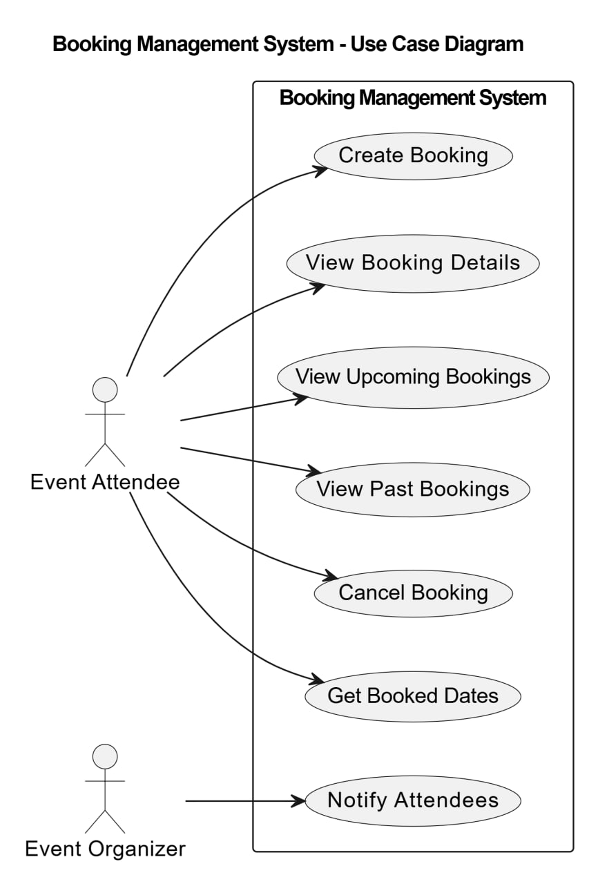
Figure 4:Use Case Booking Management System

Figure 5:use case Booking Management System

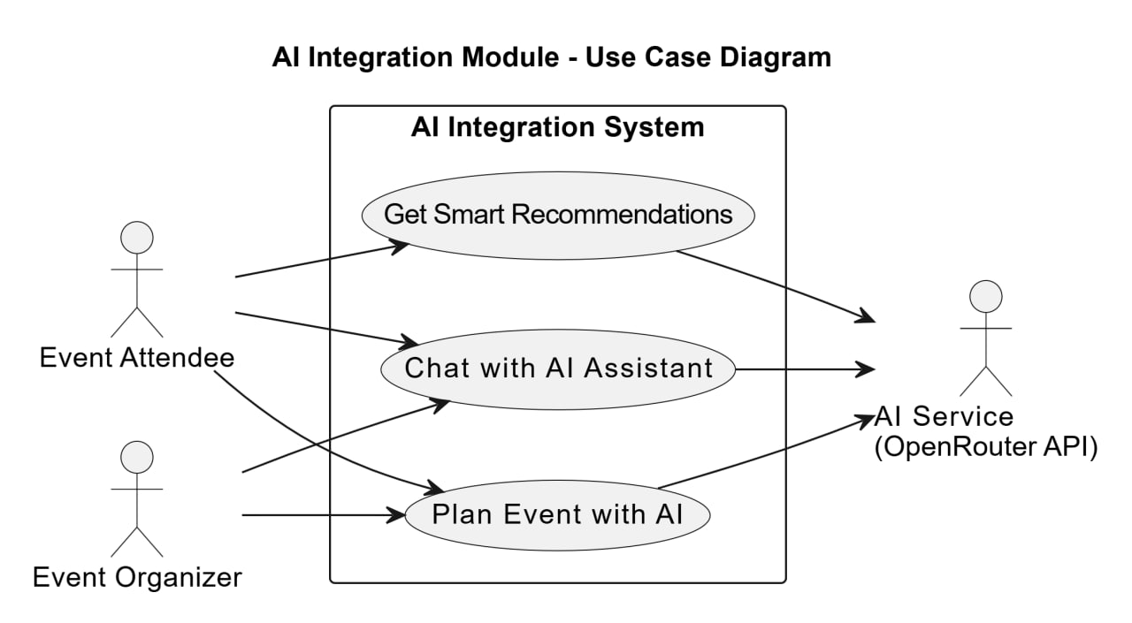
Figure 6:Use Case AI Integration Module

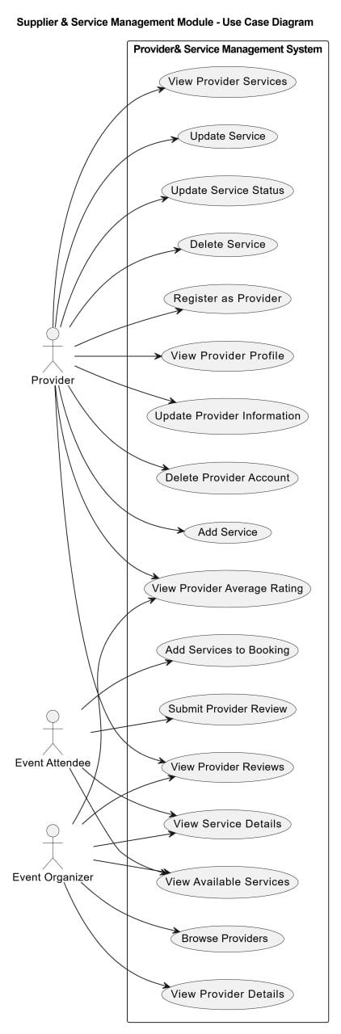
Figure 7:Use Case Supplier& Servier Management Module

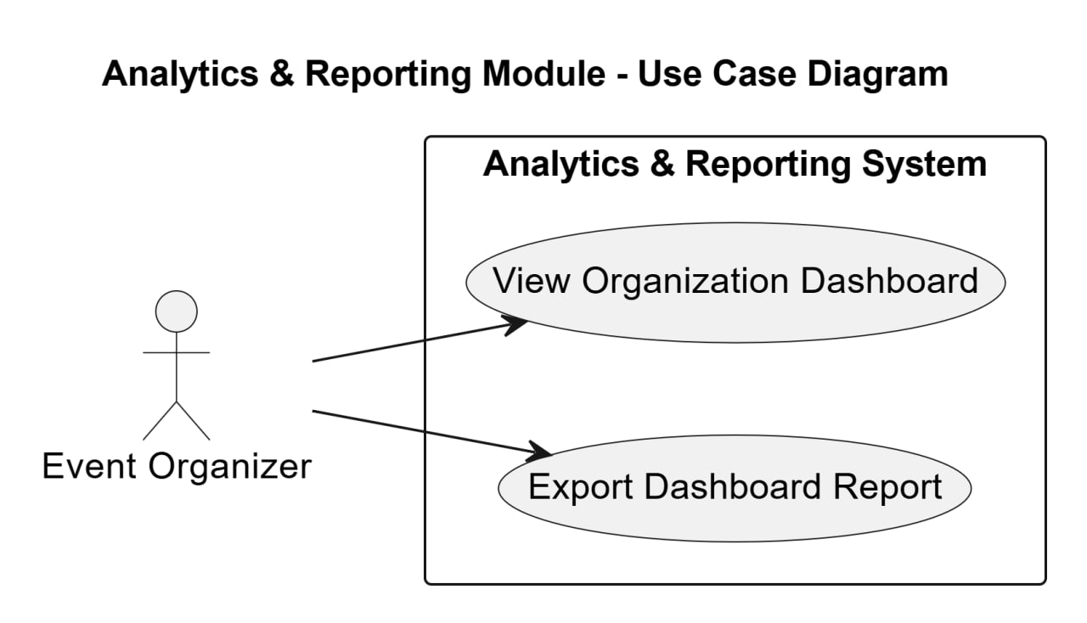
Figure 8:Use Case Analytics & Reporting Module

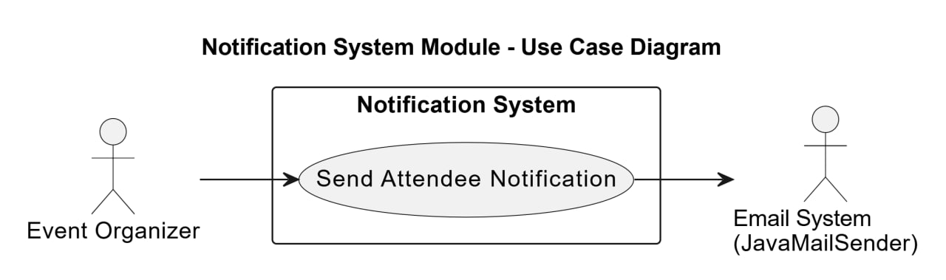
Figure 9:Use Case Notification System Module
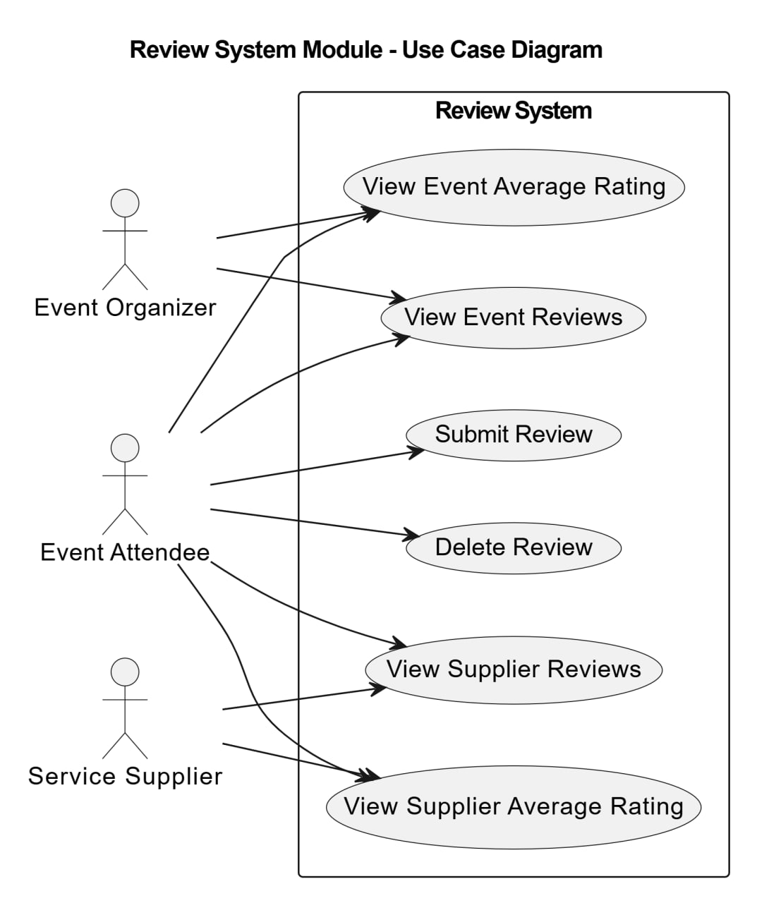
Figure 10:Use Case Review System Module

4.7.2 use case Descriptions:
Use Case Descriptions aim to provide a detailed explanation of each main use case in the system by identifying the use case name, the responsible actor, the main execution flow, and the possible alternative scenarios. This description helps in understanding how users interact with the system and how different functionalities are executed in a structured and accurate manner.

1.Event management module:

Create event | Use Case Name:
Event Organizer | Actor(s):
1. Organizer selects Create Event.  2. System displays event creation form.  3. Organizer enters event details and submits.  4. System validates entered data.  5. System creates new event record.  6. System saves event to database.  7. System displays confirmation message. | Basic path:
- 4a. Required fields are missing → System displays validation errors and highlights missing fields.  - 4b. Invalid data format (e.g., date, email) → System displays error and requests correction. | Alternative:
Table (15): Use Case Specification 1

Update event | Use Case Name:
Event Organizer , Email Service | Actor(s):
1.Organizer selects an event to update.  System displays event details in editable form.  2.Organizer modifies event data and submits.  3.System validates updated data.  4.System updates event record and saves to database.  5.System checks for confirmed bookings.  6.If confirmed bookings exist, System sends update notifications via Email Service.  7.System displays confirmation message to Organizer. | Basic path:
- 42a. Event not found → System displays error message.  - 4a. Required fields missing / invalid format → System displays validation errors.  - 6a. No confirmed bookings → System skips notifications. | Alternative path:
Table (16): Use Case Specification 2

Delete event | Use Case Name:
Event Organizer | Actor(s):
1.Organizer selects an event to delete.  2.System displays delete confirmation dialog.  3.Organizer confirms deletion.  4.System deletes event from database.  5. System displays deletion confirmation message. | Basic path:
- 2a. Event not found → System displays error message.  - 3a. Organizer cancels deletion → System aborts process and returns to event details. | Alternative path:
Table (17): Use Case Specification 3

Toggle Booking Status | Use Case Name:
Event Organizer | Actor(s):
- Organizer selects an event.  - System displays current booking status (Open/Closed).  - Organizer requests to toggle booking status.  - System updates booking status.  - System saves updated event record.  - System displays confirmation message. | Basic path:
2a. Event not found → System displays error message. | Alternative path:
Table (18): Use Case Specification 4

Upload Event Media | Use Case Name:
Event Organizer , Storage Service | Actor(s):
- Organizer selects an event and chooses to upload media.  - System displays the file upload dialog.  - Organizer selects files (images or videos) and clicks Upload.  - System validates:  - File type (Image / Video)  - File size (within allowed limits)  - System sends the files to the Storage Service.  - Storage Service stores the files and returns permanent URLs.  - System saves the URLs in the database  - System displays a confirmation message to the Organizer. | Basic path:
- 4a. Unsupported file type → System displays an error and requests a valid file.  - 4b. File size exceeds limit → System displays an error and requests a smaller file.  - 6a. Storage Service failure → System displays an error and allows retry.  - 3a. Organizer cancels upload → System aborts the operation and returns to the previous page. | Alternative path:
Table (19): Use Case Specification 5

View Event Details | Use Case Name:
Event Organizer | Actor(s):
1.Organizer selects an event to view.  2. System retrieves event data from database.  3. System displays event details. | Basic path:
- 2a. Event not found → System displays error message. | Alternative path:
Table (20): Use Case Specification 6

Browse Events | Use Case Name:
Event Organizer | Actor(s):
- Organizer selects Browse Events.  - System retrieves all available events.  - System displays event list. | Basic path:
- 2a. No events exist → System displays empty list message. | Alternative path:
Table (21): Use Case Specification 7

Plan Event with AI | Use Case Name:
Event Organizer , AI Service | Actor(s):
1.Organizer selects Plan Event with AI.  - System displays planning form and collects event requirements.  - Organizer submits planning request.  - System filters events by type and status.  - System builds AI prompt with event requirements.  - System sends request to AI Service (OpenRouter API).  - AI Service returns event recommendations.  - System maps AI response to event objects.  - System displays recommendations to Organizer. | Basic path:
- 4a. No matching events → System uses active events as fallback.  - 6a. API call fails → System displays error message.  - 7a. No recommendations → System logs warning and displays empty result message. | Alternative path:
Table (22): Use Case Specification 8

Chatbot | Use Case Name:
Event Organizer , AI Service | Actor(s):
- Organizer opens the Chatbot (text interface).  - Chatbot greets the Organizer and indicates available query topics  - Organizer types a question or request.  - Chatbot parses the text and queries the Event Database for relevant information.  - Database returns results .  - Chatbot formats the results as a text response and displays them to the Organizer.  - Chatbot suggests follow-up actions or additional queries . | Basic path:
- 3a. Invalid or unrecognized question → Chatbot asks for clarification.  - 4a. No matching data in the database → Chatbot returns a friendly message, e.g., “No events found matching your query.”  - 5a. Database connection failure → Chatbot displays an error and suggests retry.  - 3b. Organizer cancels query → Chatbot returns to main menu. | Alternative path:
Table (23): Use Case Specification 9

2. Booking Management Module
Create Booking | Use Case Name:
Event Attendee | Actor(s):
1. Attendee selects an event and submits booking.  2. System validates event availability.  3. System creates booking record.  4. System saves booking to database.  5. Attendee receives booking confirmation. | Basic path:
2a. Event is closed or full → System returns unavailability error. | Alternative path:
Table (24): Use Case Specification 10

View Booking Details | Use Case Name:
Event Attendee | Actor(s):
1. Attendee requests specific booking details.  2. System retrieves booking record.  3. System returns booking data to attendee. | Basic path:
2a. Booking not found → System returns error. | Alternative path:
Table (25): Use Case Specification 11

View Upcoming Bookings | Use Case Name:
Event Attendee | Actor(s):
1. Attendee requests list of upcoming bookings.  2. System retrieves all future bookings for attendee.  3. System returns list to attendee. | Basic path:
2a. No upcoming bookings → System returns empty list. | Alternative path:
Table (26): Use Case Specification 12

View Past Bookings | Use Case Name:
Event Attendee | Actor(s):
1. Attendee requests list of past bookings.  2. System retrieves all historical bookings.  3. System returns list to attendee. | Basic path:
2a. No past bookings → System returns empty list. | Alternative path:
Table (27): Use Case Specification 13

Cancel Booking | Use Case Name:
Event Attendee | Actor(s):
1. Attendee requests booking cancellation.  2. System retrieves booking record.  3. System updates booking status to cancelled.  4. System saves changes.  5. Attendee receives cancellation confirmation. | Basic path:
2a. Booking not found → System returns error.  3a. Booking already cancelled → System returns status error. | Alternative path:
Table (28): Use Case Specification 14

Get Booked Dates | Use Case Name:
Event Attendee | Actor(s):
1. Attendee requests their booked event dates.  2. System retrieves all confirmed bookings.  3. System extracts and returns date information. | Basic path:
2a. No bookings exist → System returns empty list. | Alternative path:
Table (29): Use Case Specification 15

Notify Attendees | Use Case Name:
Event Organizer | Actor(s):
1. Organizer triggers attendee notification.  2. System retrieves confirmed bookings for the event.  3. System sends notifications to all attendees.  4. Organizer receives send confirmation. | Basic path:
2a. No confirmed bookings → No notifications sent | Alternative path:

Table (30): Use Case Specification 16

- Supplier & Service Management Module

Manage Provider Profile | Use Case Name:
Provider | Actor(s):
1. Provider registers, views, updates, or deletes profile information.  2. System validates the request.  3. System processes and updates profile data.  4. Confirmation or profile information is returned to the provider | Basic path:
If provider/user is not found → system displays an error message | Alternative path:
Table (31): Use Case Specification 17

Manage Services | Use Case Name:
Provider | Actor(s):
1. Provider creates, updates, deletes, views, or changes service status.  2. System validates service data.  3. System updates the service information.  4. System saves changes and returns confirmation. | Basic path:
If service not found or required fields are missing → system displays an error message. | Alternative path:
Table (32): Use Case Specification 18

Manage Provider Reviews | Use Case Name:
Provider , Event Organizer | Actor(s):
1.User submits or views provider reviews and ratings.  2.System validates the request.  3.System retrieves or stores review data.  4.System returns review information or confirmation. | Basic path:
If no reviews exist or booking is invalid → system returns empty result or error message.. | Alternative path:
Table (33): Use Case Specification 19

Browse Providers and Services | Use Case Name:
Event Attendee, Event Organizer | Actor(s):
1.User browses providers or services.  2.System retrieves requested data.  3.System displays provider or service information. | Basic path:
If no providers/services found → system returns empty result | Alternative path:
Table (34): Use Case Specification 20

Add Services to Booking | Use Case Name:
Event Attendee, Provider | Actor(s):
1.User requests to add services to a booking.  2.System validates booking and service data.  3.System updates the booking.  4.System returns confirmation. | Basic path:
If booking or service not found → system displays an error message. | Alternative path:

Table (35): Use Case Specification 21

4. Review System Module
Use Case Name | Actor(s) | Basic Path | Alternative Path
View Event Average Rating | Event Organizer  Event Attendee | 1. Actor requests event average rating.  2. System aggregates all event reviews.  3. System calculates and returns average score. | 2a. No reviews exist → System returns zero or default.
View Event Reviews | Event Organizer  Event Attendee | 1. Actor requests list of reviews for an event.  2. System retrieves all associated reviews.  3. System returns review list. | 2a. No reviews found → System returns empty list.
Submit Review | Event Attendee | 1. Attendee submits a review (rating + comment).  2. System validates attendee attended the event.  3. System saves review.  4. Attendee receives confirmation. | 2a. Attendee has no booking → System rejects submission.  2b. Review already submitted → System returns duplicate error.
Delete Review | Event Attendee | 1. Attendee requests deletion of their review.  2. System verifies attendee owns the review.  3. System deletes review.  4. Attendee receives confirmation. | 2a. Review not found or not owned → System returns error.
View Supplier Reviews | Event Attendee  Service Supplier | 1. Actor requests reviews for a supplier.  2. System retrieves all reviews for supplier.  3. System returns review list. | 2a. No reviews exist → System returns empty list.
View Supplier Average Rating | Event Attendee  Service Supplier | 1. Actor requests average rating for a supplier.  2. System aggregates all supplier reviews.  3. System returns calculated average. | 2a. No reviews exist → System returns zero or default.
Table (36): Use Case Specification 22
5. Notification System Module
Send Attendee Notification | Use Case Name:
Event Organizer  Email System (JavaMailSender) | Actor(s):
1. Event Organizer triggers a notification.  2. System composes notification message.  3. System sends message via JavaMailSender.  4. Email System delivers notification to attendees.  5. Organizer receives send confirmation. | Basic path:
3a. Email service unavailable → System logs error and returns failure.  3b. Invalid attendee email → System skips that recipient and continues | Alternative path:
Table (37): Use Case Specification 23
6. Analytics & Reporting Module
View Organization Dashboard | Use Case Name:
Event Organizer | Actor(s):
1. Organizer navigates to the analytics dashboard.  2. System retrieves aggregate data (events, bookings, revenue, reviews).  3. System computes KPIs and metrics.  4. System renders dashboard with charts and summaries.  5. Organizer views organizational performance data. | Basic path:
2a. No data available → System displays empty state with guidance. | Alternative path:
Table (38): Use Case Specification 24

Export Dashboard Report | Use Case Name:
Event Organizer | Actor(s):
1. Organizer requests export of current dashboard data.  2. System compiles data into report format.  3. System generates downloadable report file.  4. Organizer downloads the report. | Basic path:
2a. Data retrieval fails → System returns export error.  3a. Unsupported format requested → System returns format error. | Alternative path:
Table (39): Use Case Specification 25
- AI Integration Module
Chat with AI Assistant | Use Case Name:
Event Attendee  Event Organizer  AI Service (OpenRouter API) | Actor(s):
1. User sends a chat message.  2. System loads conversation history.  3. System retrieves active events.  4. System builds event context.  5. System assembles AI context message.  6. System sends to AI Service via OpenRouter API.  7. AI returns response.  8. System formats response.  9. User receives AI reply. | Basic path:
3a. No active events → System returns empty list.  4a. No booking history → System sends prompt without history context.  6a. API call fails → System returns error.  8a. No matched events → System uses top 3 events as fallback. | Alternative path:
Table (40): Use Case Specification 26

Get Smart Recommendations | Use Case Name:
Event Attendee  AI Service (OpenRouter API) | Actor(s):
1. Attendee requests personalized event recommendations.  2. System retrieves attendee's past bookings.  3. System retrieves active events.  4. System extracts past event titles for context.  5. System builds AI prompt with user history.  6. System sends request to AI Service.  7. AI processes and returns recommendations.  8. System parses response and maps to event objects.  9. Attendee receives personalized event list. | Basic path:
6a. API call fails → System returns error message to user.  7a. Empty response → System returns fallback message. | Alternative path:
Table (41): Use Case Specification 27

Plan Event with AI | Use Case Name:
Event attendee  Event Organizer  AI Service (OpenRouter API) | Actor(s):
1. Organizer submits event planning request with requirements.  2. System retrieves available events.  3. System filters by type and status.  4. System prepares event list and builds AI prompt.  5. System sends request to AI Service.  6. AI returns planning recommendations.  7. System parses recommendations and maps to event objects.  8. Organizer receives event recommendations. | Basic path:
3a. No matching events → System uses all active events as fallback.  5a. API call fails → System returns error.  7a. No results mapped → System logs warning | Alternative path:
Table (42): Use Case Specification 28

4-7-3 Activity Diagrams
Activity Diagrams are used to represent the workflow within the system and to illustrate the sequence of activities and steps performed during the execution of a specific function. These diagrams help in understanding the workflow, data movement, and decision-making process throughout the various stages of the system’s main operations.
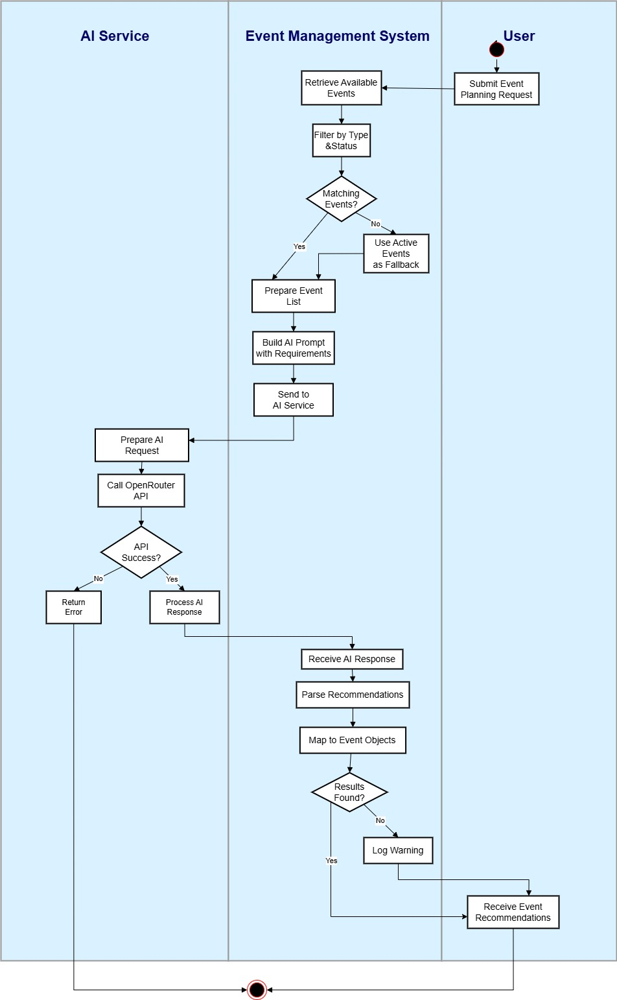

Figure 11:Activity 1
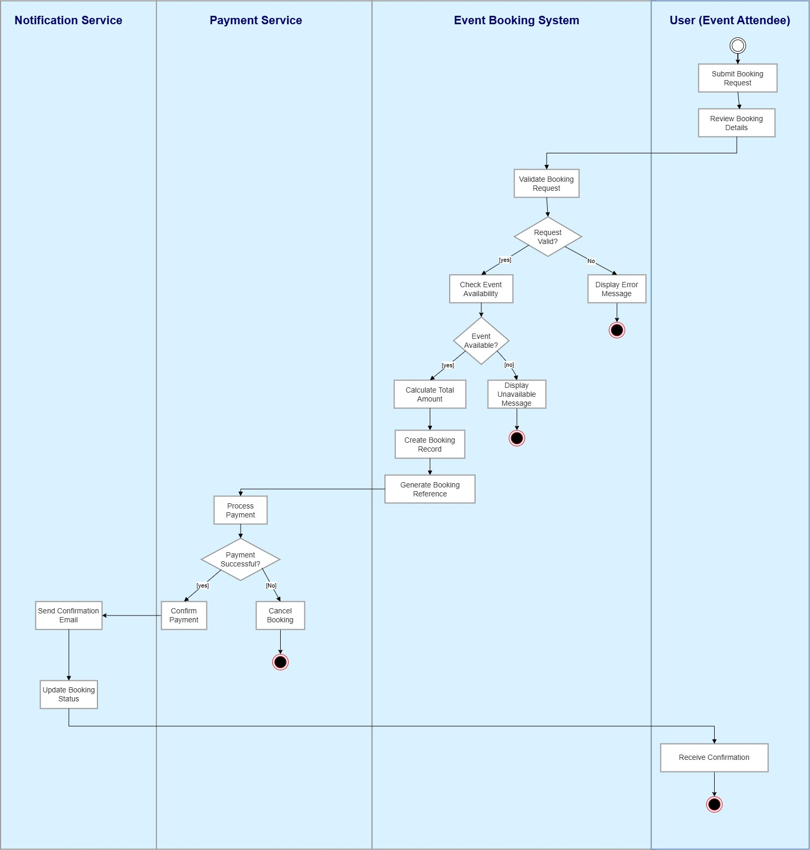
Figure 12:Activity 2
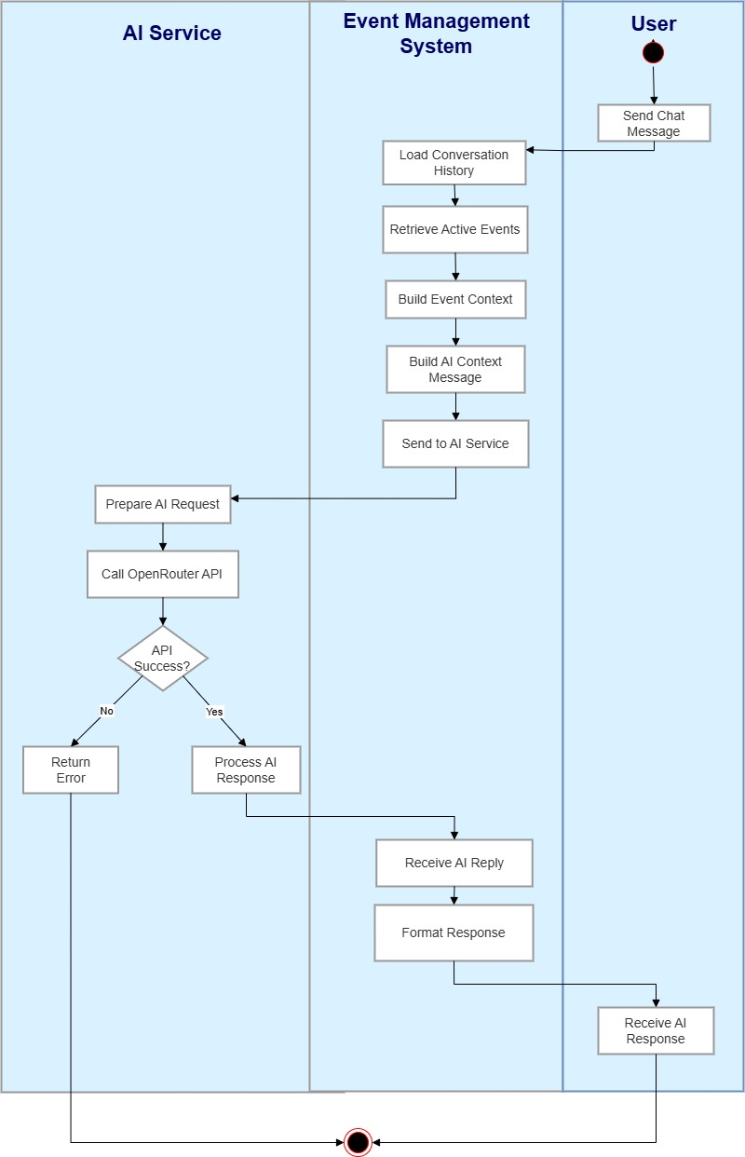
Figure 13:Activity 3
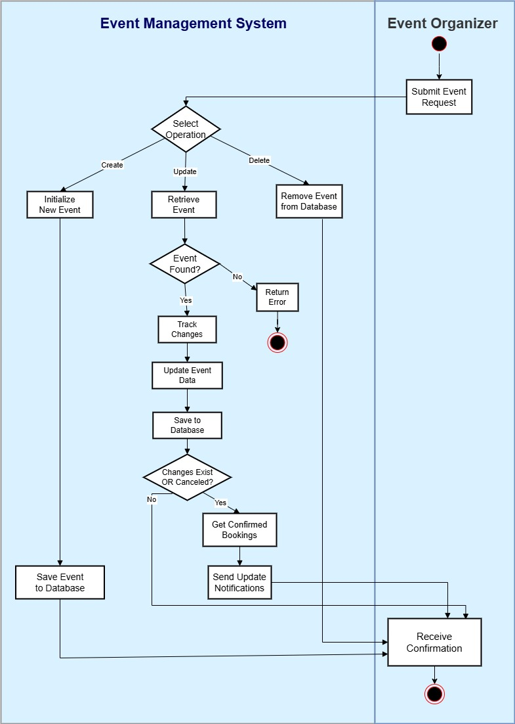
Figure 14:Activity 4
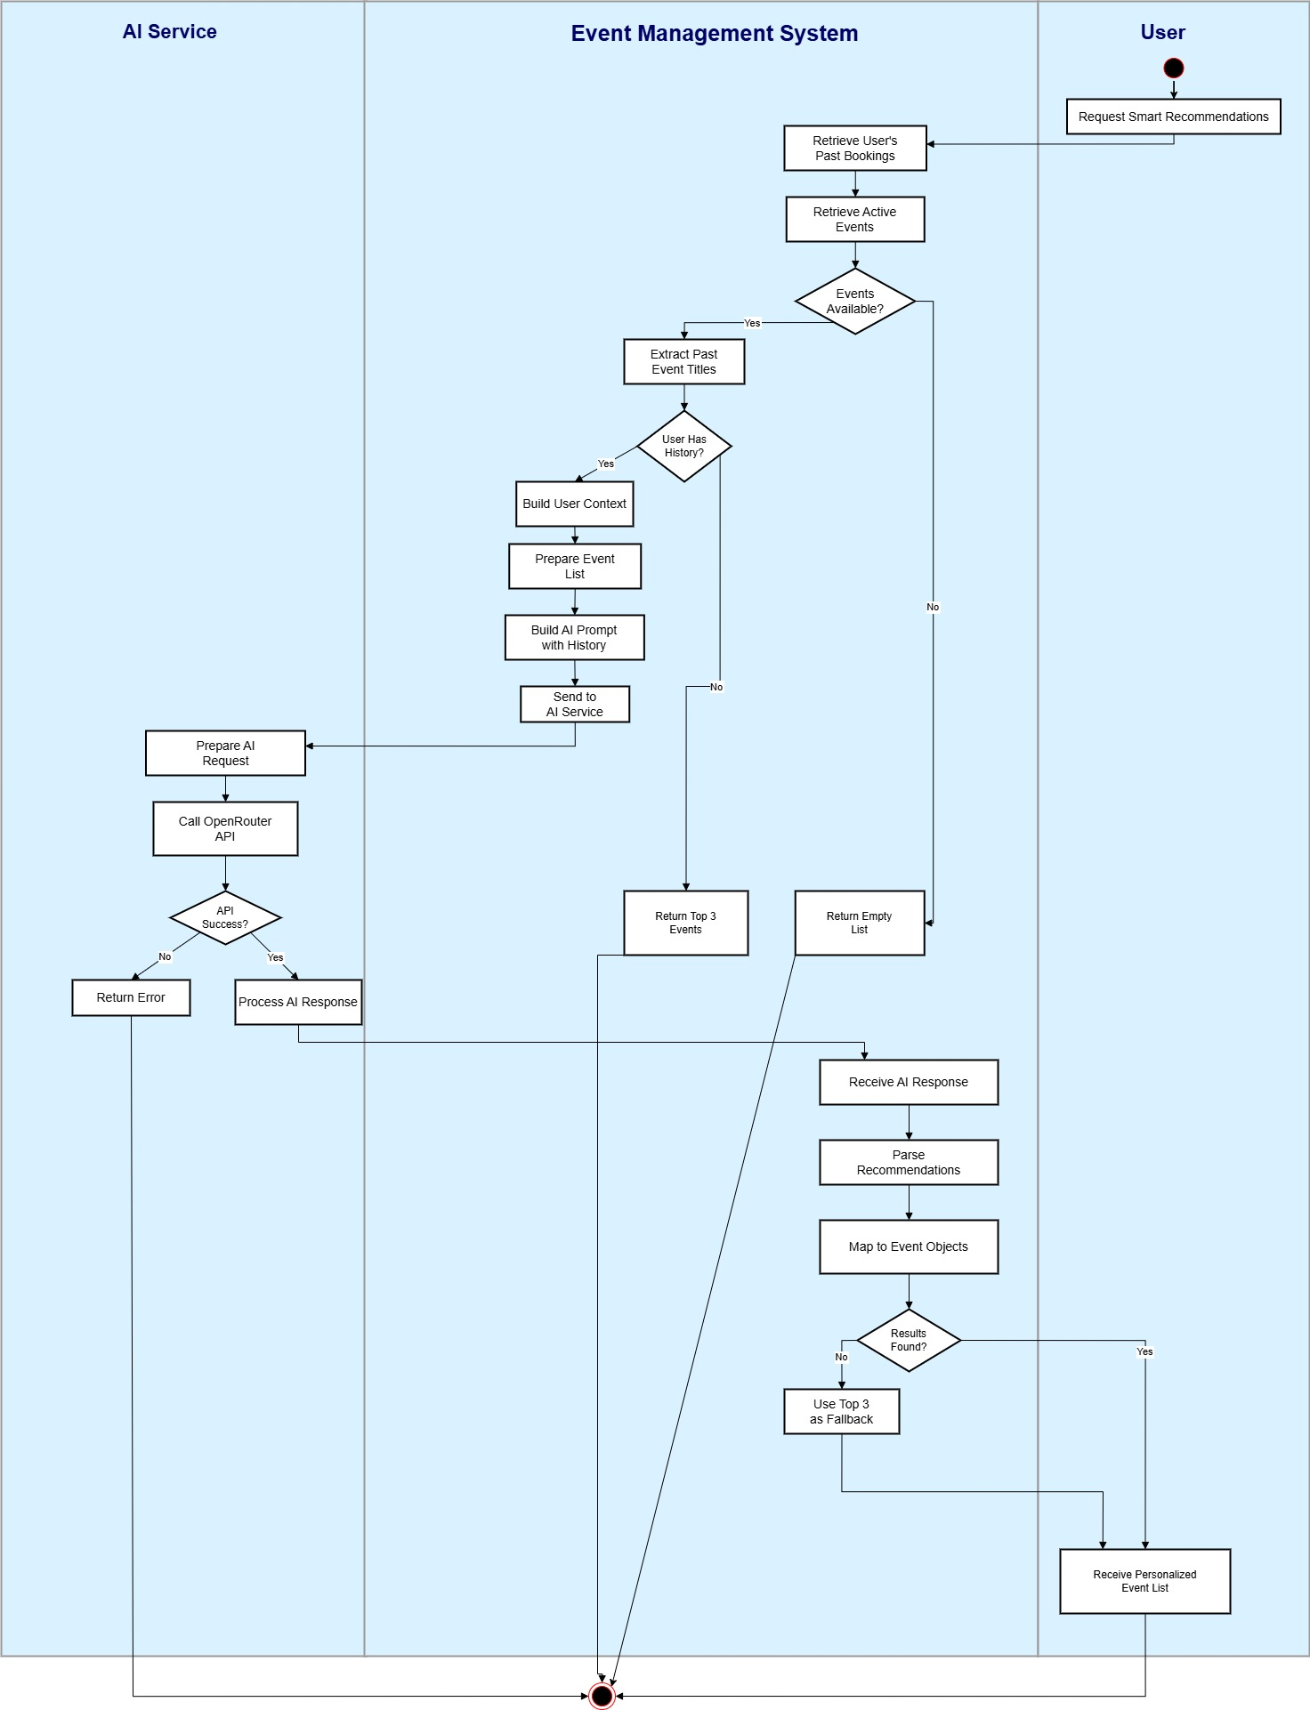
Figure 15:Activity 5
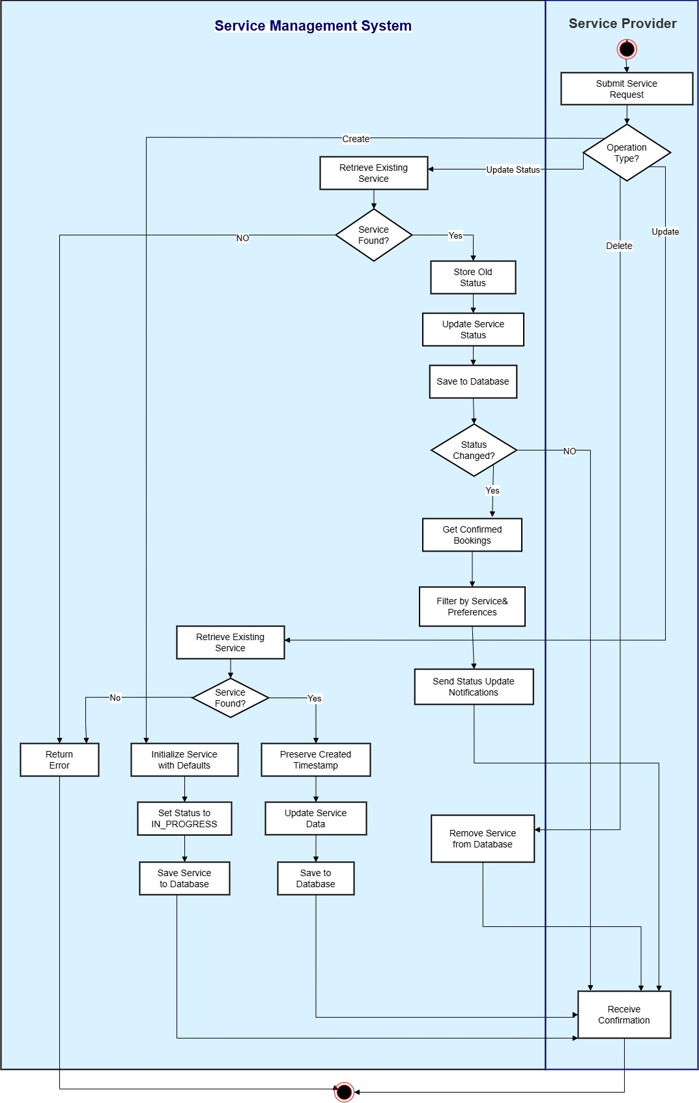
Figure 16: Activity For Service Management System
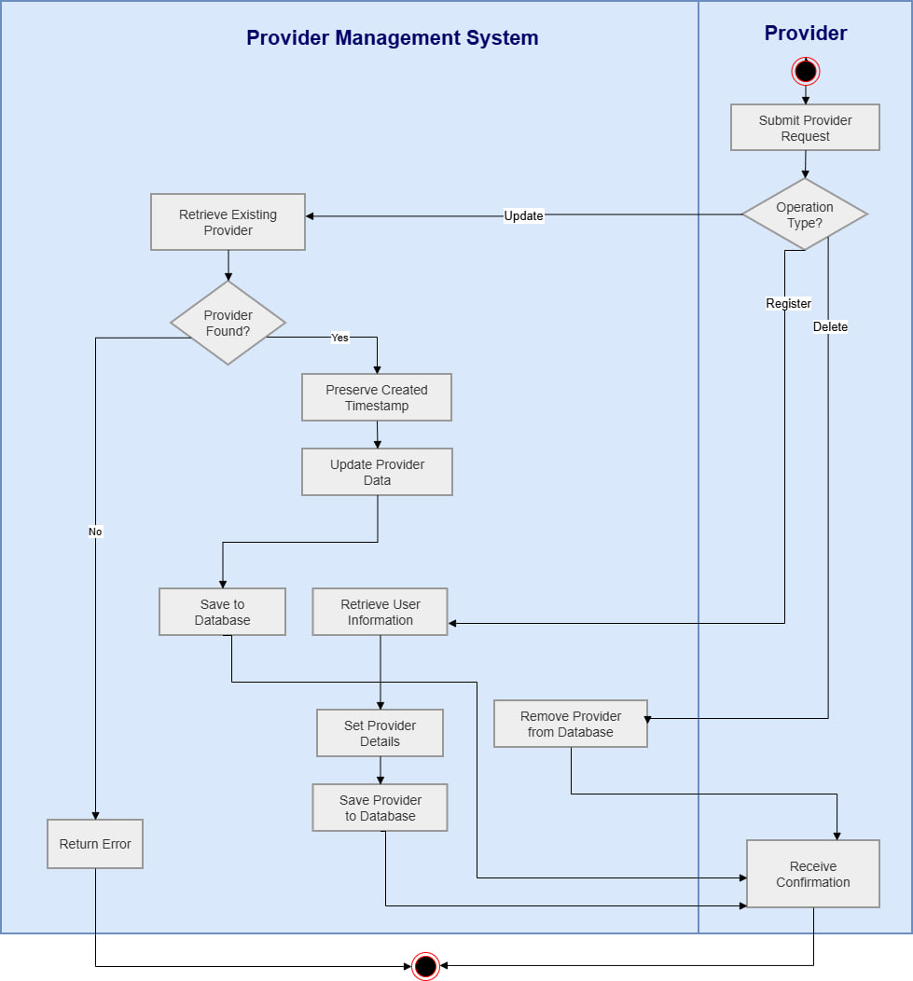
Figure 17:Activity For Provider Management System

4-7-4 Sequence Diagrams
Sequence Diagrams illustrate how messages and interactions are exchanged between different system components over time while executing the main operations. These diagrams help explain the communication process between the frontend, backend, database, and AI services, providing a clear understanding of the logical sequence of operations within the system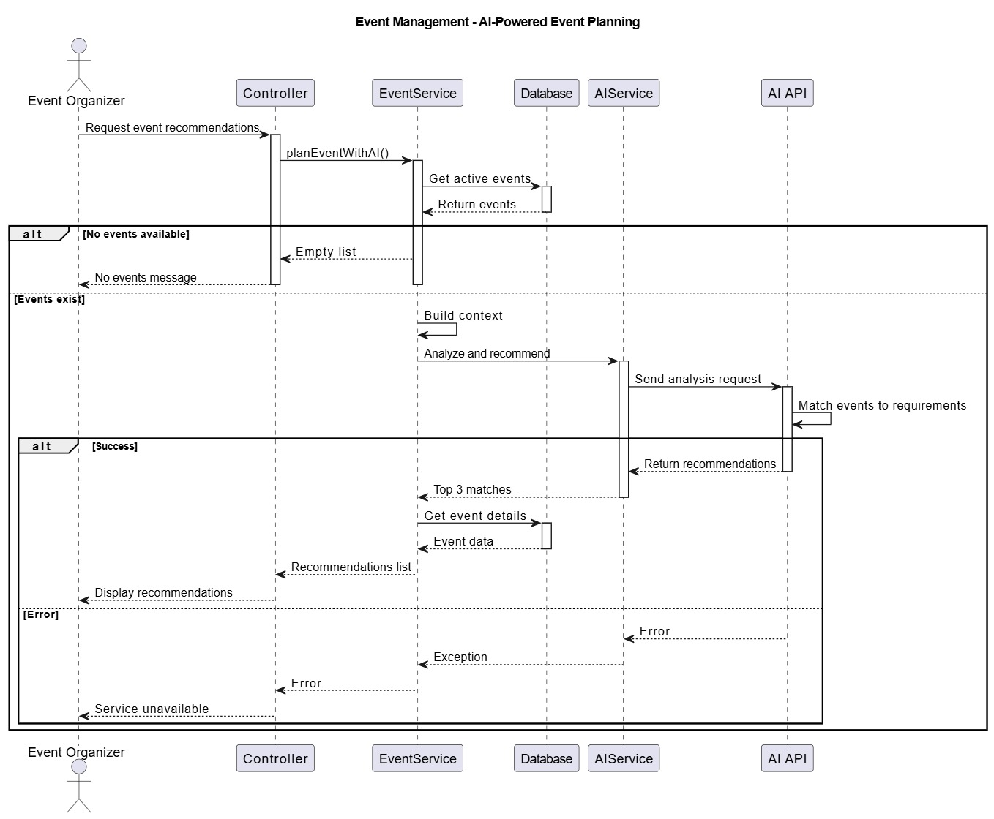
Figure 18:Sequence For AI Powered Event Planning

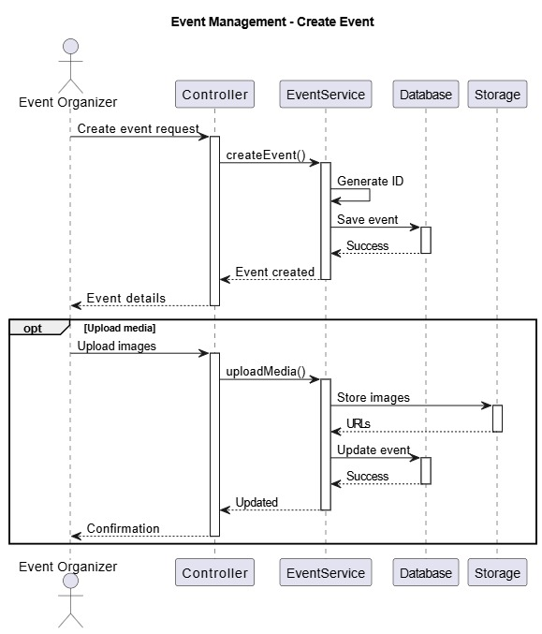
Figure 19:Sequence For Create Event
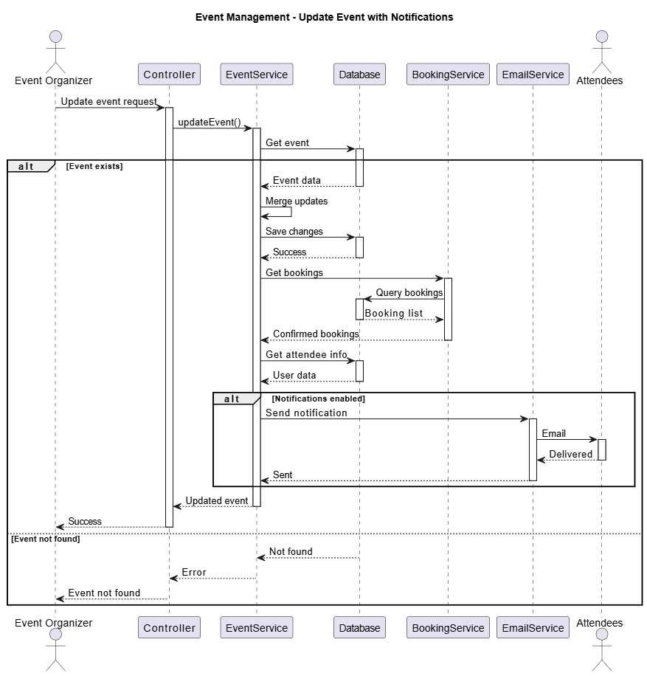
Figure 20:Sequence For Update Event With Notifications

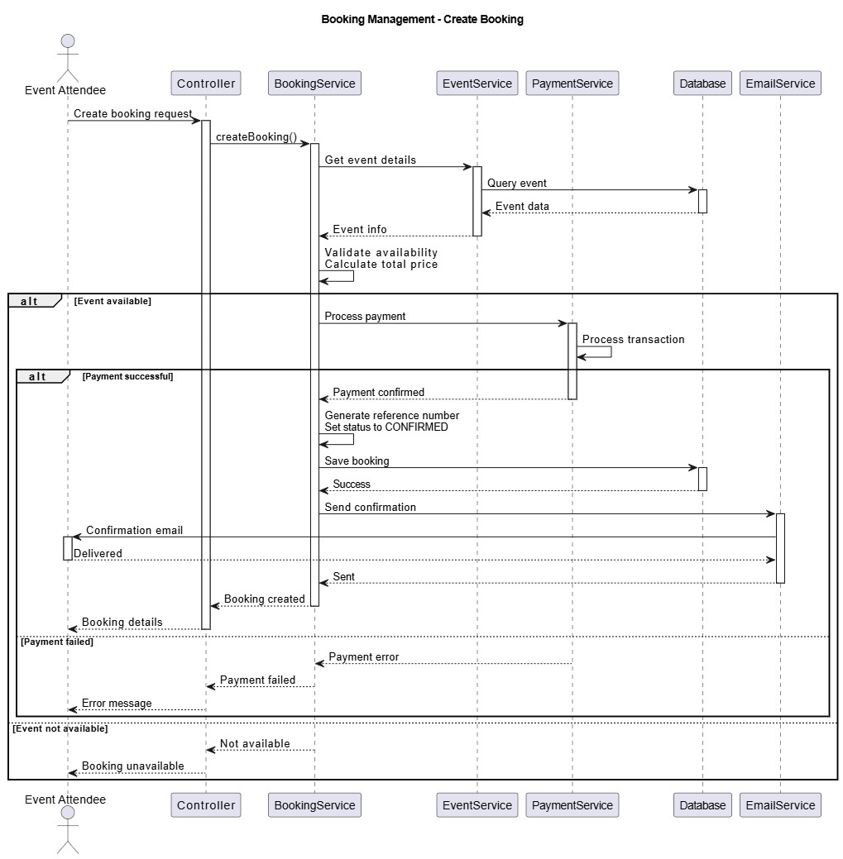
Figure 21:Sequence For Create Booking

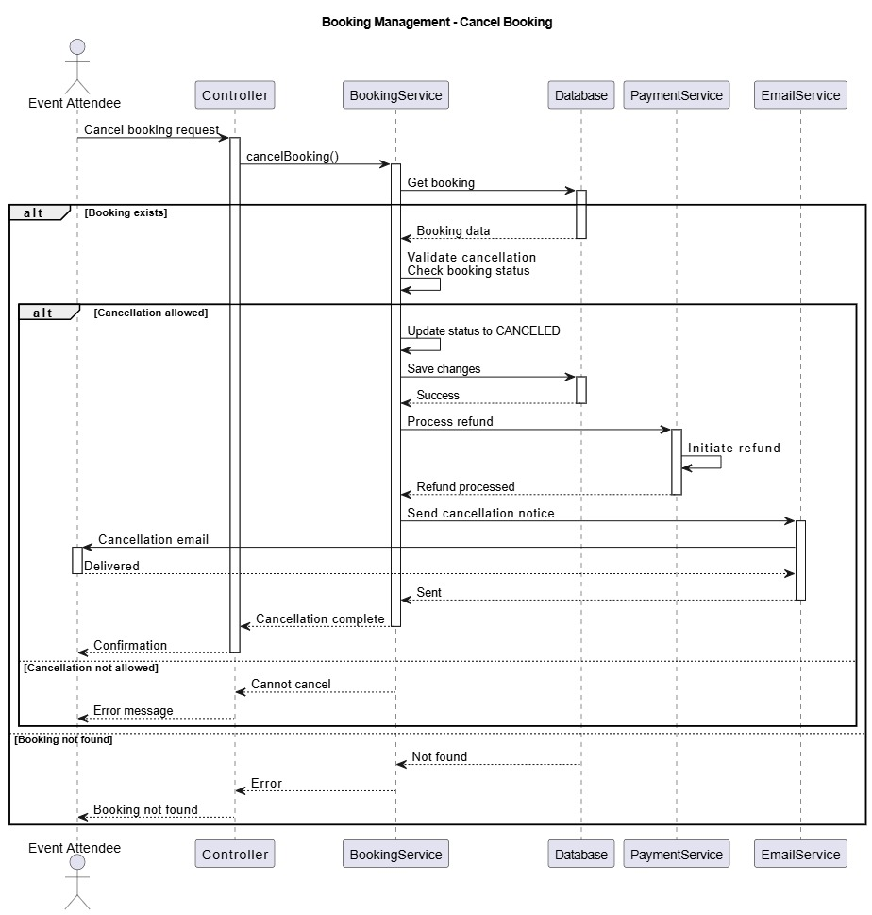
Figure 22:Sequence For Cancel Booking

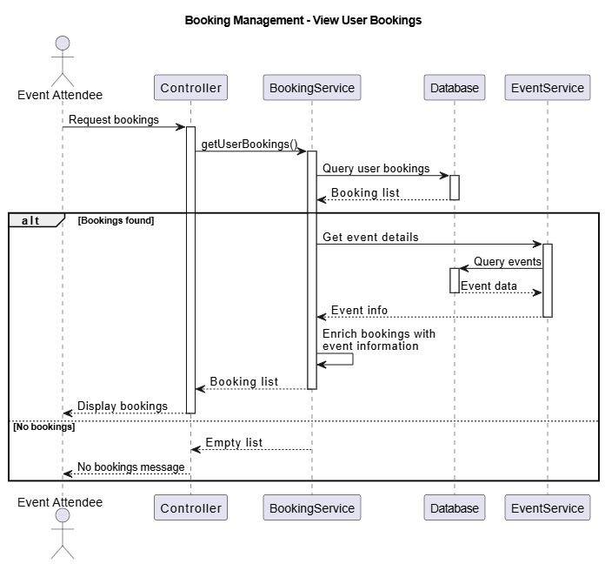
Figure 23:Sequence For View User Bookings

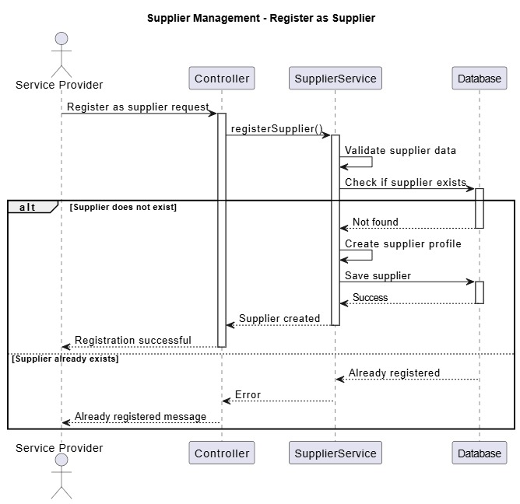
Figure 24:Sequence For Register as Supplier

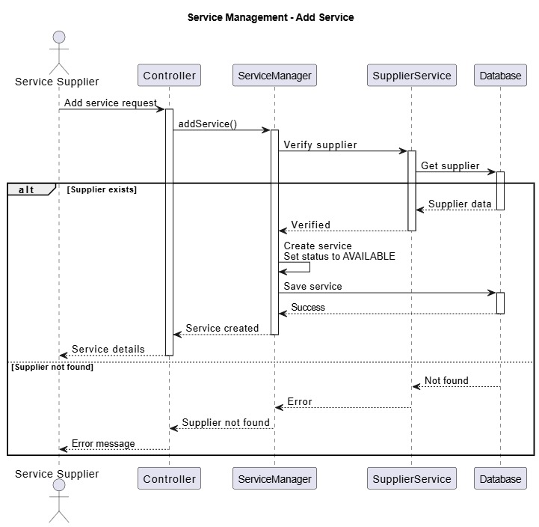
Figure 25:Sequence For Add Service

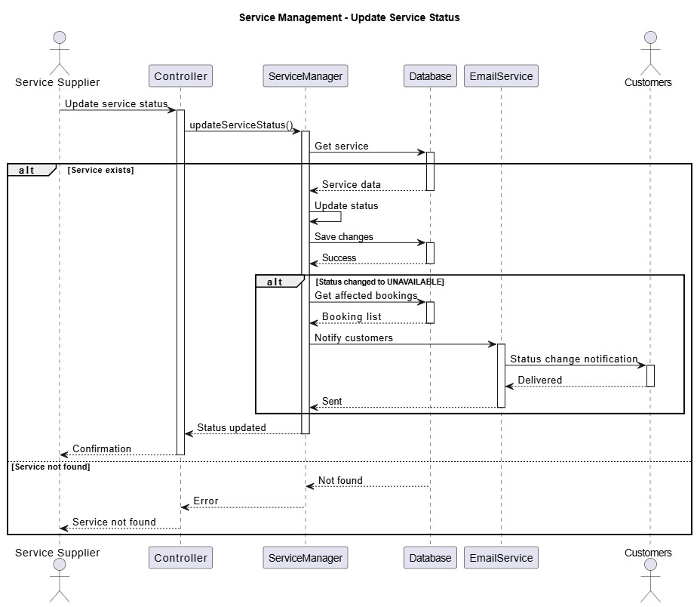
Figure 26:Sequence For Update Service Status

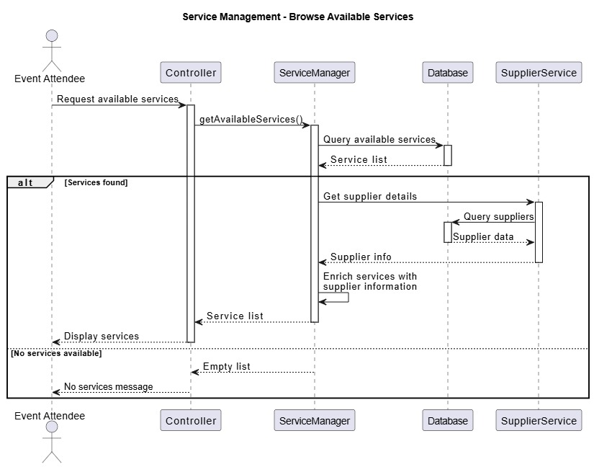
Figure 27:Sequence For Browse Available Service

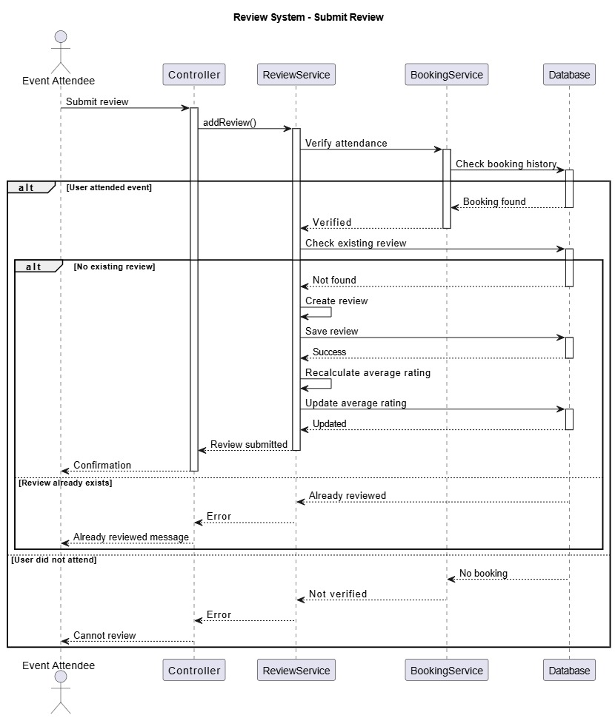
Figure 28:Sequence For Submit Review

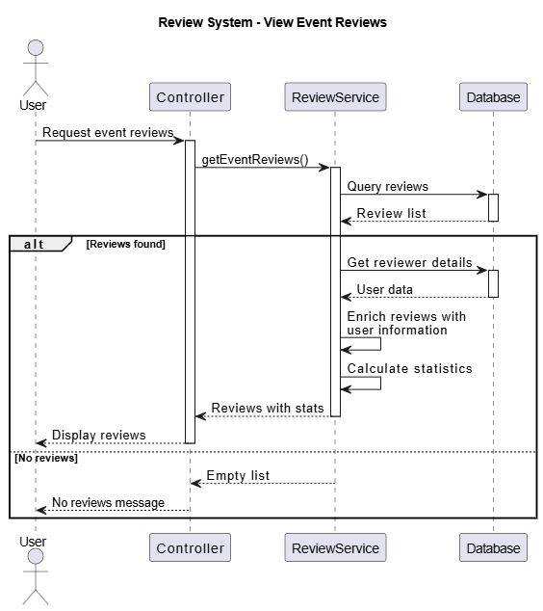
Figure 29:Sequence For View Event Reviews

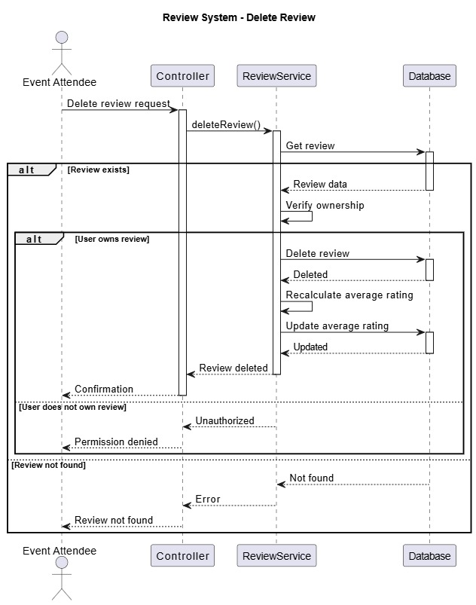
Figure 30:Sequence For Delete Review

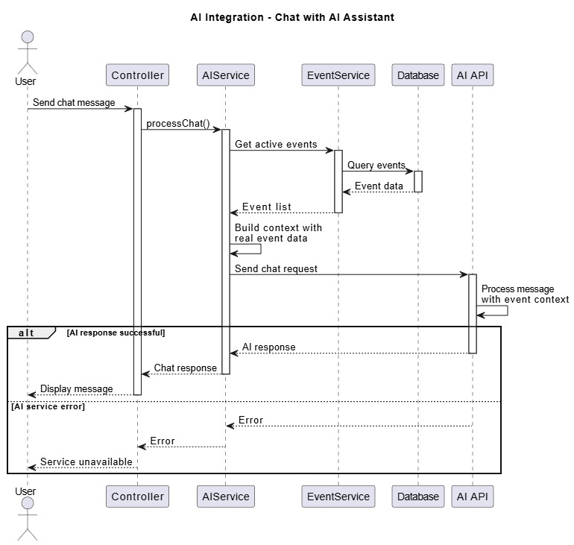
Figure 31:Sequence For Chat With AI Assistant

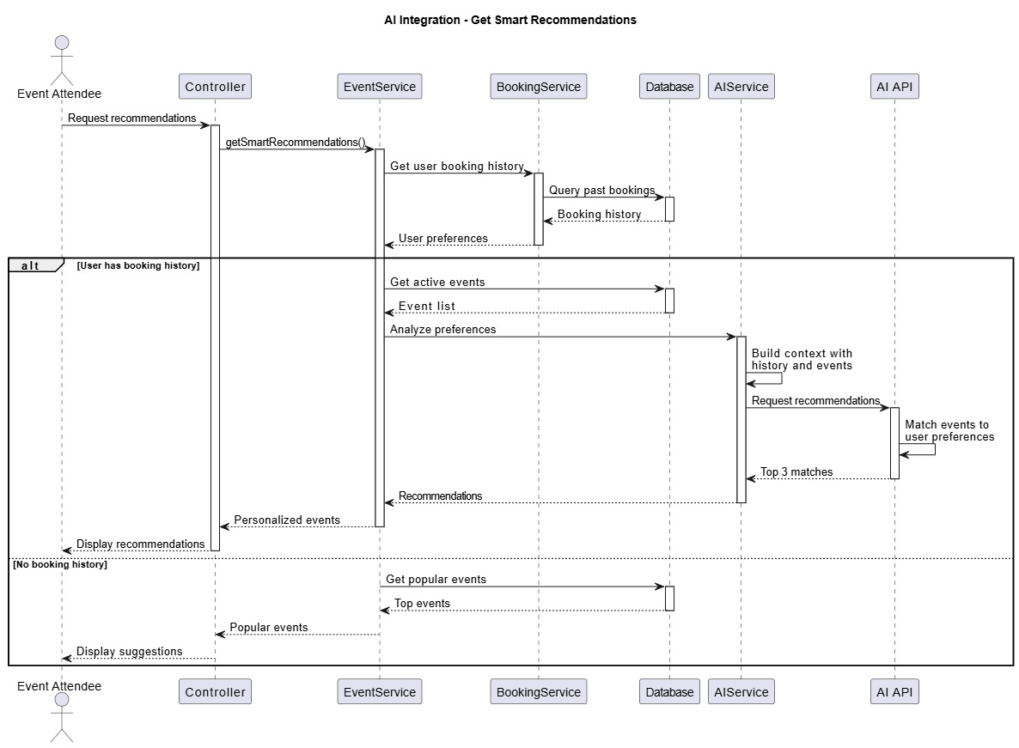
Figure 32:Sequence For Get Smart Recommendations

6
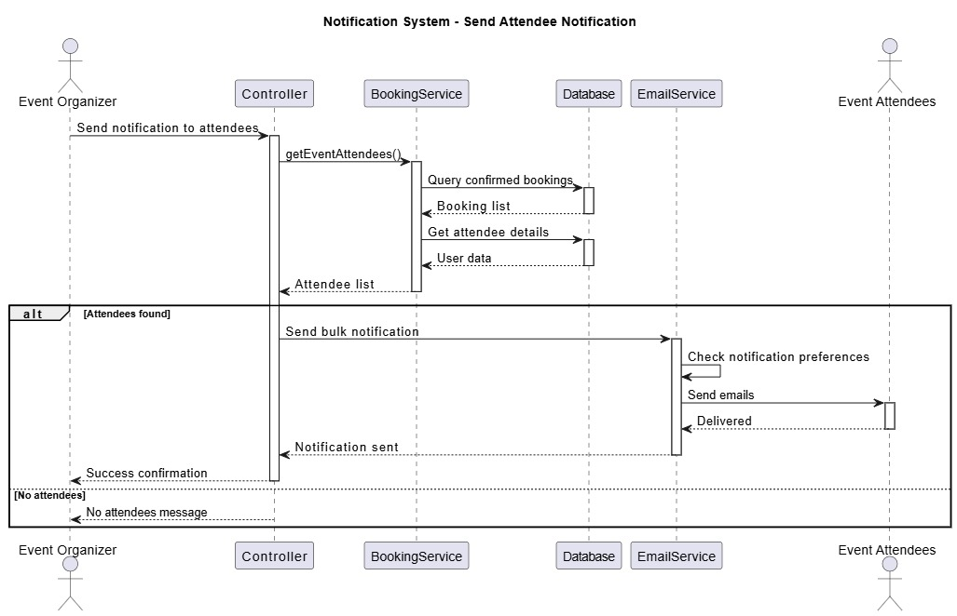
Figure 33:Sequence For Send Attendee Notification

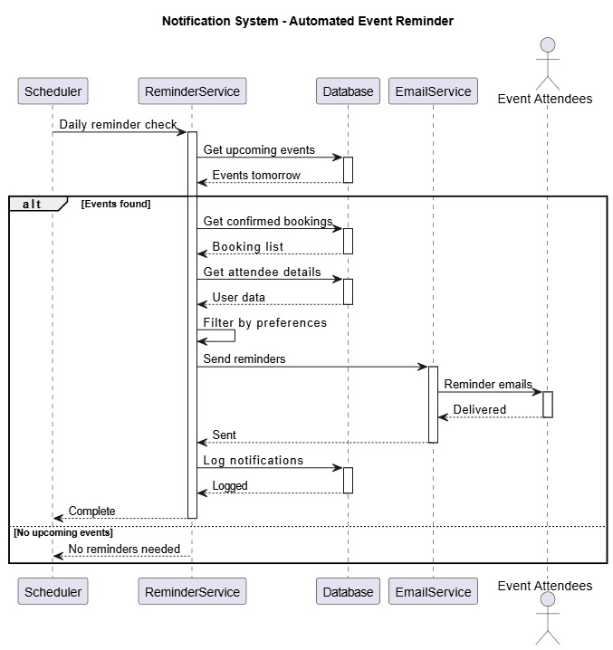
Figure 34:Sequence For Automated Event Reminder

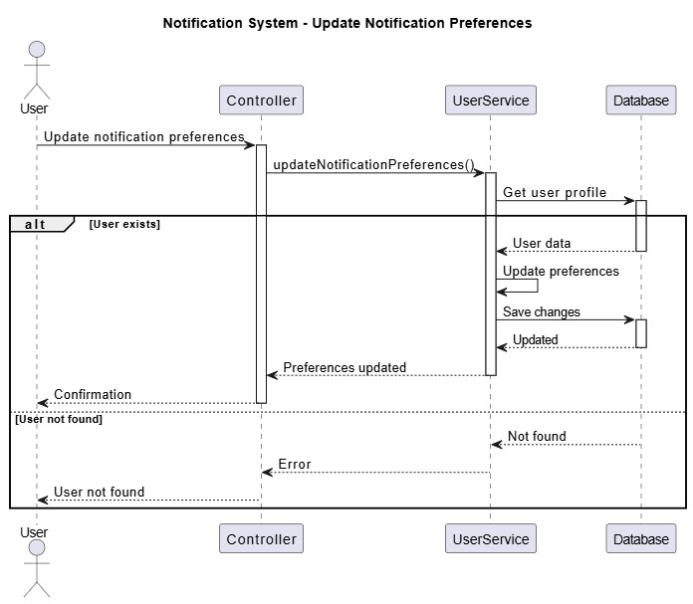
Figure 35:Sequence For Update Notification Preferences

7

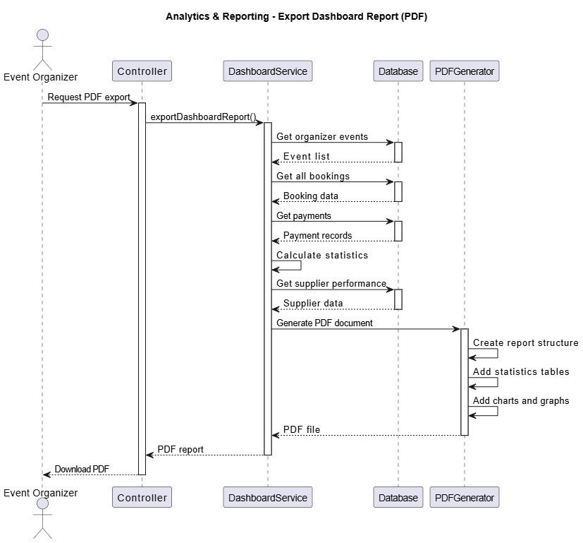
Figure 36:Sequence For Export Dashboard Report

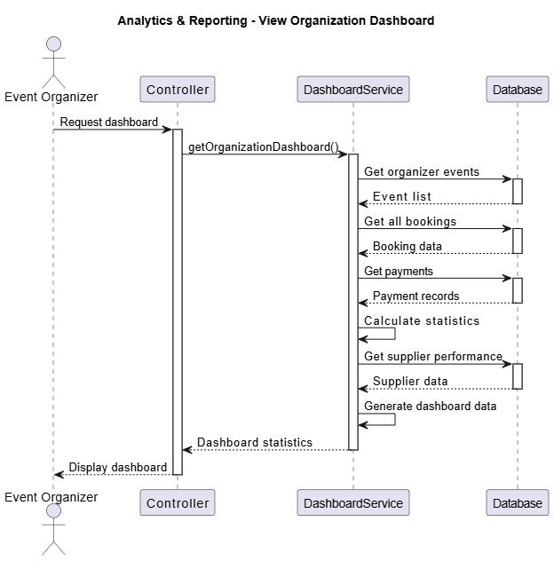
Figure 37:Sequence For View Organization Dashboard

4-8 Agile Modeling and Methodology Implementation
To support the development process of the EventMarketPlace platform, agile methodologies and modeling techniques were adopted throughout the project lifecycle. These methodologies helped organize requirements, prioritize system features, and manage development tasks incrementally while maintaining alignment with user needs and business objectives. The agile approach also supported iterative delivery, allowing the platform to evolve progressively through multiple development phases.

4-8-1 Story Mapping
Introduction
To better organize the requirements of the EventMarketPlace platform, the Story Mapping technique was adopted during the planning phase. This approach helped transform user requirements into a structured development roadmap by focusing on user activities, priorities, and complete end-to-end user journeys. Instead of treating features as isolated tasks, Story Mapping enabled the system to be designed from the users’ perspective, ensuring that each implemented feature contributes meaningful value to the overall user experience.

User Personas
Three primary user groups were identified within the platform. Understanding these user roles was essential for defining the core workflows of the system and ensuring that all functional requirements were aligned with actual user needs.

 | User Persona | Description
1 | Event Attendee | Users who browse, discover, and book events available on the marketplace platform.
2 | Event Organizer | Users who create, publish, and manage events, including controlling booking availability and communicating with attendees.
3 | Service Provider | Users who register as suppliers and offer additional services — such as catering, decoration, photography, or technical support — that can be added to bookings.
Table (43): User Personas

Backbone Activities
Based on the identified user personas, six core activities were defined as the backbone of the story map. Each activity represents a major user goal and was further divided into smaller user stories representing the required system functionalities.

 | Backbone Activity | Description
1 | Discover Events | Users browse the marketplace to find and explore events of interest based on type, location, and availability.
2 | Book Events | Users select desired events, choose seats, optionally add supplementary services, and complete the booking process.
3 | Manage Events | Event organizers create, update, and control events, including managing booking availability and notifying attendees.
4 | Provide Services | Service providers register on the platform and offer additional services that attendees can attach to their bookings.
5 | Review Experience | Attendees submit ratings and written reviews for events and service providers following their experience.
6 | Analyze Data | Event organizers access an analytics dashboard to monitor performance metrics and export summary reports.
Table (44): Backbone Activities

MVP Release Planning
For the first release (Minimum Viable Product - MVP), priority was given to the core functionalities that provide immediate value to users. The MVP focused on delivering complete user journeys rather than isolated features in order to ensure a coherent and usable platform from the initial release.
MVP Core Features
User Activity | MVP Core Features
Discover Events | 1. Browse all available events  2. Search and filter events by type and location  3. View complete event details including media and ratings
Book Events | 1. Select number of seats and validate availability  2. Optionally add supplementary services to a booking  3. Confirm booking and receive email confirmation with reference number
Manage Events | 1. Create new events with complete details  2. Update event information and notify attendees of changes  3. Toggle booking availability and control event status
Provide Services | 1. Register as a service provider on the platform  2. Create and manage service listings
Review Experience | 1. Submit ratings and written reviews for attended events  2. View average ratings and review summaries on event pages
Analyze Data | 1. Access an organizational dashboard with key performance metrics  2. View booking and revenue statistics
Table (45): MVP Release Planning

Features Planned for Future Releases
The following advanced features were identified during the planning process but postponed to future releases in order to keep the MVP focused and achievable within the project timeline:
- AI-powered event recommendations based on booking history
- AI chat assistant for event support and discovery
- Advanced analytics and trend analysis
- Dashboard report export functionality
- Supplier ranking and rating aggregation

Benefits of Story Mapping
Applying the Story Mapping technique provided several benefits throughout the development process:
- Improved backlog prioritization by distinguishing essential MVP features from future enhancements
- Helped identify dependencies between system features during early development stages
- Supported incremental delivery through manageable development iterations
- Maintained focus on complete user journeys and user-centered design
- Ensured alignment between development activities and business objectives

4-8-2 Product Backlog
Introduction
The Product Backlog represents the complete collection of functional requirements, features, and development tasks identified for the EventMarketPlace platform. Backlog items were organized and prioritized according to their business value, implementation complexity, and importance to the MVP release. This prioritization ensured that critical functionalities were implemented first while allowing future enhancements to be scheduled for later iterations.
Product Backlog Summary
The following table summarizes the primary user stories included in the product backlog, organized according to epic and implementation priority.
Story ID | User Story Title | Primary Actor | Priority | Points | Epic
US-1.1 | Create Event | Event Organizer | P0 – Critical | 8 | Event Management
US-1.2 | Browse All Events | Event Attendee | P0 – Critical | 5 | Event Management
US-1.3 | View Event Details | Event Attendee | P0 – Critical | 5 | Event Management
US-1.4 | Update Event Details | Event Organizer | P1 – High | 8 | Event Management
US-1.5 | Delete Event | Event Organizer | P1 – High | 3 | Event Management
US-1.6 | Upload Event Media | Event Organizer | P2 – Medium | 5 | Event Management
US-1.7 | Toggle Booking Status | Event Organizer | P1 – High | 3 | Event Management
US-2.1 | Create Booking | Event Attendee | P0 – Critical | 13 | Booking Management
US-2.2 | View Booking Details | Event Attendee | P0 – Critical | 3 | Booking Management
US-2.3 | View Upcoming Bookings | Event Attendee | P1 – High | 5 | Booking Management
US-2.4 | View Past Bookings | Event Attendee | P1 – High | 5 | Booking Management
US-2.5 | Cancel Booking | Event Attendee | P1 – High | 8 | Booking Management
US-2.6 | Get Booked Dates | Event Attendee | P2 – Medium | 3 | Booking Management
US-2.7 | Notify Event Attendees | Event Organizer | P2 – Medium | 5 | Booking Management
US-3.1 | User Registration | New User | P0 – Critical | 8 | User Management
US-3.2 | Token Verification | Registered User | P0 – Critical | 5 | User Management
US-3.3 | Update User Profile | Registered User | P1 – High | 8 | User Management
US-3.4 | Delete Profile Picture | Registered User | P2 – Medium | 3 | User Management
US-3.5 | Update Notification Preferences | Registered User | P1 – High | 5 | User Management
US-3.6 | Delete Account | Registered User | P2 – Medium | 5 | User Management

Table (46): Product Backlog Summary

Backlog Statistics
The backlog contains all identified user stories required for the implementation of the platform. Story points and priority levels were used to estimate development effort and organize implementation phases according to business importance and MVP objectives.
Metric | Value
Total User Stories | 20
Total Story Points | 130
Critical (P0) Stories | 7
High Priority (P1) Stories | 9
Medium Priority (P2) Stories | 4
Completion Status | 100% — All stories code-verified

Table (47): Backlog Statistics

4-8-3 User Stories
Introduction
User Stories were used to describe the functional requirements of the system from the perspective of end users. Each story follows the agile format “As a… I want… So that…” to clearly define the user role, desired functionality, and expected benefit. In addition, each user story includes acceptance criteria, test scenarios, and implementation references to ensure that all functionalities are clearly defined, testable, and traceable to the implemented system components.
3. Detailed User Stories
The following section presents each user story in full detail. Stories are grouped by epic and presented in priority order. Each card includes the user story statement, acceptance criteria in Given–When–Then format, test scenarios, and code references.
Epic 1: Event Management System
US-1.1 Create Event | Priority: P0 – Critical | Story Points: 8
User Story | As a Event Organizer,  I want to create new events with complete details,  so that attendees can discover and book my events.
Acceptance Criteria | 1. Given I am logged in as an organizer, when I navigate to the create event page, then I see a form with all required fields.  2. Given I fill in event title, description, location, city, and date/time, when I set ticket price and capacity, then the system validates all inputs.  3. Given I select event type (PUBLIC_EVENT or HOST_PACKAGE), when I submit the form, then the event is created with ACTIVE status.  4. Given the event is created successfully, when I view the event, then available seats equals total capacity.  5. Given the event is created, when I check the database, then the event has a unique ID and creation timestamps.
Test Scenarios | ✓ Create PUBLIC_EVENT with valid data.  ✓ Create HOST_PACKAGE with valid data.  ✓ Validate that required fields are enforced.  ✓ Validate that ticket price must be positive.  ✓ Validate that capacity must be positive.  ✓ Verify that timestamps are correctly set upon creation.
Code Reference | EventService.createEvent() — lines 47–57  EventController.createEvent() — lines 23–31

Table (48): Detailed User Stories 1

US-1.2 Browse All Events | Priority: P0 – Critical | Story Points: 5
User Story | As a Event Attendee,  I want to view all available events,  so that I can discover events to attend.
Acceptance Criteria | 1. Given I am on the marketplace homepage, when I view the events list, then I see all events with ACTIVE status.  2. Given events are displayed, when I view each event card, then I see title, location, price, and available seats.  3. Given an event has bookingEnabled set to false, when I browse events, then that event is excluded from the list.  4. Given there are no active events, when I browse events, then I see a 'No events available' message.
Test Scenarios | ✓ Display all ACTIVE events.  ✓ Exclude events with CANCELED status.  ✓ Exclude events with bookingEnabled=false.  ✓ Handle an empty event list gracefully.  ✓ Verify completeness of event data in each card.
Code Reference | EventController.getAllEvents() — lines 42–48  EventService.getAllEvents()

Table (49): Detailed User Stories 2
US-1.3 View Event Details | Priority: P0 – Critical | Story Points: 5
User Story | As a Event Attendee,  I want to view complete details of a specific event,  so that I can make an informed decision about booking it.
Acceptance Criteria | 1. Given I am browsing events, when I select an event, then I am navigated to the event details page.  2. Given I am on the event details page, when I view the information, then I see title, description, location, city, and date/time.  3. Given I am viewing event details, when I scroll further, then I see ticket price, total capacity, and available seats.  4. Given the event has uploaded media, when I view event details, then I see event images and the promotional video.  5. Given the event has reviews, when I view event details, then I see the average rating and total review count.
Test Scenarios | ✓ Display complete event information.  ✓ Show event images when available.  ✓ Show promotional video when available.  ✓ Display the computed average rating.  ✓ Return HTTP 404 when event is not found.
Code Reference | EventController.getEvent() — lines 33–40  EventService.getEventById()
Table (50): Detailed User Stories 3

US-1.4 Update Event Details | Priority: P1 – High | Story Points: 8
User Story | As a Event Organizer,  I want to modify event information,  so that I can keep event details accurate and notify attendees of any changes.
Acceptance Criteria | 1. Given I am the event organizer, when I update the event title, description, or location, then changes are persisted immediately.  2. Given I update the event date or ticket price, when I save changes, then the system records exactly which fields were modified.  3. Given the event has confirmed bookings, when I update event details, then all attendees receive an automated email notification.  4. Given a notification email is dispatched, when an attendee opens it, then the email lists the specific changes that were made.  5. Given a user has disabled event update notifications, when I update the event, then that user does not receive an email.  6. Given I update the event status to CANCELED, when I save, then all attendees receive a cancellation email.
Test Scenarios | ✓ Update event title successfully.  ✓ Update event date and time.  ✓ Update ticket price.  ✓ Update event capacity.  ✓ Change event status to CANCELED.  ✓ Verify attendees are notified of changes.  ✓ Verify notification preferences are respected.  ✓ Verify all changed fields are tracked and reported.
Code Reference | EventService.updateEvent() — lines 59–165  EmailService.sendEventNotification()
Table (51): Detailed User Stories 4

US-1.5 Delete Event | Priority: P1 – High | Story Points: 3
User Story | As a Event Organizer,  I want to remove events from the system,  so that outdated or canceled events are no longer visible to attendees.
Acceptance Criteria | 1. Given I am the event organizer, when I delete an event, then the event record is removed from the database.  2. Given the event has confirmed bookings, when I delete the event, then all associated bookings are automatically canceled.  3. Given the event is deleted, when an attendee tries to view it, then they receive an 'Event not found' message.  4. Given the event is deleted, when I browse events, then the deleted event no longer appears in the list.
Test Scenarios | ✓ Delete an event successfully.  ✓ Verify the event record is removed from the database.  ✓ Return HTTP 404 when accessing a deleted event.  ✓ Verify all associated bookings are canceled upon deletion.
Code Reference | EventService.deleteEvent() — lines 166–169  EventController.deleteEvent() — lines 115–122
Table (52): Detailed User Stories 5

US-1.6 Upload Event Media | Priority: P2 – Medium | Story Points: 5
User Story | As a Event Organizer,  I want to upload promotional images and videos for my event,  so that the event page appears attractive to potential attendees.
Acceptance Criteria | 1. Given I am editing my event, when I upload an image, then the file is stored securely in Firebase Storage.  2. Given an image is uploaded, when I view the event, then the image is displayed on the event page.  3. Given I want to add multiple images, when I upload additional files, then all images are stored and displayed.  4. Given I want to add a promotional video, when I upload a video file, then the video is stored and playable on the event page.  5. Given an upload fails, when I attempt to upload media, then I receive an error message indicating the reason.
Test Scenarios | ✓ Upload a single image successfully.  ✓ Upload multiple images successfully.  ✓ Upload a video file successfully.  ✓ Verify files are persisted in Firebase Storage.  ✓ Verify download URLs are generated and stored.  ✓ Handle upload failures with appropriate error messages.
Code Reference | EventService.uploadEventMedia() — lines 195–213  EventService.uploadEventVideo() — lines 181–193  StorageService
Table (53): Detailed User Stories 6

US-1.7 Toggle Booking Status | Priority: P1 – High | Story Points: 3
User Story | As a Event Organizer,  I want to enable or disable booking for my event,  so that I can control the period during which attendees may book.
Acceptance Criteria | 1. Given my event has bookingEnabled set to true, when I toggle the booking status, then bookingEnabled changes to false.  2. Given bookingEnabled is false, when an attendee attempts to book, then they receive a 'Booking not available' message.  3. Given bookingEnabled is false, when I toggle booking status, then bookingEnabled changes back to true.  4. Given the event already has existing bookings, when I disable booking, then existing bookings remain valid and unaffected.
Test Scenarios | ✓ Enable booking on an event.  ✓ Disable booking on an event.  ✓ Verify existing bookings remain valid when booking is disabled.  ✓ Prevent new bookings from being created when booking is disabled.
Code Reference | EventService.toggleBookingEnabled() — lines 175–179  EventController.toggleBooking() — lines 58–66
Table (54): Detailed User Stories 7

Epic 2: Booking Management System
US-2.1 Create Booking | Priority: P0 – Critical | Story Points: 13
User Story | As a Event Attendee,  I want to book events with seat selection and optional services,  so that I can secure my attendance and personalize my experience.
Acceptance Criteria | 1. Given I am viewing an event, when I select the number of seats, then the system validates seat availability in real time.  2. Given seats are available, when I proceed to booking, then I may optionally add supplementary services.  3. Given I have selected seats and optional services, when I review the booking summary, then I see the total price computed as (ticket price × number of seats) + service costs.  4. Given the event type is HOST_PACKAGE, when I create a booking, then I am required to select a specific event date.  5. Given I select a date for a HOST_PACKAGE event, when that date is already booked, then I receive a 'Date unavailable' error.  6. Given all validations pass, when I complete the booking, then a booking record is created with CONFIRMED status.  7. Given the booking is created, when I check my email, then I receive a confirmation email containing a unique reference number.  8. Given the booking is successful, when I view the event details, then the available seat count is decremented accordingly.
Test Scenarios | ✓ Book a PUBLIC_EVENT with a valid number of seats.  ✓ Book a HOST_PACKAGE with a valid selected date.  ✓ Add optional services to a booking.  ✓ Validate that the total price is calculated correctly.  ✓ Prevent double-booking on the same HOST_PACKAGE date.  ✓ Verify that a unique booking reference number is generated.  ✓ Verify that a confirmation email is dispatched.  ✓ Verify that available seats are decremented after booking.
Code Reference | BookingService.createBooking() — lines 48–142  BookingController.createBooking() — lines 24–31
Table (55): Detailed User Stories 8

US-2.2 View Booking Details | Priority: P0 – Critical | Story Points: 3
User Story | As a Event Attendee,  I want to view my booking information,  so that I can review my reservation details at any time.
Acceptance Criteria | 1. Given I have a confirmed booking, when I view booking details, then I see the unique booking reference number.  2. Given I am viewing a booking, when I inspect the details, then I see the event title, date, and location.  3. Given I am viewing a booking, when I scroll further, then I see the number of seats booked and the total amount paid.  4. Given I added services to my booking, when I view booking details, then I see the complete list of selected services.  5. Given I am viewing a booking, when I check the status section, then I see both booking status and payment status.
Test Scenarios | ✓ Display complete booking information.  ✓ Show the list of selected services.  ✓ Display both booking and payment statuses.  ✓ Return HTTP 404 when booking is not found.
Code Reference | BookingController.getBooking() — lines 35–43  BookingService.getBookingById()
Table (56): Detailed User Stories 9

US-2.3 View Upcoming Bookings | Priority: P1 – High | Story Points: 5
User Story | As a Event Attendee,  I want to see my future event bookings,  so that I can plan my schedule effectively.
Acceptance Criteria | 1. Given I have bookings, when I view upcoming bookings, then I see only CONFIRMED bookings whose event date is in the future.  2. Given I have canceled bookings, when I view upcoming bookings, then canceled bookings are not included.  3. Given I have multiple upcoming bookings, when I view the list, then bookings are sorted by event date in ascending order (earliest first).  4. Given I have no upcoming bookings, when I view the section, then I see a 'No upcoming bookings' message.
Test Scenarios | ✓ Display only upcoming bookings.  ✓ Exclude canceled bookings from the list.  ✓ Exclude past bookings from the list.  ✓ Verify bookings are sorted by date (ascending).  ✓ Handle an empty upcoming bookings list gracefully.
Code Reference | BookingController.getUserUpcomingBookings() — lines 53–61  BookingService.getUserUpcomingBookings() — lines 164–172
Table (57): Detailed User Stories 10

US-2.4 View Past Bookings | Priority: P1 – High | Story Points: 5
User Story | As a Event Attendee,  I want to see my past event bookings,  so that I can review my event attendance history.
Acceptance Criteria | 1. Given I have attended events, when I view past bookings, then I see only CONFIRMED bookings whose event date has passed.  2. Given I have canceled bookings, when I view past bookings, then canceled bookings are not included.  3. Given I have multiple past bookings, when I view the list, then bookings are sorted by event date in descending order (most recent first).  4. Given I have no past bookings, when I view the section, then I see a 'No past bookings' message.
Test Scenarios | ✓ Display only past bookings.  ✓ Exclude canceled bookings.  ✓ Exclude upcoming bookings.  ✓ Verify bookings are sorted by date (descending).  ✓ Handle an empty past bookings list gracefully.
Code Reference | BookingController.getUserPastBookings() — lines 63–71  BookingService.getUserPastBookings() — lines 173–180
Table (58): Detailed User Stories 11

US-2.5 Cancel Booking | Priority: P1 – High | Story Points: 8
User Story | As a Event Attendee,  I want to cancel my booking,  so that I can receive a refund if I am unable to attend.
Acceptance Criteria | 1. Given I have a confirmed booking, when I request cancellation, then the system verifies I am the booking owner.  2. Given the event date has not yet passed, when I cancel the booking, then the booking status changes to CANCELED.  3. Given the booking is canceled, when I check the payment status, then the payment status changes to REFUNDED.  4. Given the booking is canceled, when I check my email, then I receive a cancellation confirmation email.  5. Given the event date has already passed, when I attempt to cancel, then I receive a 'Cannot cancel a past event' error.  6. Given the booking is canceled, when I view the event details, then the available seat count is incremented.
Test Scenarios | ✓ Cancel a confirmed booking successfully.  ✓ Verify booking status changes to CANCELED.  ✓ Verify payment status changes to REFUNDED.  ✓ Verify a cancellation confirmation email is sent.  ✓ Prevent cancellation of bookings for past events.  ✓ Verify only the booking owner can cancel.  ✓ Verify available seats are incremented after cancellation.
Code Reference | BookingService.cancelBooking() — lines 182–206  BookingController.cancelBooking() — lines 73–81
Table (59): Detailed User Stories 12

US-2.6 Get Booked Dates | Priority: P2 – Medium | Story Points: 3
User Story | As a Event Attendee,  I want to see which dates are already booked for HOST_PACKAGE events,  so that I can select an available date when making a booking.
Acceptance Criteria | 1. Given the event is of type HOST_PACKAGE, when I view the booking form, then I see a calendar with booked dates visually marked.  2. Given a date is already booked, when I attempt to select it, then the date is disabled and cannot be chosen.  3. Given I select an available date, when I proceed with the booking, then the system allows the booking to continue.  4. Given no dates are currently booked, when I view the calendar, then all future dates are shown as available.
Test Scenarios | ✓ Return the complete list of booked dates for an event.  ✓ Include only CONFIRMED bookings in the booked dates list.  ✓ Verify dates are formatted consistently.  ✓ Handle the case where no bookings exist for the event.
Code Reference | BookingService.getBookedDatesForEvent() — lines 233–241  BookingController.getBookedDates() — lines 83–91
Table (60): Detailed User Stories 13

US-2.7 Notify Event Attendees | Priority: P2 – Medium | Story Points: 5
User Story | As a Event Organizer,  I want to send custom messages to event attendees,  so that I can communicate important information directly to confirmed participants.
Acceptance Criteria | 1. Given I am the event organizer, when I compose a message, then I can enter a subject and message body.  2. Given I submit the notification, when the system processes the request, then an email is sent to all confirmed attendees.  3. Given an attendee has disabled event update notifications, when I send the notification, then that attendee does not receive an email.  4. Given the notification is dispatched, when I review the results, then I see the total count of emails successfully sent.  5. Given an attendee has an invalid email address, when I send the notification, then that attendee is skipped and the process continues.
Test Scenarios | ✓ Send notification to all confirmed attendees.  ✓ Verify notification preferences are respected.  ✓ Skip attendees with invalid email addresses.  ✓ Return the correct count of emails sent.  ✓ Enforce that both subject and message body are required.
Code Reference | BookingService.notifyEventAttendees() — lines 207–226  BookingController.notifyAttendees() — lines 93–108
Table (61): Detailed User Stories 14

Epic 3: User Management & Authentication

US-3.1 User Registration | Priority: P0 – Critical | Story Points: 8
User Story | As a New User,  I want to create an account on the platform,  so that I can access the marketplace and its features.
Acceptance Criteria | 1. Given I am on the registration page, when I enter my email, password, name, and phone, then the system validates the email format.  2. Given I enter valid information, when I select a user role (USER, ORGANIZER, or SUPPLIER), then the system creates a Firebase Authentication user.  3. Given the Firebase user is created, when the system initializes my profile, then the user profile is saved to the database.  4. Given registration is successful, when I check my email, then I receive a welcome email.  5. Given the email address already exists in the system, when I attempt to register, then I receive an 'Email already in use' error.
Test Scenarios | ✓ Register with valid user data.  ✓ Validate email format before submission.  ✓ Validate password strength requirements.  ✓ Create the Firebase Authentication user.  ✓ Persist the user profile in the database.  ✓ Verify a welcome email is sent upon success.  ✓ Handle duplicate email addresses with an appropriate error.
Code Reference | AuthService.registerUser() — lines 28–59  AuthController.register() — lines 25–33
Table (62): Detailed User Stories 15

US-3.2 Token Verification | Priority: P0 – Critical | Story Points: 5
User Story | As a Registered User,  I want my authentication token to be verified on each request,  so that I can securely access protected resources.
Acceptance Criteria | 1. Given I am logged in, when I make an API request, then the system verifies my Firebase authentication token.  2. Given the token is valid, when the system completes verification, then I am granted access to the requested resource.  3. Given the token is invalid or expired, when the system verifies it, then I receive an HTTP 401 Unauthorized error.  4. Given the token is verified successfully, when the system retrieves my user profile, then my user information is returned.
Test Scenarios | ✓ Verify a valid authentication token.  ✓ Reject an invalid token with HTTP 401.  ✓ Reject an expired token with HTTP 401.  ✓ Return the user profile upon successful verification.  ✓ Handle requests with no token provided.
Code Reference | AuthService.verifyToken() — lines 64–66  AuthController.verifyToken() — lines 35–50
Table (63): Detailed User Stories 16

US-3.3 Update User Profile | Priority: P1 – High | Story Points: 8
User Story | As a Registered User,  I want to modify my profile information,  so that my personal details remain accurate and up to date.
Acceptance Criteria | 1. Given I am logged in, when I update my name or phone number, then the changes are saved immediately.  2. Given I upload a new profile picture, when the upload completes, then the image is stored in Firebase Storage.  3. Given a profile picture has been uploaded, when I view my profile, then the new profile picture is displayed.  4. Given I change my email address, when I save the changes, then the email is updated in both Firebase Authentication and the database.  5. Given the update is successful, when I inspect the record, then the updatedAt timestamp reflects the current time.
Test Scenarios | ✓ Update name and phone number.  ✓ Upload a new profile picture.  ✓ Update email in Firebase Authentication and database.  ✓ Verify the profile picture is stored in Firebase Storage.  ✓ Verify the updatedAt timestamp is refreshed.
Code Reference | AuthService.updateUserProfile() — lines 68–100  AuthController.updateProfile() — lines 52–63
Table (64): Detailed User Stories 17

US-3.4 Delete Profile Picture | Priority: P2 – Medium | Story Points: 3
User Story | As a Registered User,  I want to remove my profile picture,  so that I can upload a new one or revert to the default avatar.
Acceptance Criteria | 1. Given I have a profile picture, when I request deletion, then the image is removed from Firebase Storage.  2. Given the profile picture is deleted, when I view my profile, then the default avatar is displayed.  3. Given the profile picture is deleted, when I inspect the database record, then the profilePictureUrl field is set to null.  4. Given I do not have a profile picture, when I attempt to delete, then I receive a 'No profile picture to delete' error.
Test Scenarios | ✓ Delete an existing profile picture.  ✓ Verify the file is removed from Firebase Storage.  ✓ Verify the profilePictureUrl is set to null in the database.  ✓ Handle the case where no profile picture exists.
Code Reference | AuthService.deleteProfilePicture() — lines 102–122  AuthController.deleteProfilePicture() — lines 65–73
Table (65): Detailed User Stories 18

US-3.5 Update Notification Preferences | Priority: P1 – High | Story Points: 5
User Story | As a Registered User,  I want to control which email notifications I receive,  so that I only receive communications that are relevant to me.
Acceptance Criteria | 1. Given I am on the settings page, when I view notification preferences, then I see options for booking confirmations, event reminders, and event updates.  2. Given I disable booking confirmations, when I create a booking, then I do not receive a confirmation email.  3. Given I disable event updates, when an organizer updates an event I have booked, then I do not receive an update email.  4. Given I enable event reminders, when an event I have booked is scheduled for the following day, then I receive a reminder email.  5. Given I save my preferences, when I inspect the database, then the preferences are correctly stored in my user profile.
Test Scenarios | ✓ Enable and disable booking confirmation notifications.  ✓ Enable and disable event reminder notifications.  ✓ Enable and disable event update notifications.  ✓ Verify preferences are persisted in the database.  ✓ Verify the system respects saved preferences when sending emails.
Code Reference | AuthService.updateNotificationPreferences() — lines 124–132  AuthController.updateNotificationPreferences() — lines 75–85
Table (66): Detailed User Stories 19

US-3.6 Delete Account | Priority: P2 – Medium | Story Points: 5
User Story | As a Registered User,  I want to permanently delete my account,  so that all my personal data is removed from the system.
Acceptance Criteria | 1. Given I am logged in, when I request account deletion, then the system prompts for confirmation before proceeding.  2. Given I confirm the deletion, when the system processes the request, then my user account is removed from Firebase Authentication.  3. Given the Firebase user is deleted, when the system completes cleanup, then my user profile is removed from the database.  4. Given my account is deleted, when I attempt to log in, then I receive a 'User not found' error.  5. Given my account is deleted, when I attempt account recovery, then recovery is not possible as all data has been permanently removed.
Test Scenarios | ✓ Delete a user account successfully.  ✓ Verify the Firebase Authentication account is removed.  ✓ Verify the user profile is removed from the database.  ✓ Prevent login after account deletion.  ✓ Handle the case where the user is not found.
Code Reference | AuthService.deleteUserAccount() — lines 134–137  AuthController.deleteAccount() — lines 87–95
Table (67): Detailed User Stories 20

4. User Story Format Reference

All user stories in this document follow the standard agile format defined below:

Element | Description
User Story | Expressed as: As a [role], I want [goal], so that [benefit]. Captures the who, what, and why.
Acceptance Criteria | Written in Given–When–Then (GWT) format. Each criterion defines a concrete, testable condition that must be satisfied for the story to be considered complete.
Test Scenarios | Specific test cases derived from the acceptance criteria. Each scenario is independently verifiable and maps directly to a system behavior.
Code Reference | The specific service method and controller method (with line numbers) that implement this story, enabling full traceability between requirements and code.
Story Points | Relative effort estimates using a Fibonacci-like scale. Used for sprint planning and velocity tracking.
Priority | P0 (Critical) — must be delivered. P1 (High) — high business value. P2 (Medium) — important but deferrable.

Table (68): User Story Format Reference

Column1 | Column2 | Column3 | Column4 | Column5 | Column6 | Column7
Requirement ID | Requirement Description | Design Reference | Implementation Reference |  | Test Case ID | Status
 |  |  | backend | frontend
FR1 | Allow users to create a new account |  | AuthController.java | RegisterPage.jsx,
 |  |  | AuthService.java | authService.js
 |  |  | User.java
FR2 | Allow users to log in |  | AuthController.java | LoginPage.jsx
 |  |  | AuthService.java | AuthContext.jsx
FR3 | Allow users to log out |  | AuthContext.jsx | AuthContext.jsx
FR4 | Password recovery via email |  | AuthController.java | ForgotPasswordPage.jsx
 |  |  | EmailService.java
FR5 | Edit profile information |  | AuthController.java | ProfilePage.jsx
 |  |  | AuthService.java | EditProfileDialog.jsx
FR6 | Delete account |  | AuthController.java | ProfilePage.jsx
 |  |  | AuthService.java | DeleteAccountDialog.jsx
FR7 | Manage user roles & permissions |  | User.java (Role enum) | AuthContext.jsx
 |  |  | AuthService.java | ProtectedRoute.jsx
FR8 | Browse available events |  | EventController.java | EventsListPage.jsx
 |  |  | EventService.java | EventCard.jsx
 |  |  | EventRepository.java
FR9 | View detailed event information |  | EventController.java | EventDetailsView.jsx
 |  |  | EventService.java
FR10 | Event search functionality |  | EventService.java | EventsListPage.jsx
 |  |  |  | EventFilters.jsx
FR11 | Filter events by date |  | EventService.java | EventFilters.jsx
FR12 | Filter events by location |  | EventService.java | EventFilters.jsx
FR13 | Filter events by price |  | EventService.java | EventFilters.jsx
FR14 | Filter events by type |  | EventService.java | EventFilters.jsx
FR15 | Book public events |  | BookingController.java | BookingFormPage.jsx
 |  |  | BookingService.java
 |  |  | Booking.java
FR16 | Book host packages |  | BookingController.java | BookingFormPage.jsx
 |  |  | BookingService.java
FR17 | Generate unique booking reference |  | BookingService.java | BookingConfirmationPage.jsx
FR18 | Online payment functionality |  | PaymentService.java | BookingFormPage.jsx
 |  |  | Payment.java
FR19 | Update available seats |  | BookingService.java | EventCard.jsx
 |  |  | EventService.java
FR20 | Prevent overbooking |  | BookingService.java | BookingFormPage.jsx
FR21 | Generate QR code tickets |  | BookingService.java | BookingConfirmationPage.jsx
 |  |  |  | MyBookingsPage.jsx
FR22 | View user bookings |  | BookingController.java | MyBookingsPage.jsx
 |  |  | BookingService.java | BookingCard.jsx
FR23 | Cancel bookings |  | BookingController.java | MyBookingsPage.jsx
 |  |  | BookingService.java
FR24 | Send booking confirmation emails |  | EmailService.java | -
 |  |  | BookingService.java
FR25 | Create events |  | EventController.java | CreateEditEventPage.jsx
 |  |  | EventService.java
 |  |  | Event.java
FR26 | Update event details |  | EventController.java | CreateEditEventPage.jsx
 |  |  | EventService.java
FR27 | Delete events |  | EventController.java | OrganizerEventsPage.jsx
 |  |  | EventService.java
FR28 | Support different event types |  | Event.java (EventType enum) | CreateEditEventPage.jsx
FR29 | Enter complete event details |  | Event.java | CreateEditEventPage.jsx
FR30 | Support different event statuses |  | Event.java (EventStatus enum) | EventCard.jsx
FR31 | Enable/disable bookings |  | EventController.java | OrganizerEventsPage.jsx
 |  |  | EventService.java
FR32 | Dashboard interface |  | DashboardController.java | OrganizerDashboard.jsx
 |  |  | DashboardService.java
 |  |  | DashboardStats.java
FR33 | Display booking statistics |  | DashboardService.java | OrganizerDashboard.jsx
FR34 | Display remaining seats |  | DashboardService.java | OrganizerDashboard.jsx
 |  |  | EventStatsDTO.java
FR35 | Display revenue statistics |  | DashboardService.java | OrganizerDashboard.jsx
FR366 | Display attendance & cancellation rates |  | DashboardService.java | OrganizerDashboard.jsx
FR37 | View all event bookings |  | BookingController.java | OrganizerBookingsPage.jsx
 |  |  | BookingService.java
FR38 | View attendee lists |  | BookingController.java | OrganizerBookingsPage.jsx
 |  |  | BookingService.java
FR39 | Monitor payment statuses |  | PaymentService.java | OrganizerBookingsPage.jsx
 |  |  | BookingService.java
FR40 | Create service provider accounts |  | SupplierController.java | SupplierProfilePage.jsx
 |  |  | SupplierService.java
 |  |  | Supplier.java
FR41 | Add services |  | ServiceController.java | SupplierProfilePage.jsx
 |  |  | ServiceService.java
 |  |  | Service.java
FR42 | Edit services |  | ServiceController.java | SupplierProfilePage.jsx
 |  |  | ServiceService.java | EditSupplierDialog.jsx
FR43 | Delete services |  | ServiceController.java | SupplierProfilePage.jsx
 |  |  | ServiceService.java
FR44 | Support different service statuses |  | Service.java (ServiceStatus enum) | SupplierProfilePage.jsx
 |  |  | ServiceController.java
FR45 | View customer feedback |  | ReviewController.java | SupplierProfilePage.jsx
 |  |  | ReviewService.java
FR46 | Search for service providers |  | SupplierController.java | SupplierDirectoryPage.jsx
 |  |  | SupplierService.java
FR47 | Rate attended events |  | ReviewController.java | RatingDialog.jsx
 |  |  | ReviewService.java | MyBookingsPage.jsx
 |  |  | Review.java
FR48 | Restrict reviews to attendees |  | ReviewService.java (validation logic) | RatingDialog.jsx
FR49 | Submit event reviews |  | ReviewController.java | RatingDialog.jsx
 |  |  | ReviewService.java
FR50 | Rate service providers |  | ReviewController.java | RatingDialog.jsx
 |  |  | ReviewService.java | ProviderDetailPage.jsx
FR51 | Display reviews publicly |  | ReviewController.java | EventDetailsView.jsx
 |  |  | ReviewService.java | ProviderDetailPage.jsx
FR52 | Enable/disable notifications |  | AuthController.java | ProfilePage.jsx
 |  |  | AuthService.java
 |  |  | User.java (notificationPreferences)
FR56 | Send welcome emails |  | EmailService.java | -
 |  |  | AuthService.java
FR57 | Send booking confirmation |  | EmailService.java | -
 |  |  | BookingService.java
FR58 | Send booking cancellation |  | EmailService.java | -
 |  |  | BookingService.java
FR59 | Send event update notifications |  | EmailService.java | -
 |  |  | EventService.java
FR60 | Send event cancellation |  | EmailService.java | -
 |  |  | EventService.java
FR61 | Send collaboration requests |  | EmailService.java | -
FR62 | Send service status notifications |  | EmailService.java | -
 |  |  | ServiceService.java
FR63 | Interactive dashboards |  | DashboardController.java | OrganizerDashboard.jsx
 |  |  | DashboardService.java | SupplierDashboard.jsx
FR64 | Ticket sales statistics |  | DashboardService.java | OrganizerDashboard.jsx
FR65 | Revenue growth reports |  | DashboardService.java | OrganizerDashboard.jsx
FR66 | Provider performance metrics |  | DashboardService.java | OrganizerDashboard.jsx
 |  |  | ProviderPerformanceDTO.java
64 | Display popular events |  | DashboardService.java | OrganizerDashboard.jsx
FR67 | Display popular services |  | DashboardService.java | OrganizerDashboard.jsx
FR68 | Export reports as PDF |  | DashboardController.java | OrganizerDashboard.jsx
 |  |  | DashboardService.java (generatePDFReport method)
FR69 | Enter event preferences |  | EventController.java | AiEventPlannerPage.jsx
 |  |  | EventService.java
FR70 | Analyze events using AI |  | AIController.java | AiEventPlannerPage.jsx
 |  |  | AIService.java
 |  |  | EventService.java (planEventWithAI)
FR71 | Display personalized recommendations |  | EventController.java | HomePage.jsx
 |  |  | EventService.java (getSmartRecommendations) | EventsListPage.jsx
FR72 | AI-powered chatbot assistant |  | AIController.java | ChatBot.jsx
 |  |  | AIService.java
FR73 | Natural language communication |  | AIService.java (chat method) | ChatBot.jsx
FR74 | Use real-time event data |  | AIService.java | ChatBot.jsx
 |  |  | EventService.java
FR75 | Display AI recommendation cards |  | EventService.java | EventCard.jsx
 |  |  |  | HomePage.jsx
74 | Analyze booking history |  | EventService.java (getSmartRecommendations) | HomePage.jsx
 |  |  | BookingService.java
75 | "Recommended for You" section |  | EventController.java | HomePage.jsx
 |  |  | EventService.java
Table (69): User Story Format Reference 2

Test cases table:

Test Case ID | Requirement ID | Test Objective | Expected Result | Status
TC-01 | FR1 | Verify user registration functionality | User account is created successfully | Passed
TC-02 | FR2 | Verify user login process | User logs into the system successfully | Passed
TC-03 | FR3 | Verify logout functionality | User session is terminated successfully | Passed
TC-04 | FR4 | Verify password recovery process | Password reset email is sent successfully | Passed
TC-05 | FR5 | Verify profile editing functionality | User profile information is updated successfully | Passed
TC-06 | FR6 | Verify account deletion | User account is permanently deleted | Passed
TC-07 | FR7 | Verify role and permission management | Different user roles are correctly managed | Passed
TC-08 | FR8 | Verify browsing available events | Events are displayed successfully | Passed
TC-09 | FR9 | Verify viewing event details | Event details are displayed correctly | Passed
TC-10 | FR10 | Verify event search functionality | Matching events are returned successfully | Passed
TC-11 | FR11 | Verify filtering events by date | Events are filtered correctly by date | Passed
TC-12 | FR12 | Verify filtering events by location | Events are filtered correctly by location | Passed
TC-13 | FR13 | Verify filtering events by price | Events are filtered correctly by price | Passed
TC-14 | FR14 | Verify filtering events by type | Events are filtered correctly by type | Passed
TC-15 | FR15 | Verify booking public events | Booking is created successfully | Passed
TC-16 | FR16 | Verify booking host packages | Host package booking is completed successfully | Passed
TC-17 | FR17 | Verify booking reference generation | Unique booking reference number is generated | Passed
TC-18 | FR18 | Verify online payment functionality | Payment process completes successfully | Passed
TC-19 | FR19 | Verify automatic seat updates | Available seats decrease after booking | Passed
TC-20 | FR20 | Verify capacity validation | Booking is prevented when capacity is full | Passed
TC-21 | FR21 | Verify digital ticket generation | QR digital ticket is generated successfully | Passed
TC-22 | FR22 | Verify viewing user bookings | User bookings are displayed correctly | Passed
TC-23 | FR23 | Verify booking cancellation | Booking is canceled successfully | Passed
TC-24 | FR24 | Verify booking confirmation email | Confirmation email is sent successfully | Passed
TC-25 | FR25 | Verify event creation | Organizer creates event successfully | Passed
TC-26 | FR26 | Verify updating event details | Event information is updated successfully | Passed
TC-27 | FR27 | Verify event deletion | Event is deleted successfully | Passed
TC-28 | FR28 | Verify event type support | Different event types are handled correctly | Passed
TC-29 | FR29 | Verify entering complete event information | Event data is stored correctly | Passed
TC-30 | FR30 | Verify event status management | Event statuses are updated correctly | Passed
TC-31 | FR31 | Verify booking enable/disable functionality | Booking status changes successfully | Passed
TC-32 | FR32 | Verify dashboard display | Organizer dashboard loads successfully | Passed
TC-33 | FR33 | Verify booking statistics display | Booking statistics are calculated correctly | Passed
TC-34 | FR34 | Verify remaining seats statistics | Remaining seats are displayed correctly | Passed
TC-35 | FR35 | Verify revenue statistics | Revenue analytics are displayed correctly | Passed
TC-36 | FR36 | Verify attendance and cancellation rates | KPIs are calculated correctly | Passed
TC-37 | FR37 | Verify viewing event bookings | Organizer can access booking list | Passed
TC-38 | FR38 | Verify attendee list viewing | Attendee list is displayed successfully | Passed
TC-39 | FR39 | Verify payment status monitoring | Payment statuses are displayed correctly | Passed
TC-40 | FR40 | Verify supplier account creation | Supplier account is created successfully | Passed
TC-41 | FR41 | Verify adding services | Service is added successfully | Passed
TC-42 | FR42 | Verify editing services | Service information is updated successfully | Passed
TC-43 | FR43 | Verify deleting services | Service is deleted successfully | Passed
TC-44 | FR44 | Verify service status management | Service status changes correctly | Passed
TC-45 | FR45 | Verify viewing customer feedback | Customer reviews are displayed correctly | Passed
TC-46 | FR46 | Verify searching service providers | Matching providers are displayed successfully | Passed
TC-47 | FR47 | Verify rating attended events | Rating is submitted successfully | Passed
TC-48 | FR48 | Verify review restrictions | Only attendees can submit reviews | Passed
TC-49 | FR49 | Verify event review submission | Review is stored successfully | Passed
TC-50 | FR50 | Verify rating service providers | Provider rating is submitted successfully | Passed
TC-51 | FR51 | Verify displaying reviews publicly | Reviews appear publicly on the platform | Passed
TC-52 | FR52 | Verify notification preferences | Notification settings are updated successfully | Passed
TC-53 | FR53 | Verify welcome email notifications | Welcome email is sent successfully | Passed
TC-54 | FR54 | Verify booking confirmation notifications | Booking notification is delivered successfully | Passed
TC-55 | FR55 | Verify booking cancellation notifications | Cancellation email is sent successfully | Passed
TC-56 | FR56 | Verify event update notifications | Event update notifications are delivered | Passed
TC-57 | FR57 | Verify event cancellation notifications | Cancellation notifications are sent successfully | Passed
TC-58 | FR58 | Verify collaboration request notifications | Collaboration email is sent successfully | Passed
TC-59 | FR59 | Verify service status notifications | Service notifications are delivered correctly | Passed
TC-60 | FR60 | Verify interactive dashboards | Dashboard components function correctly | Passed
TC-61 | FR61 | Verify ticket sales statistics | Ticket sales statistics are displayed correctly | Passed
TC-62 | FR62 | Verify revenue growth reports | Revenue reports are generated successfully | Passed
TC-63 | FR63 | Verify provider performance metrics | Provider performance analytics are displayed | Passed
TC-64 | FR64 | Verify displaying popular events | Popular events are displayed correctly | Passed
TC-65 | FR65 | Verify displaying popular services | Popular services are displayed correctly | Passed
TC-66 | FR66 | Verify exporting reports as PDF | PDF report is generated successfully | Passed
TC-67 | FR67 | Verify entering event preferences | User preferences are processed successfully | Passed
TC-68 | FR68 | Verify AI event analysis | AI recommendations are generated correctly | Passed
TC-69 | FR69 | Verify personalized recommendations | Personalized recommendations are displayed | Passed
TC-70 | FR70 | Verify AI chatbot functionality | Chatbot responds successfully | Passed
TC-71 | FR71 | Verify natural language communication | AI processes user messages correctly | Passed
TC-72 | FR72 | Verify real-time event data usage | AI uses real event data successfully | Passed
TC-73 | FR73 | Verify AI recommendation cards | Recommendation cards are displayed correctly | Passed
TC-74 | FR74 | Verify booking history analysis | Recommendations are generated from booking history | Passed
TC-75 | FR75 | Verify “Recommended for You” section | Personalized section is displayed successfully | Passed

Table (70): Test Case

Chapter 5:

System Architecture Design

5-1- High-Level Design:
The system consists of three main layers:
1. Presentation Layer:
- React (Frontend)
- Responsible for displaying data and handling user interaction
- Provides the user interface for the system
2. Application Layer:
APIs (Flask Services) Includes:
- User Service
- Event Service
- Booking/Borrow Service
- This layer handles business logic and communication between the frontend and the data layer.
3. Data Layer:
- Databases for each service (or shared database depending on implementation).
- Stores users, events, and bookings information.

5-1-1- System Block Diagram:
The system can be described as follows:

- User → interacts with → Frontend (React).
- Frontend → sends HTTP requests → APIs.
- APIs → communicate with → Databases.
- Services communicate with each other via HTTP requests.

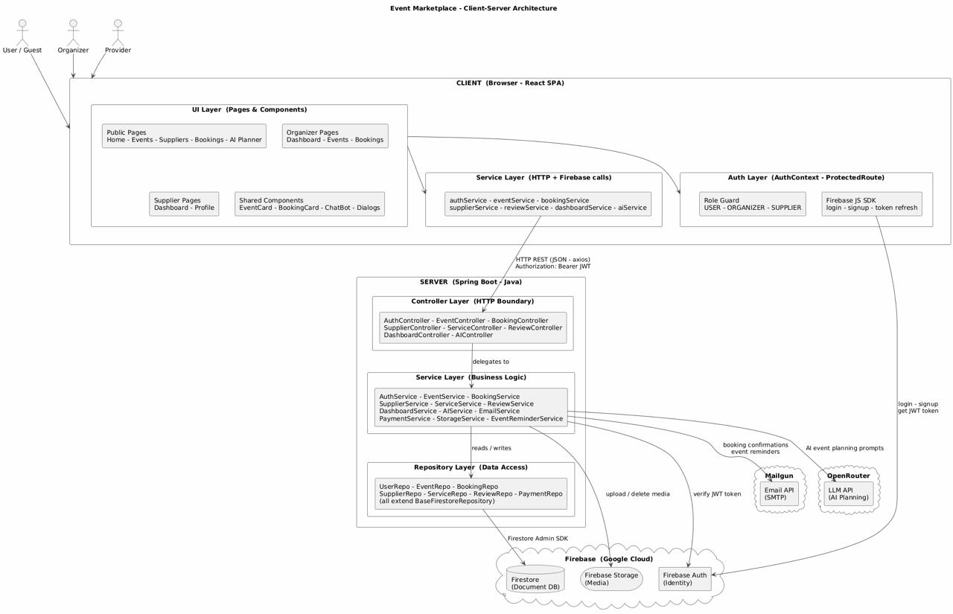

5-1-2- Architectural Design Pattern Used:
The system is based on a layered architecture. The system is divided into three main layers to ensure separation of responsibilities and scalability.

1. Presentation Layer:
Developed using React, this layer is responsible for:
- Presenting data to the user
- Receiving user input
- Sending HTTP requests to back-end services (APIs)

2. Application Layer:
This layer consists of a set of microservices built using Flask, including:
- User Service: Responsible for managing user data
- Event Service: Responsible for managing events
- Booking Service: Responsible for executing bookings, including user and event verification logic through calls to other services
This layer relies on REST APIs for communication between services.

3. Data Layer:
This layer is used to store system data, including:
- User data
- Event data
- Booking data

5-1-3- System Architecture Design:
The system is implemented using a microservices-based architecture, where each service operates independently and communicates with other services through RESTful APIs.
When a user performs an action through the frontend (such as booking an event), a request is sent to the Booking Service, which represents the core component responsible for handling the main business logic of the system.

The booking process follows a clear sequence:
- First, the Booking Service sends a request to the User Service to verify that the user exists
- Then, it sends another request to the Event Service to check that the event exists
- If both validations are successful, the booking is created and stored
- Finally, a response is returned to the frontend indicating whether the operation was successful or not.

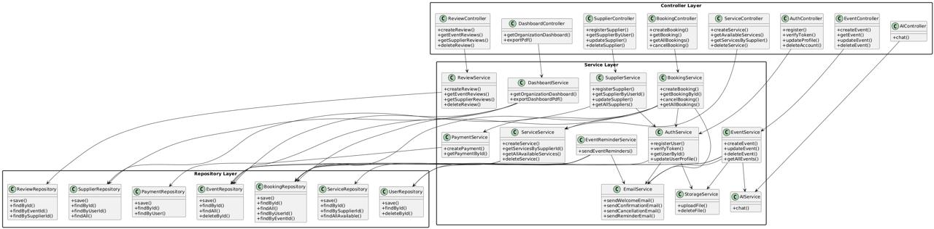
Figure 38:System Architecture Design

5-2- Database Design:
The system data model defines the core entities and their relationships that support the event management platform. The design ensures scalability, modularity, and clear separation of responsibilities.
Entities Description:
- User
Represents a system user who can assume one of the following roles:
- USER
- ORGANIZER
- SUPPLIER
Each user maintains notification preferences stored as a key-value structure to control email notifications.
- Event
Represents an event created by an organizer (identified via organizer email).
Event types include:
- Public Event: Fixed-time, physical attendance
- Host Package: Flexible booking-based event
Each event maintains the following aggregated attributes:
- Total Bookings
- Total Revenue
- Available Seats.

- Booking
Represents a reservation made by a user for a specific event.
A booking may include additional services. The total price is calculated as:
Total Price = Ticket Price + Sum of Selected Services Prices
Each booking generates a unique reference number in the format: BK-YEAR-XXXXX

- Payment
Represents the payment associated with a booking.
- Relationship: One-to-One with Booking.com
- The system supports multiple payment methods (currently simulated without actual integration)
- Supplier
Represents a service provider in the system.
- Relates to a User in a One-to-One relationship
- Classified under a service category
A supplier can provide multiple services

- Service
Represents a service offered by a supplier.
- Each Service is associated with a single Supplier
- Can be added to multiple bookings
- Review
Represents user feedback
The review can be associated with:
- Event
- Supplier
- Or both

Relationships Description:
Organizer (User) creates Events (One-to-Many)
User makes Bookings (One-to-Many)
Booking belongs to Event (Many-to-One)
Booking has Payment (One-to-One)
Supplier provides Services (One-to-Many)
Booking includes Services (Many-to-Many)
Review targets Event and/or Supplier.

5-2-1- ER Diagram:
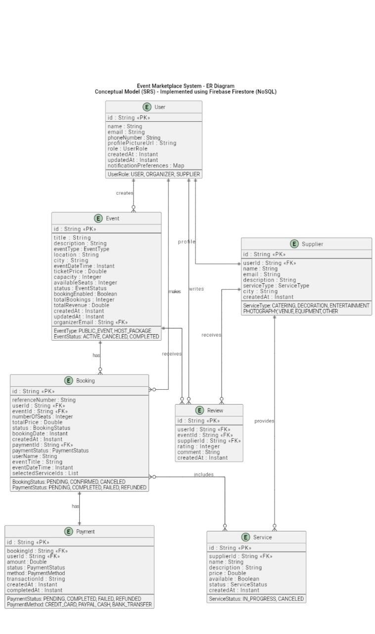
Figure 39:ER Diagram

This ER diagram represents a conceptual relational model used for system design. The actual implementation is based on a NoSQL document-oriented database (Firebase Firestore), where certain fields are denormalized to improve performance and scalability.

5-2-2- Collections& Documents:

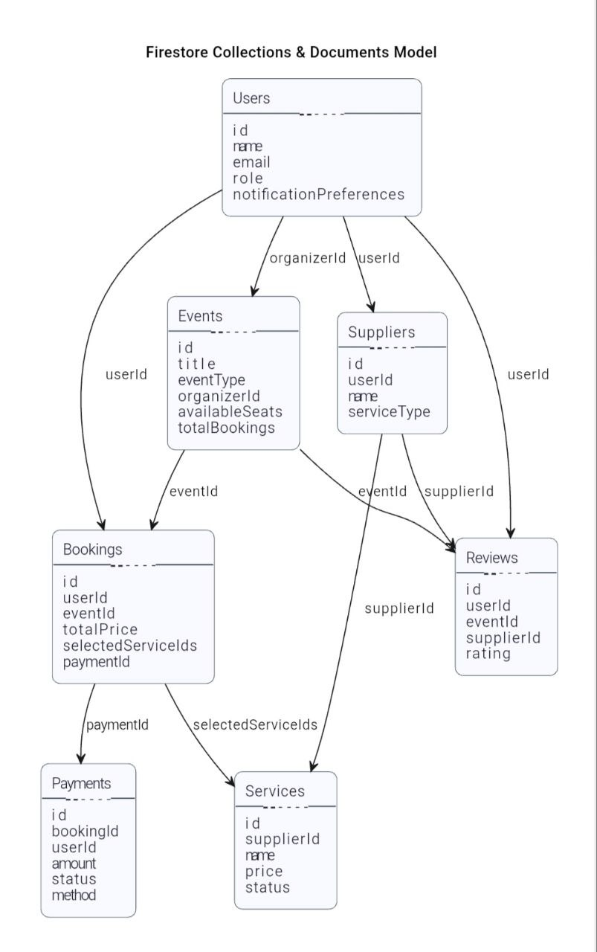
Figure 40:Collections& Documents

This section presents the logical structure of the system using Firebase Firestore collections and documents, where relationships are implemented using reference IDs instead of foreign keys.

5-2-3-Constraints and Keys:
The system enforces data integrity and consistency through relational database constraints applied across all core entities of the Event Management Platform. These constraints ensure correctness, avoid redundancy, and maintain referential integrity between tables.
The constraints are summarized in the table below:

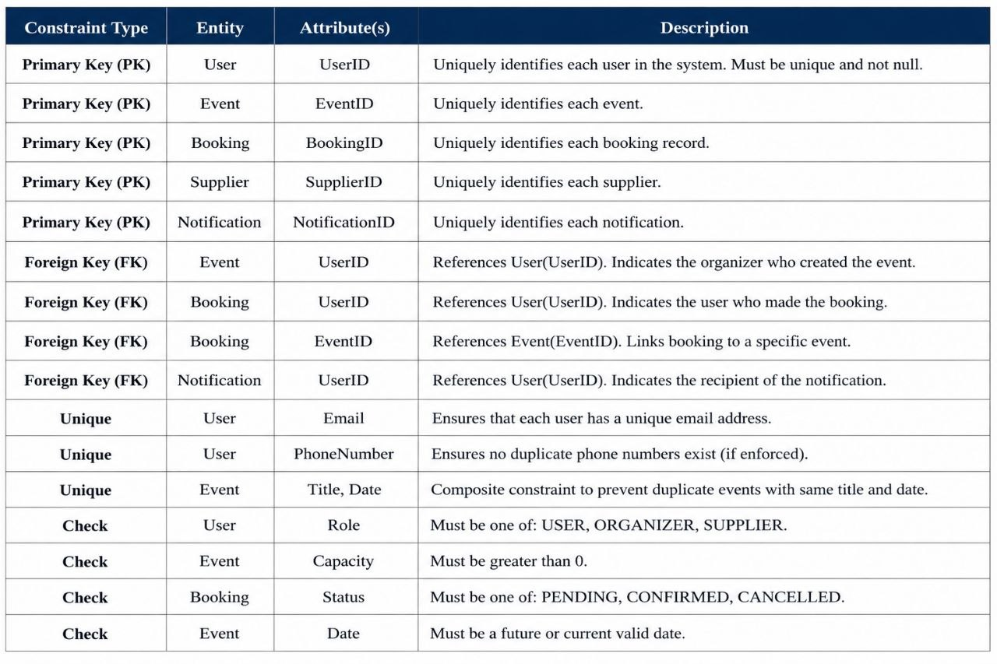

Table (71): Constraints and Keys

5-3- Designing external interfaces (APIs):
The system uses a RESTful API architecture to enable secure and efficient communication between the frontend and backend. These APIs define how different modules of the Event Marketplace interact with each other and external services. Each endpoint is clearly structured with its method, parameters, responses, and error codes to ensure consistency across all system operations. The following table summarizes the complete API .

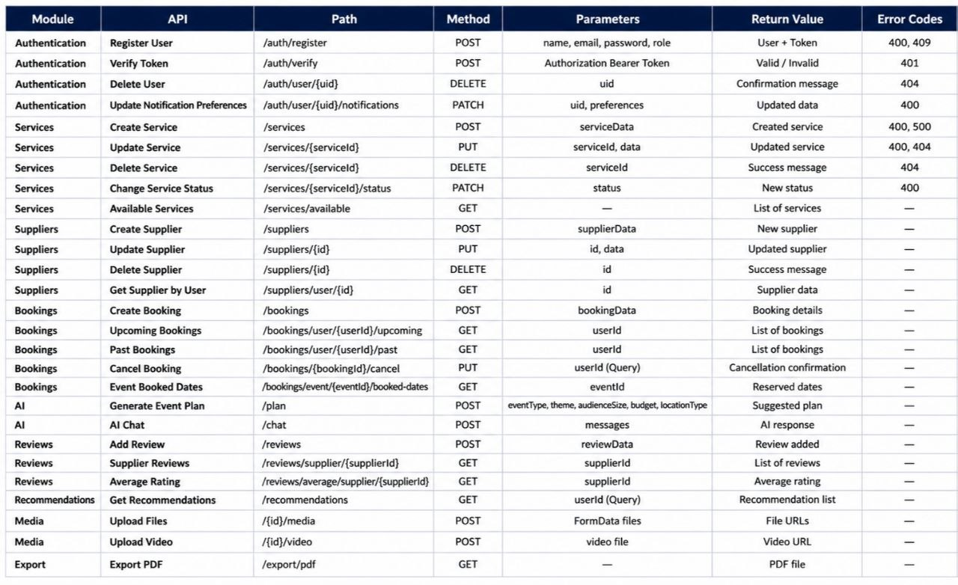
Table (72): APIs

5-4- Security & Access Control Design:
This section defines the system security mechanism and user permissions management within the Event Marketplace system. This includes how users are verified, how permissions are granted, and how user roles and access levels are defined. The design aims to ensure that each user can only access the functions and data authorized by their role within the system, thus achieving clear and effective data protection and system management.

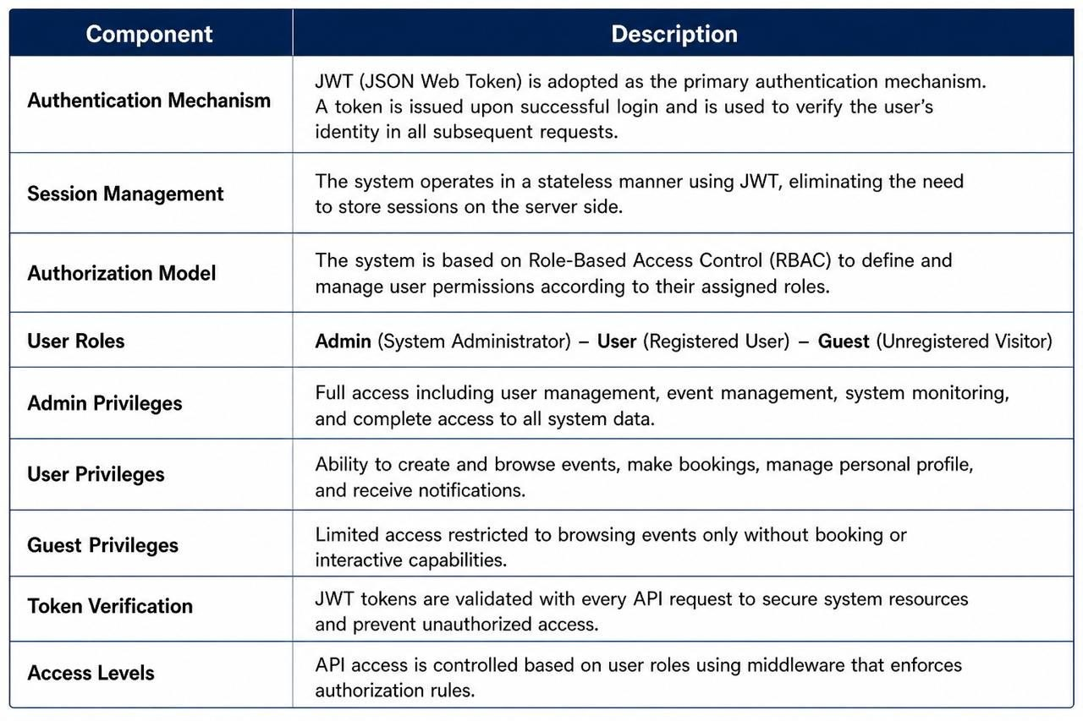
Table (73): Security & Access Control Design

Chapter 6 :

Implementation Environment & Tools

Introduction
This chapter presents the complete technical environment used to design and implement the Event Management System. It documents the programming languages, frameworks, database platform, development tools, third-party integrations, version control workflow, deployment process, and testing environment.
The purpose of this chapter is twofold. First, it provides sufficient technical details to allow another developer to reproduce the system environment and run the project successfully. Second, it explains the rationale behind the major technical choices adopted during development.

6-1 Programming Languages and Frameworks
The system follows a full-stack architecture consisting of two independent layers:
- Frontend layer: responsible for user interaction and presentation.
- Backend layer: responsible for business logic, security, data processing, and API services.
Communication between both layers is achieved through RESTful APIs, allowing each side to be developed, tested, and deployed independently.
- Backend: Java 21 and Spring Boot
Java 21 was selected as the backend programming language because it is a Long-Term Support (LTS) release that provides stability, security updates, and modern language features. Java also offers strong type checking, object-oriented design, and high maintainability for medium and large software projects.
Spring Boot was selected as the backend framework because it simplifies enterprise application development through:
- Auto-configuration
- Embedded web server support
- Dependency management through starters
- Rapid creation of REST APIs
- Strong security and testing ecosystem
The backend server can be started using the following command:
./mvnw spring-boot:run
The application runs by default on port 8080.

- Frontend: JavaScript and React
JavaScript was used for frontend development due to its native browser support and compatibility with modern web frameworks.
React was selected as the frontend framework because of its component-based architecture, efficient rendering model, and maintainability. The use of reusable components reduced duplicated code and accelerated interface development.
React also supports Single Page Application (SPA) behavior, which improves navigation speed by reducing unnecessary page reloads.
The frontend server can be started using:
npm start
The development environment runs on port 3000 and supports hot reloading.

6-2 Development Environment and Project Structure
- Development Tools
The project was developed by a three-member team using both Windows and macOS environments. The system operated consistently across all platforms due to the cross-platform support provided by Java, Node.js, and modern web technologies.
The following tools were used during development:
Purpose | Tool
Backend development and debugging | IntelliJ IDEA
Frontend development | Visual Studio Code
Backend build management | Maven Wrapper
Frontend package management | npm
Version control | Git
API testing | postman

Table (74): Development Tools

- Backend Project Structure
The backend follows a layered architecture with clear separation of responsibilities.
Responsibility | Path
Handles HTTP requests and responses | controllers/
Contains business logic | servides/
Data access layer | repositories/
Data Transfer Objects | dto/
Entity definitions | models
Configuration settings | resources/application.properties
Table (75): Backend Project Structure

-Frontend Project Structure
Responsibility | Path
Reusable UI components | components/
Main application pages | pages/
API communication layer | services/
Authentication logic | auth/
Shared layout templates | layouts/
Reusable UI components | components/
Table (76): frontend Project Structure

6-3 Libraries and Dependencies
All libraries are centrally managed to ensure consistent builds across all environments.
- Backend dependencies are defined in pom.xml using Maven.
- Frontend dependencies are defined in package.json using npm.

- Backend Dependencies
Role | Library
REST APIs and embedded server | Spring Boot Starter Web
Email integration | Spring Boot Starter Mail
Firestore and token verification | Firebase Admin SDK
PDF report generation | iText PDF
Reduces repetitive boilerplate code | Lombok
JSON serialization/deserialization | Jackson
Table (77): Backend Dependencies

-Frontend Dependencies
Role | Library
UI rendering | React / React DOM
Client-side routing | React Router DOM
HTTP requests | Axios
UI components | PrimeReact
Data visualization | Chart.js
Client-side Firebase integration | Firebase SDK
Table (78): frontend Dependencies

6-4 Database System
The system uses Firebase Firestore as the primary database platform. Firestore is a cloud-hosted NoSQL document database that offers scalability, flexibility, and managed infrastructure.
Firestore was selected because the project required rapid development, evolving data structures, and simplified deployment.
Main Advantages of Firestore
- Schema flexibility
- Automatic scaling
- Cloud hosting without server administration
- Real-time update support
- Native integration with Firebase Authentication and Storage

-Main Collections
The database is organized into the following collections:
- events
- bookings
- users
- suppliers
- services
- reviews
- payments
Each document contains a unique generated identifier.

-Firestore vs Relational Databases
Firestore | Relational DB | Criterion
Flexible schema | Fixed schema | Schema
Automatic | Manual planning | Scaling
Fully managed | Requires server management | Infrastructure
Built-in | Additional implementation required | Real-time updates
Native | External | Firebase integration
Table (79): Firestore vs Relational Databases

6-5 External Service Integrations
To reduce development complexity and focus on business requirements, the system integrates with trusted external services.
-Firebase Services
Three Firebase services are used:
- Firebase Authentication for user login and token management
- Firestore as the main database
- Firebase Storage for images and uploaded media files
-Mailgun SMTP
Mailgun is used for transactional email delivery, including:
- Booking confirmations
- Notifications
- Event updates
- Cancellation messages
Emails are sent asynchronously to avoid delaying API responses.

-OpenRouter API
OpenRouter was integrated to provide AI-powered features such as:
- User support chatbot
- Event recommendations
- Planning assistance for organizers
API credentials are stored on the backend for security purposes.

-Version Control
Git was used throughout the project for source code management.
A feature-branch workflow was followed:
- Create a branch for each feature or fix
- Implement changes independently
- Merge approved changes into the main branch
Meaningful commit messages were used to improve project traceability.
Ignored Files
The following files and folders were excluded using .gitignore:
- target/
- build/
- node_modules/
- .idea/
- .vscode/
- .DS_Store

6-7 Build Process and Deployment
- Backend Build
The backend is packaged using:
./mvnw clean package
This command generates an executable JAR file containing all required dependencies.
- Frontend Build
The frontend production build is generated using:
npm run build
This creates optimized static files ready for deployment.
- Deployment Options
The system can be deployed using common hosting platforms such as:
- Firebase Hosting
- Netlify
- Vercel
- AWS
- Google Cloud
- Azure
- Recommended Production Improvements
For future production deployment, the following enhancements are recommended:
- CI/CD pipeline using GitHub Actions or Jenkins
- Environment variables for secrets
- Separate staging and production environments
- Monitoring and centralized logging

6-8 Testing Environment
Testing was performed manually throughout development to validate complete user workflows and system integration.
Testing Levels
Functional Testing
Verification that each feature behaves according to requirements.
Integration Testing
Validation of complete data flow:
Frontend → Backend API → Firestore → Response
User Interface Testing
Checking:
- Layout consistency
- Responsiveness
- Component behavior
API Testing
Postman was used to test endpoints individually, including:
- Request payloads
- Response structures
- Authentication rules
- Authorization behavior

Future Automated Testing
The project environment also supports automated testing:
Layer | Tools
Backend | JUnit, Mockito, Spring Test
Frontend | Jest, React Testing Library
Table (80): Layer and Tools

Expanding automated test coverage is recommended in future work.

6-9 Security Considerations
Security was implemented at multiple levels.
-Authentication Security
Firebase Authentication issues secure JWT tokens after login. The backend validates every token before processing protected requests.
-Access Control
Firestore security rules restrict read/write operations according to user permissions.
-Input Validation
Both frontend and backend validate incoming data to prevent malformed requests.
-Configuration Security
Sensitive values such as API keys and credentials should be stored in environment variables in production environments.

6-10 Performance Considerations
Several performance optimizations were considered:
- Asynchronous email sending
- Efficient backend resource management
- Frontend production bundling and minification
- Lazy loading where appropriate
- CDN delivery for static assets
These measures improve responsiveness and scalability.

6-11 Lessons Learned and Future Enhancements
-Lessons Learned
The development process highlighted several practical insights:
- Clear separation between frontend and backend improves maintainability
- Component-based frontend design accelerates development
- Managed cloud services reduce infrastructure overhead
- Strong frameworks significantly improve productivity
-Future Enhancements
- Full CI/CD automation
- Swagger / OpenAPI documentation
- Redis caching layer
- Payment gateway integration
- Real-time notifications
- Mobile application using React Native
- Expanded automated testing coverage

Chapter Summary
This chapter presented the implementation environment and technologies used in the Event Management System. The system combines Java and Spring Boot for backend development, React for the frontend, and Firebase services for authentication, storage, and database management. Additional integrations such as Mailgun and OpenRouter were used to support communication and AI features. Overall, the selected technologies provide a scalable and maintainable system architecture.

Chapter 7:

Software Implementation

Introduction:
Objective: This chapter presents the software implementation of the EventMarketPlace system. It focuses on the overall project structure, explains the implementation of each main module, and provides representative code examples. Full code listings are included in the appendix.

7-1 Project File Structure
The project is organized following a layered architecture to ensure scalability, maintainability, and separation of concerns:
EventMarketPlace/
├── backend/
│ ├── src/main/java/com/eventmarketplace/
│ │ ├── controller/ # Presentation Layer: REST Controllers
│ │ ├── service/ # Business Logic Layer: Services
│ │ ├── repository/ # Data Access Layer: Repositories
│ │ ├── model/ # Domain Models (Entities)
│ │ ├── dto/ # Data Transfer Objects
│ │ └── config/ # Configuration Classes
├── frontend/
│ ├── src/
│ │ ├── components/ # Reusable React Components
│ │ ├── pages/ # Main Pages
│ │ ├── services/ # API Service Modules
│ │ ├── context/ # State and Auth Management
│ │ └── App.js # Entry Point
├── docs/ # Documentation
└── tests/ # Unit and Integration Tests
Notes:
- Each layer has a clear responsibility.
- This structure improves maintainability and simplifies testing.

7-2 Modules Implementation
The system is divided into seven main modules, each responsible for a specific area of functionality:
Module | Main Functionality
Events Module | Manage events (CRUD, updates, notifications)
Users Module | User accounts, roles, authentication
Bookings Module | User bookings, event capacity management
Dashboard Module | Statistics, analytics, and charts
AI Assistant Module | Smart recommendations and conversational AI
Notifications Module | Email notifications and alerts
Reports Module | PDF generation and data analysis
Table (81): Modules Implementation

Example: Event Service (simplified)
@Service
public class EventService {
private final EventRepository eventRepository;
public Event createEvent(Event event) {
event.setStatus(Event.EventStatus.ACTIVE);
event.setCreatedAt(Instant.now());
return eventRepository.save(event);
}
}
This snippet shows how the service layer handles business logic and interacts with the data layer.

7-3 API Implementation
The backend exposes RESTful APIs using Spring Boot to communicate with the frontend.
Example: Event Controller
@RestController
@RequestMapping("/api/events")
public class EventController {
private final EventService eventService;
@PostMapping
public ResponseEntity<?> createEvent(@RequestBody Event event) {
try {
Event created = eventService.createEvent(event);
return ResponseEntity.ok(created);
} catch (Exception e) {
return ResponseEntity.badRequest().body(e.getMessage());
}
}
}
Notes:
- Each module has its own controller.
- Error handling ensures that the API returns meaningful responses.
- CORS configuration allows requests from any frontend origin.

7-4 Data Access Layer Implementation
The repository pattern abstracts the database access. Firebase Firestore is used as the database.
Example: Event Repository
@Repository
public class EventRepository extends BaseFirestoreRepository<Event> {
public List<Event> findAll() {
return firestore.collection("events")
.get().get().getDocuments().stream()
.map(doc -> doc.toObject(Event.class))
.collect(Collectors.toList());
}
}
Notes:
- The repository handles all CRUD operations.
- Changing the database would not require modifications in the business layer.

7-5 Business Logic Layer Implementation
The business layer enforces rules, calculations, and conditions. For instance, checking event capacity before booking:
public Booking createBooking(Booking booking) {
return firestore.runTransaction(transaction -> {
Event event = transaction.get(eventRef(booking.getEventId())).toObject(Event.class);
if (event.getCapacity() <= event.getBookings().size()) {
throw new IllegalStateException("Event is fully booked");
}
return transaction.set(bookingRef(booking.getId()), booking).get();
});
}
Notes:
- Transactions prevent race conditions in concurrent bookings.
- Services can integrate with notifications or other services for side effects.

7-6 UI Implementation

The frontend is built with React and PrimeReact, following a component-based architecture.
Example: Events List Component
export const EventsList = () => {
const [events, setEvents] = useState([]);
useEffect(() => {
eventService.getAllEvents().then(setEvents);
}, []);
return <EventGrid events={events} />;
};
Notes:
- State is managed using React Hooks.
- Components like EventGrid and Spinner are reusable.
- Protected routes and role-based access are implemented via context API.

User interfaces:

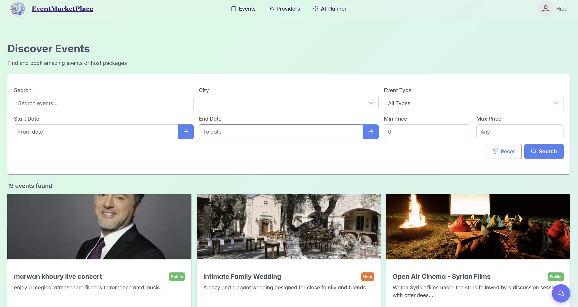
Figure 41:Discover Events1

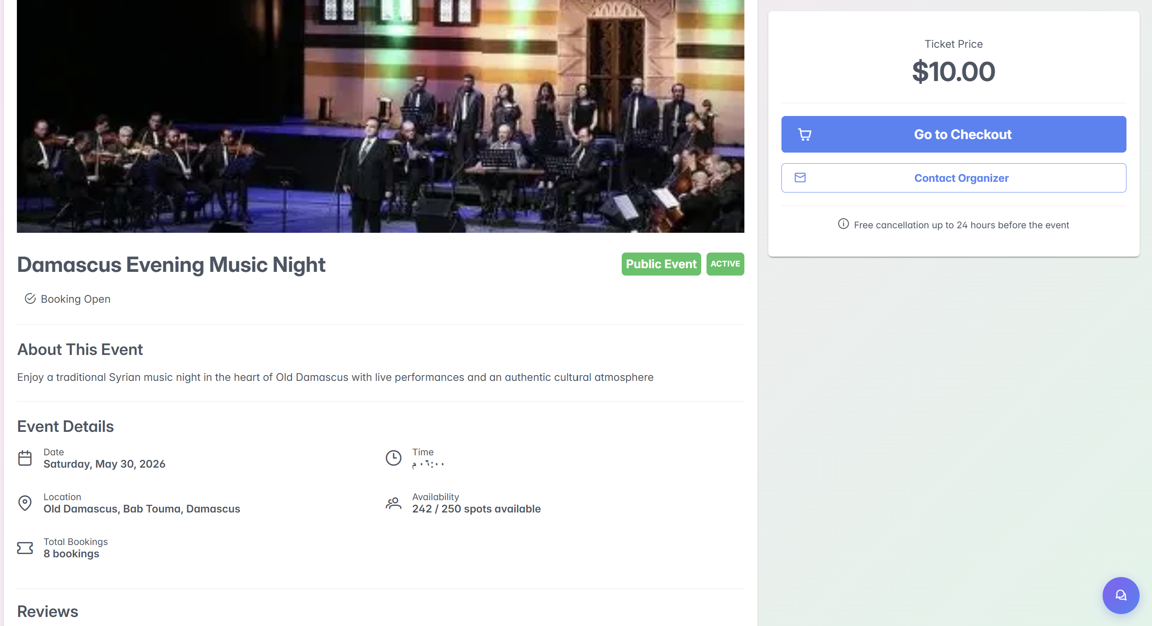
Figure 42:Discover Events2

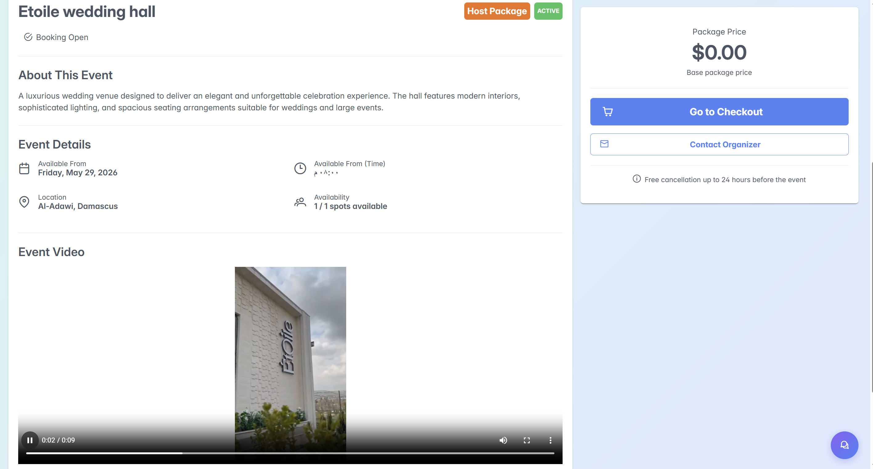
Figure 43:Discover Events3

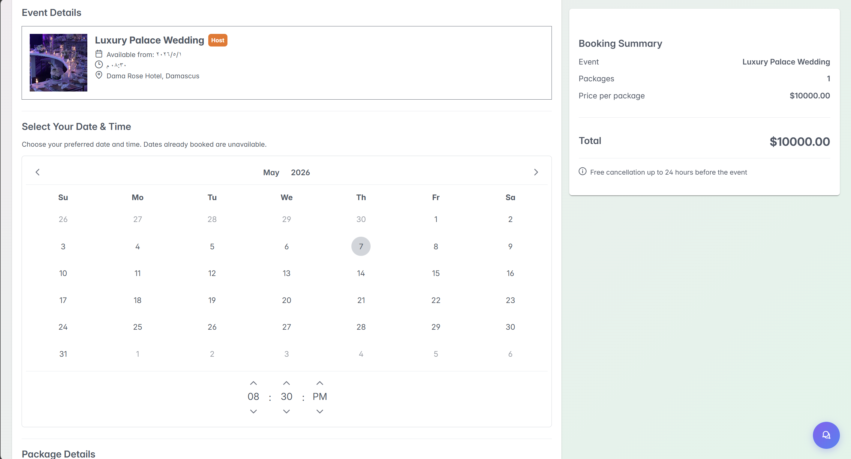
Figure 44:Discover Events4

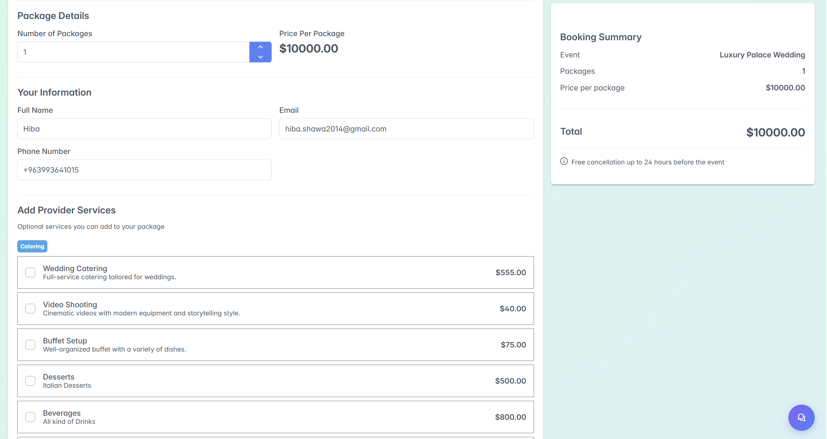
Figure 45:Discover Events5

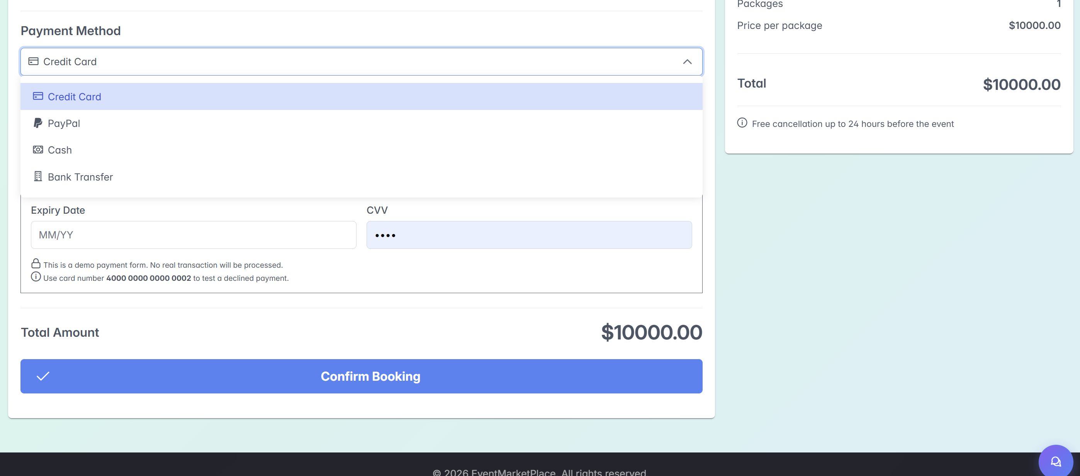
Figure 46:Discover Events6

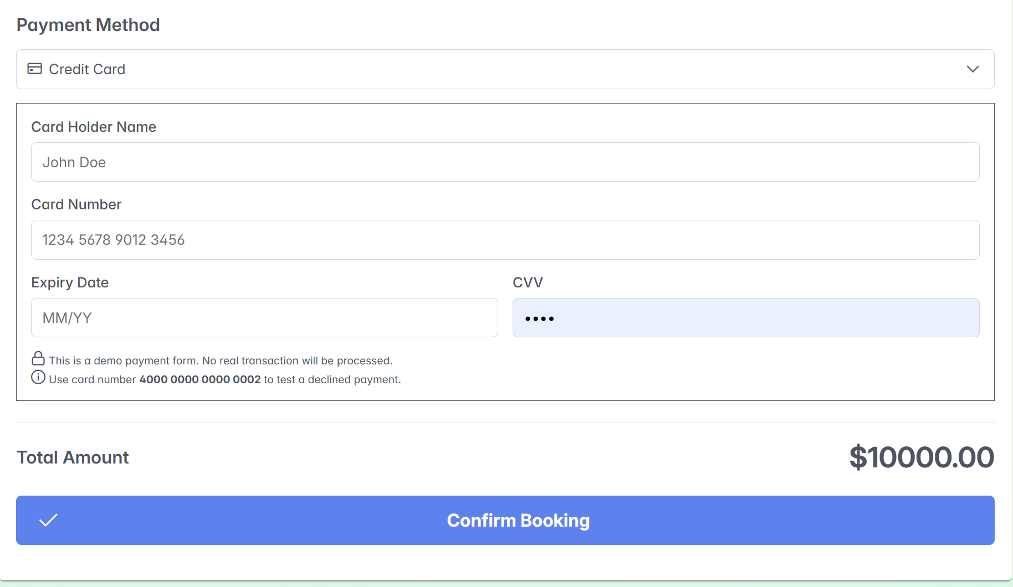
Figure 47:Discover Events7

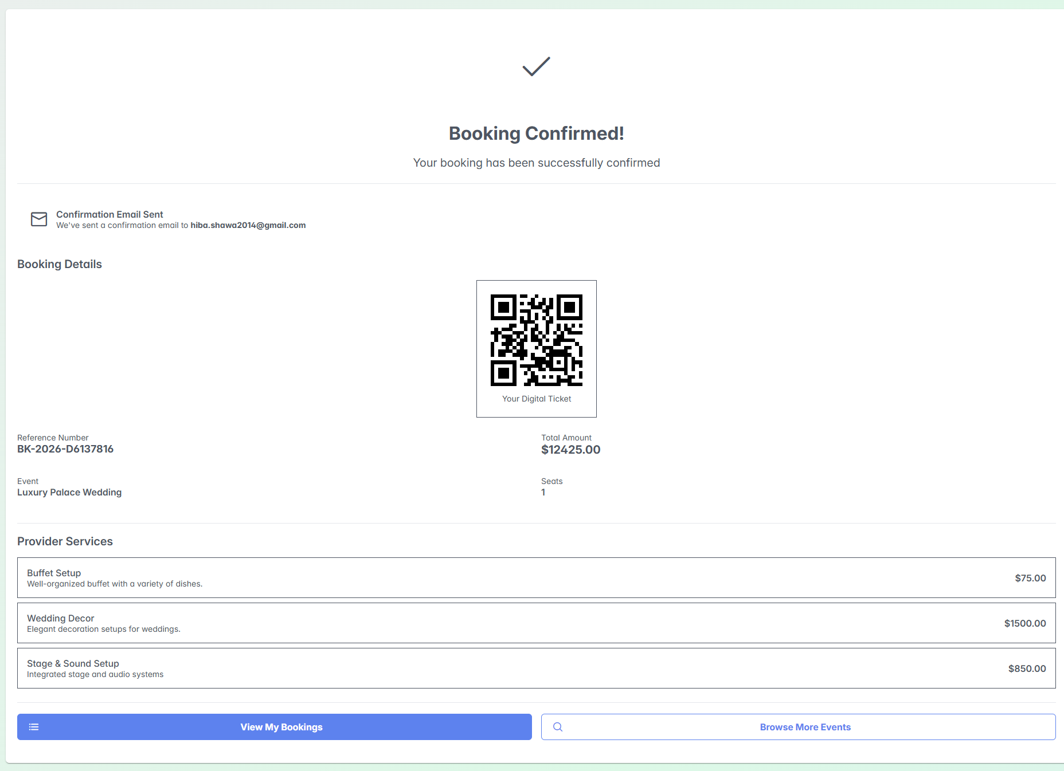
Figure 48:Discover Events8

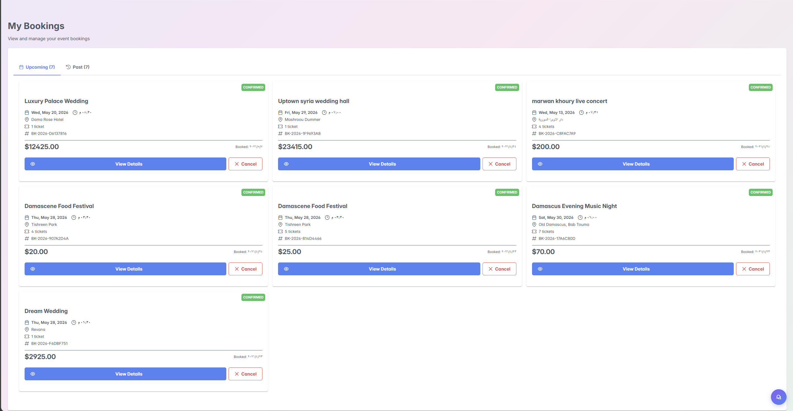
Figure 49:My Bookings
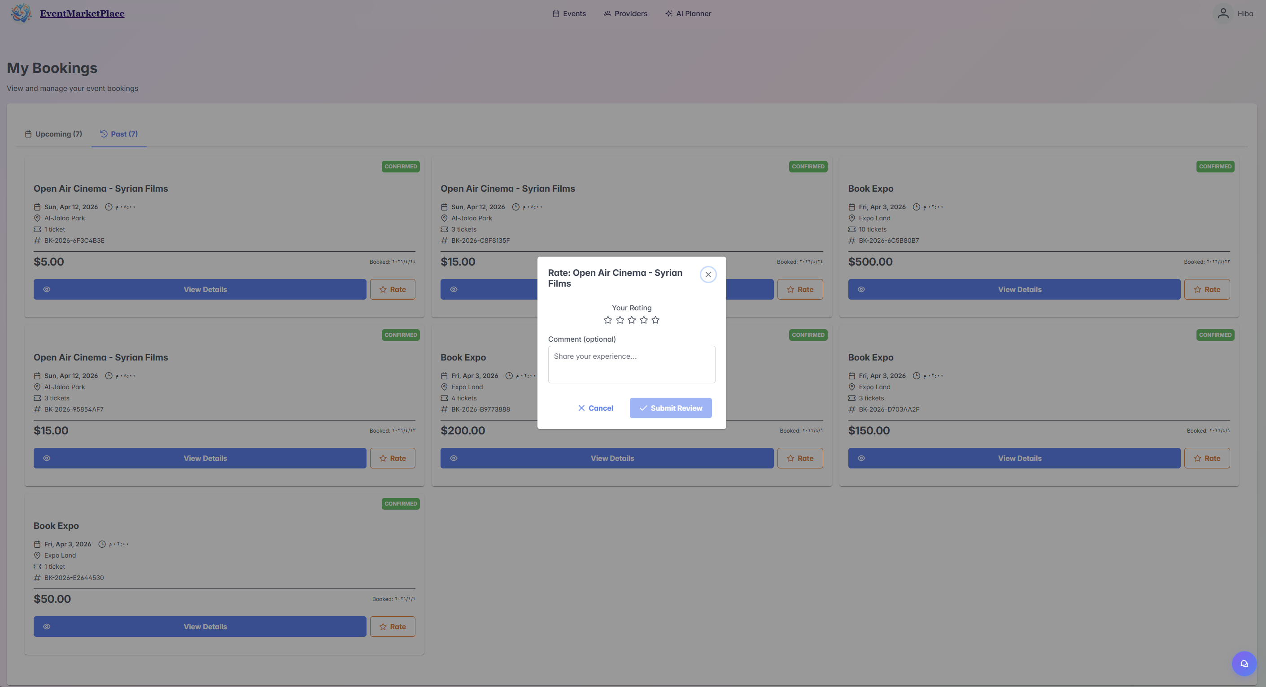
Figure 50:My Booking 2 Interface

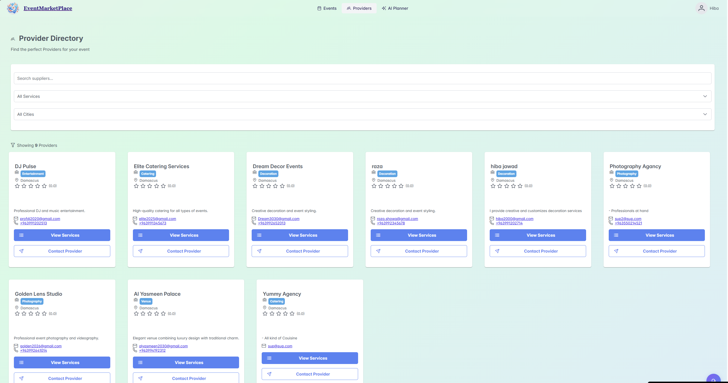
Figure 51:Provider Directory Interface

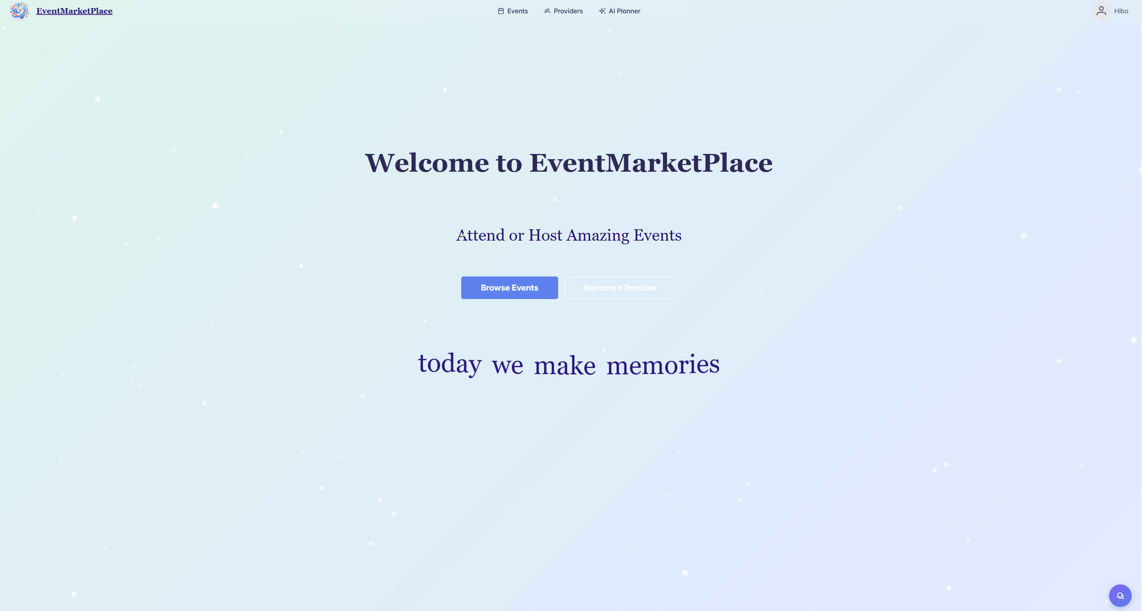
Figure 52:Welcome To EventMarketPLace Interface

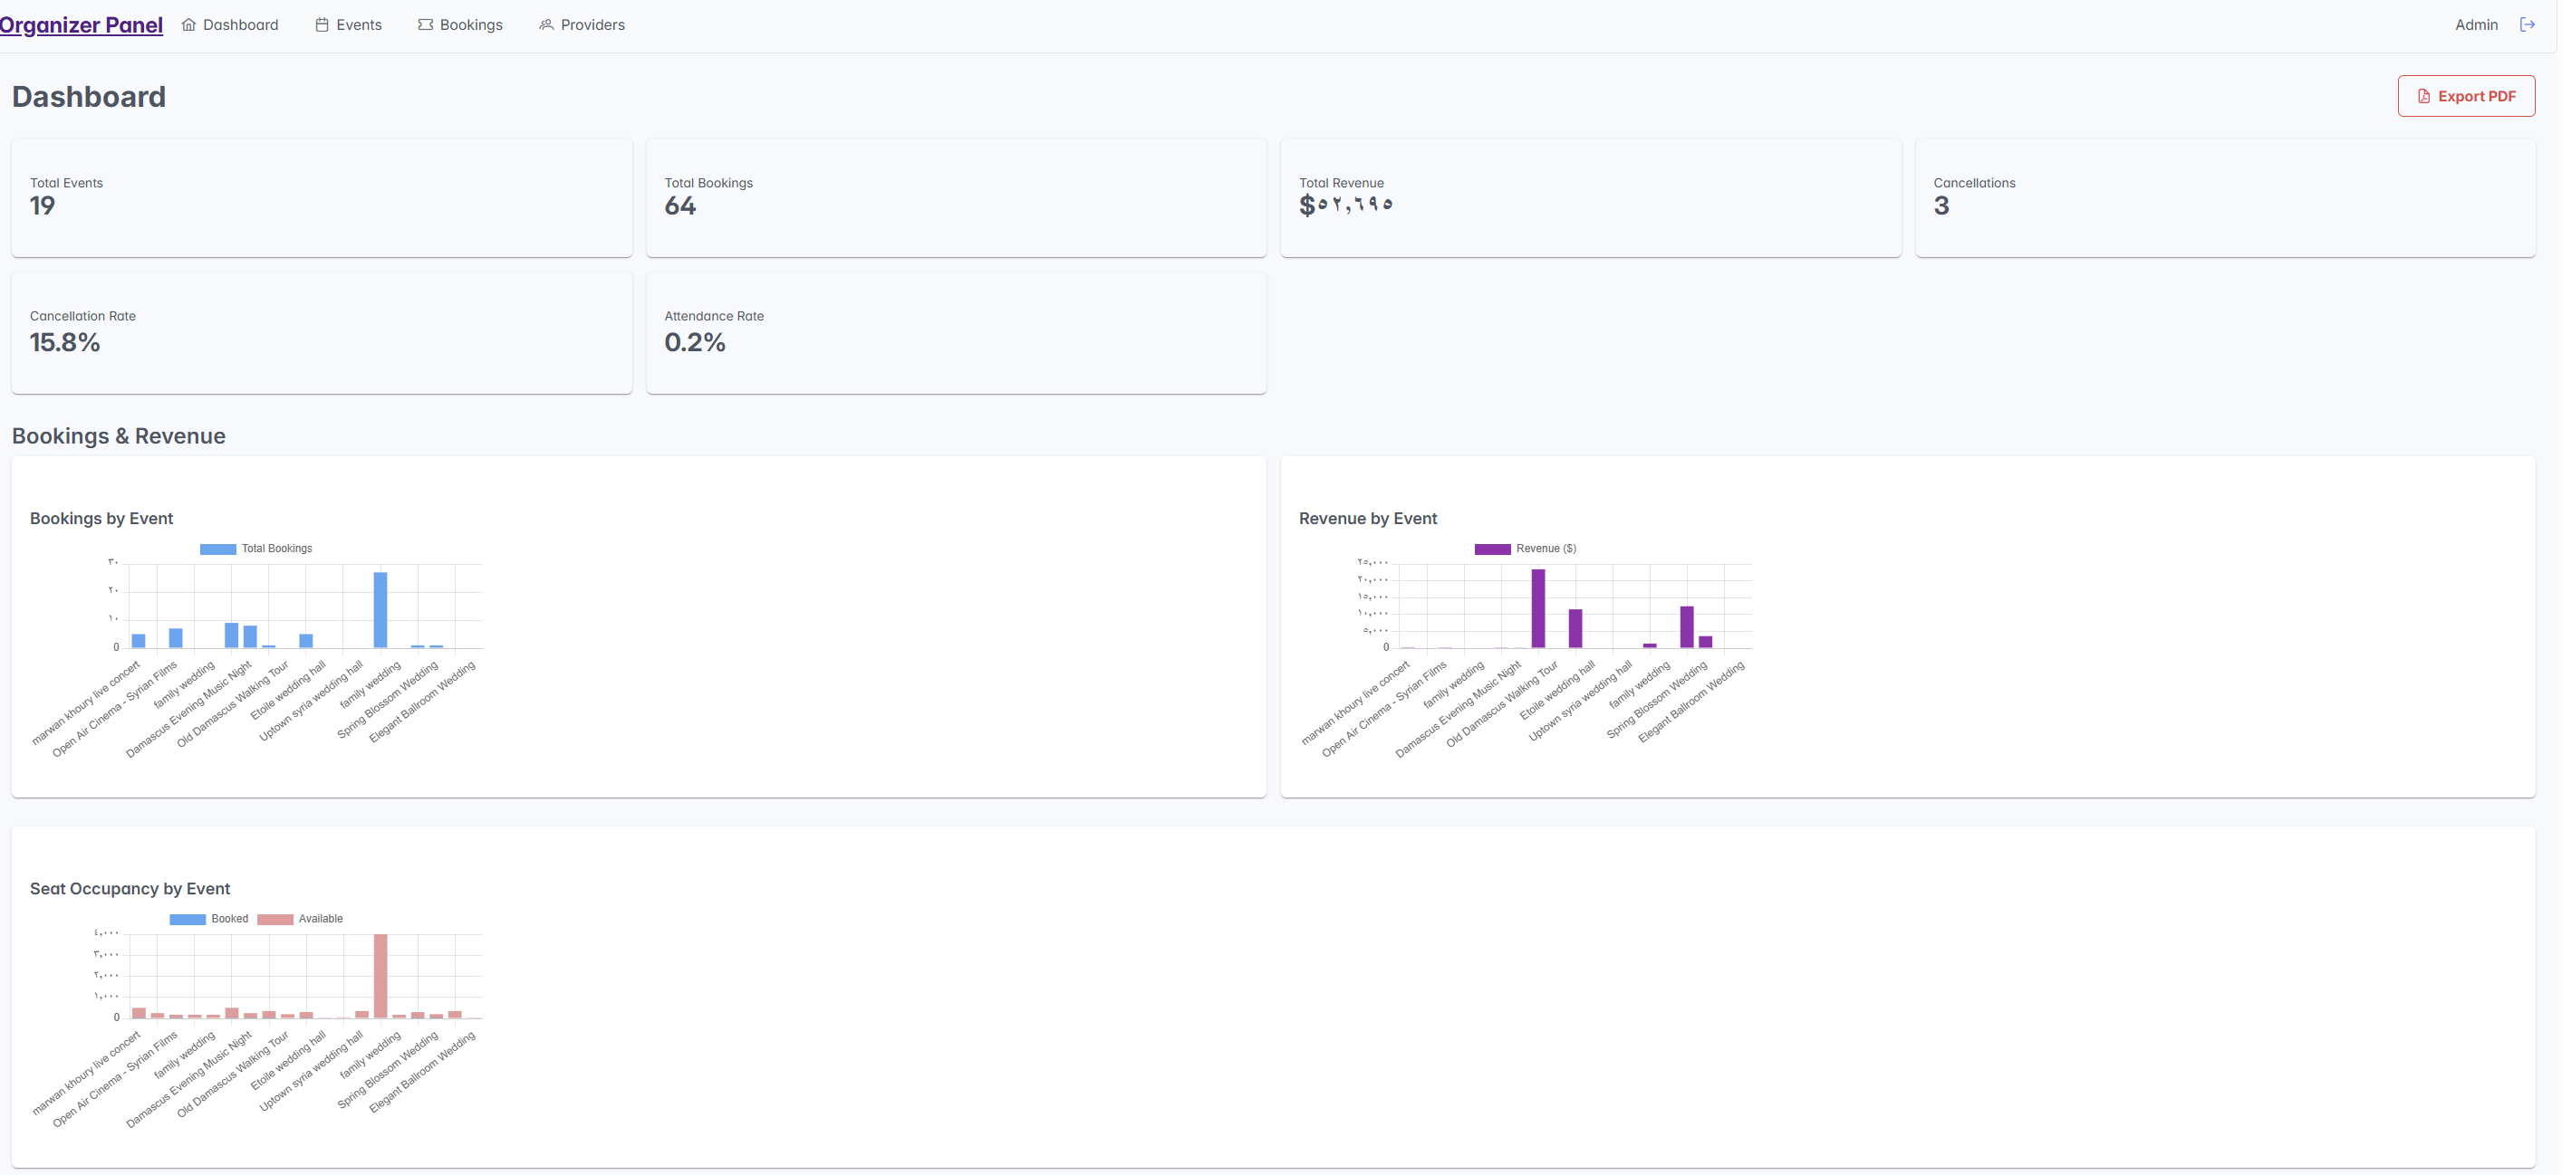
Figure 53:Dashboard Organizer Panel Interface

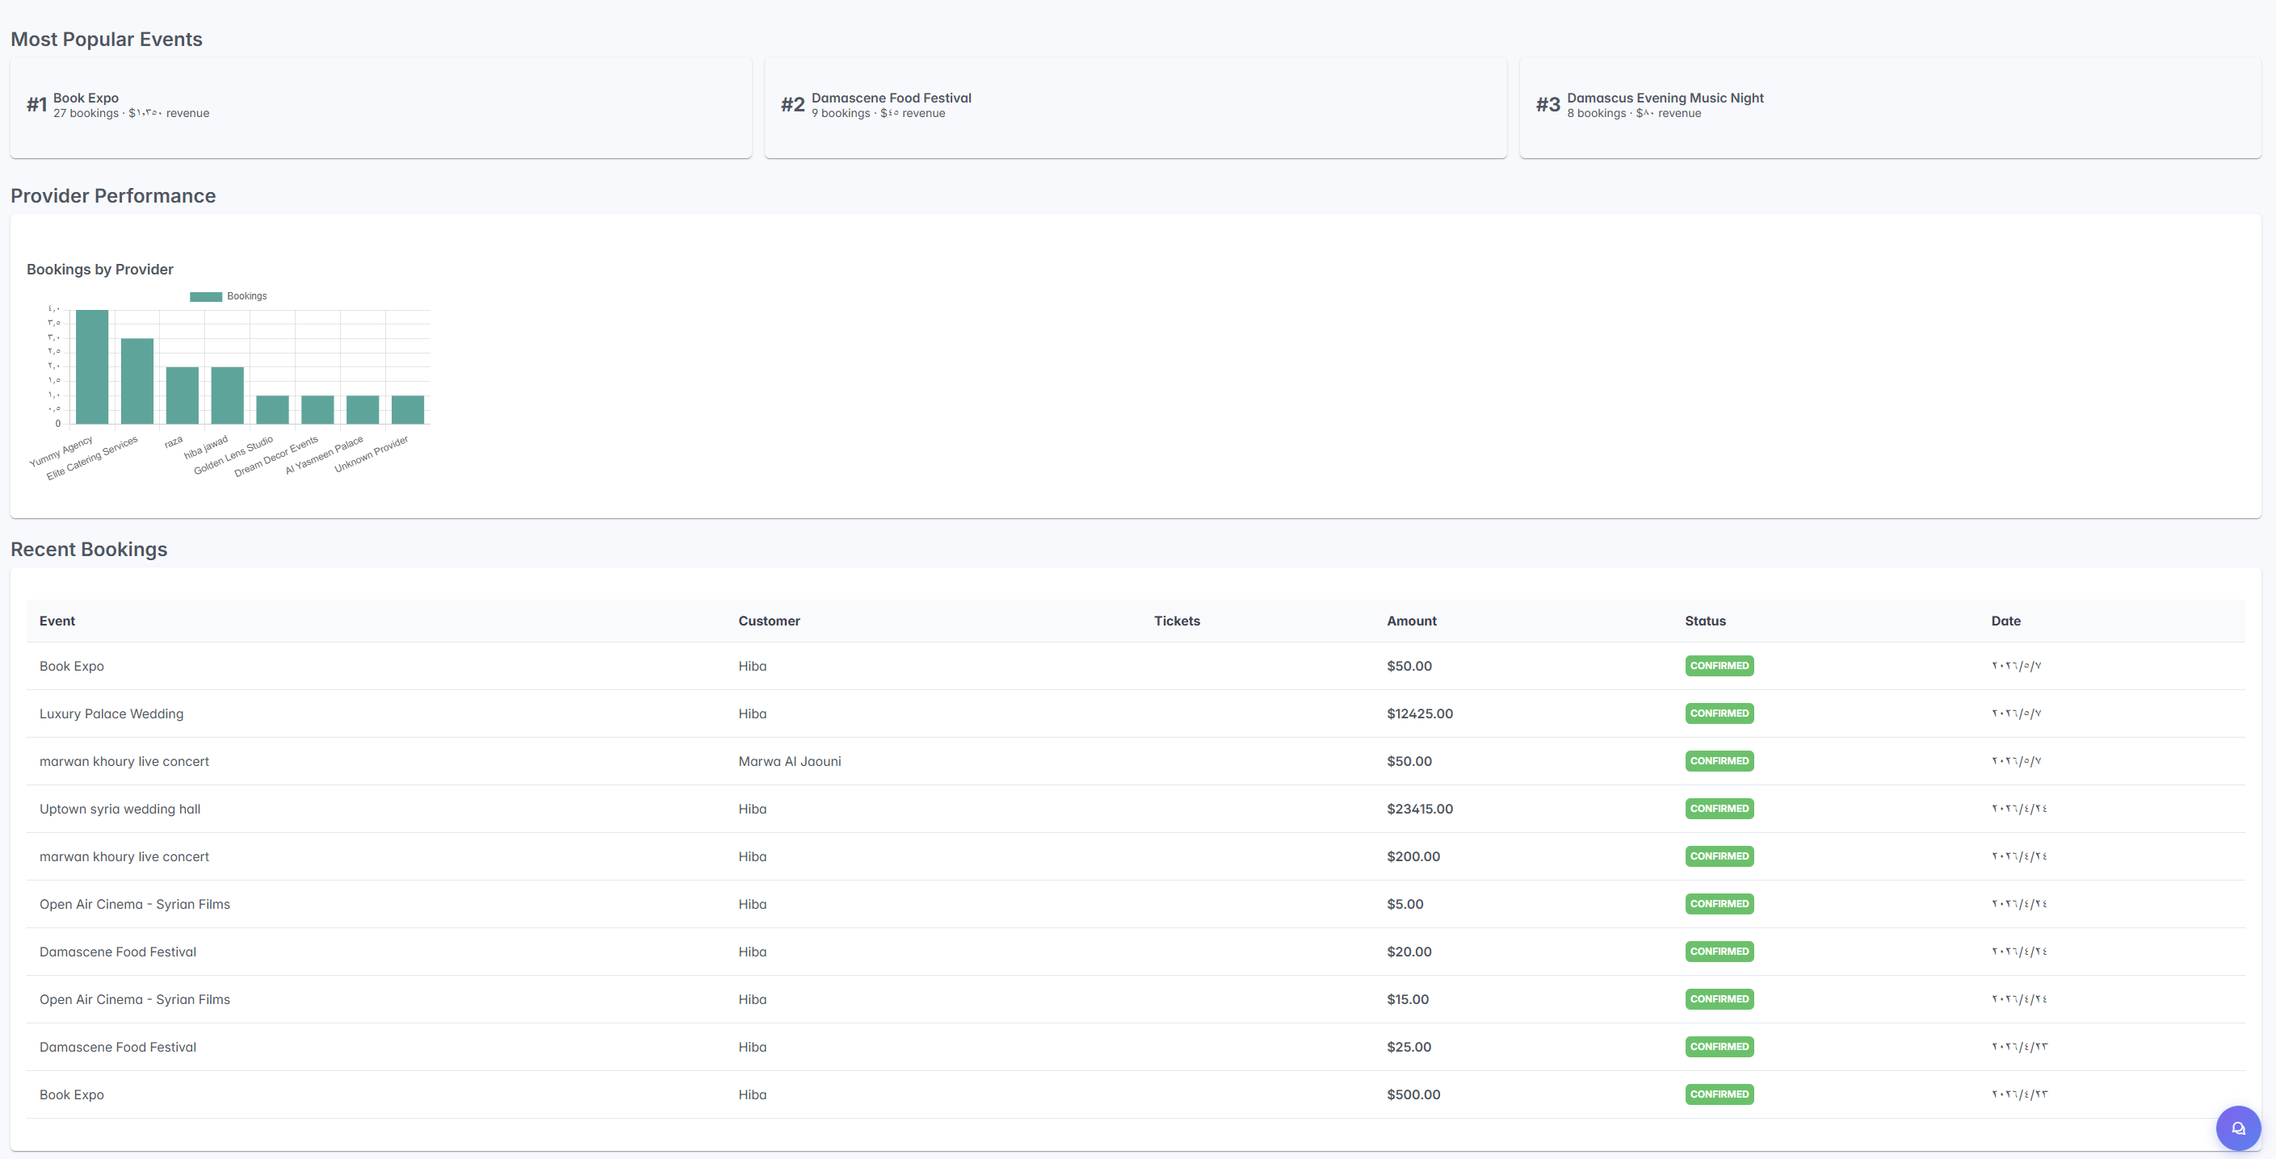
Figure 54: Recent Bookings Interface

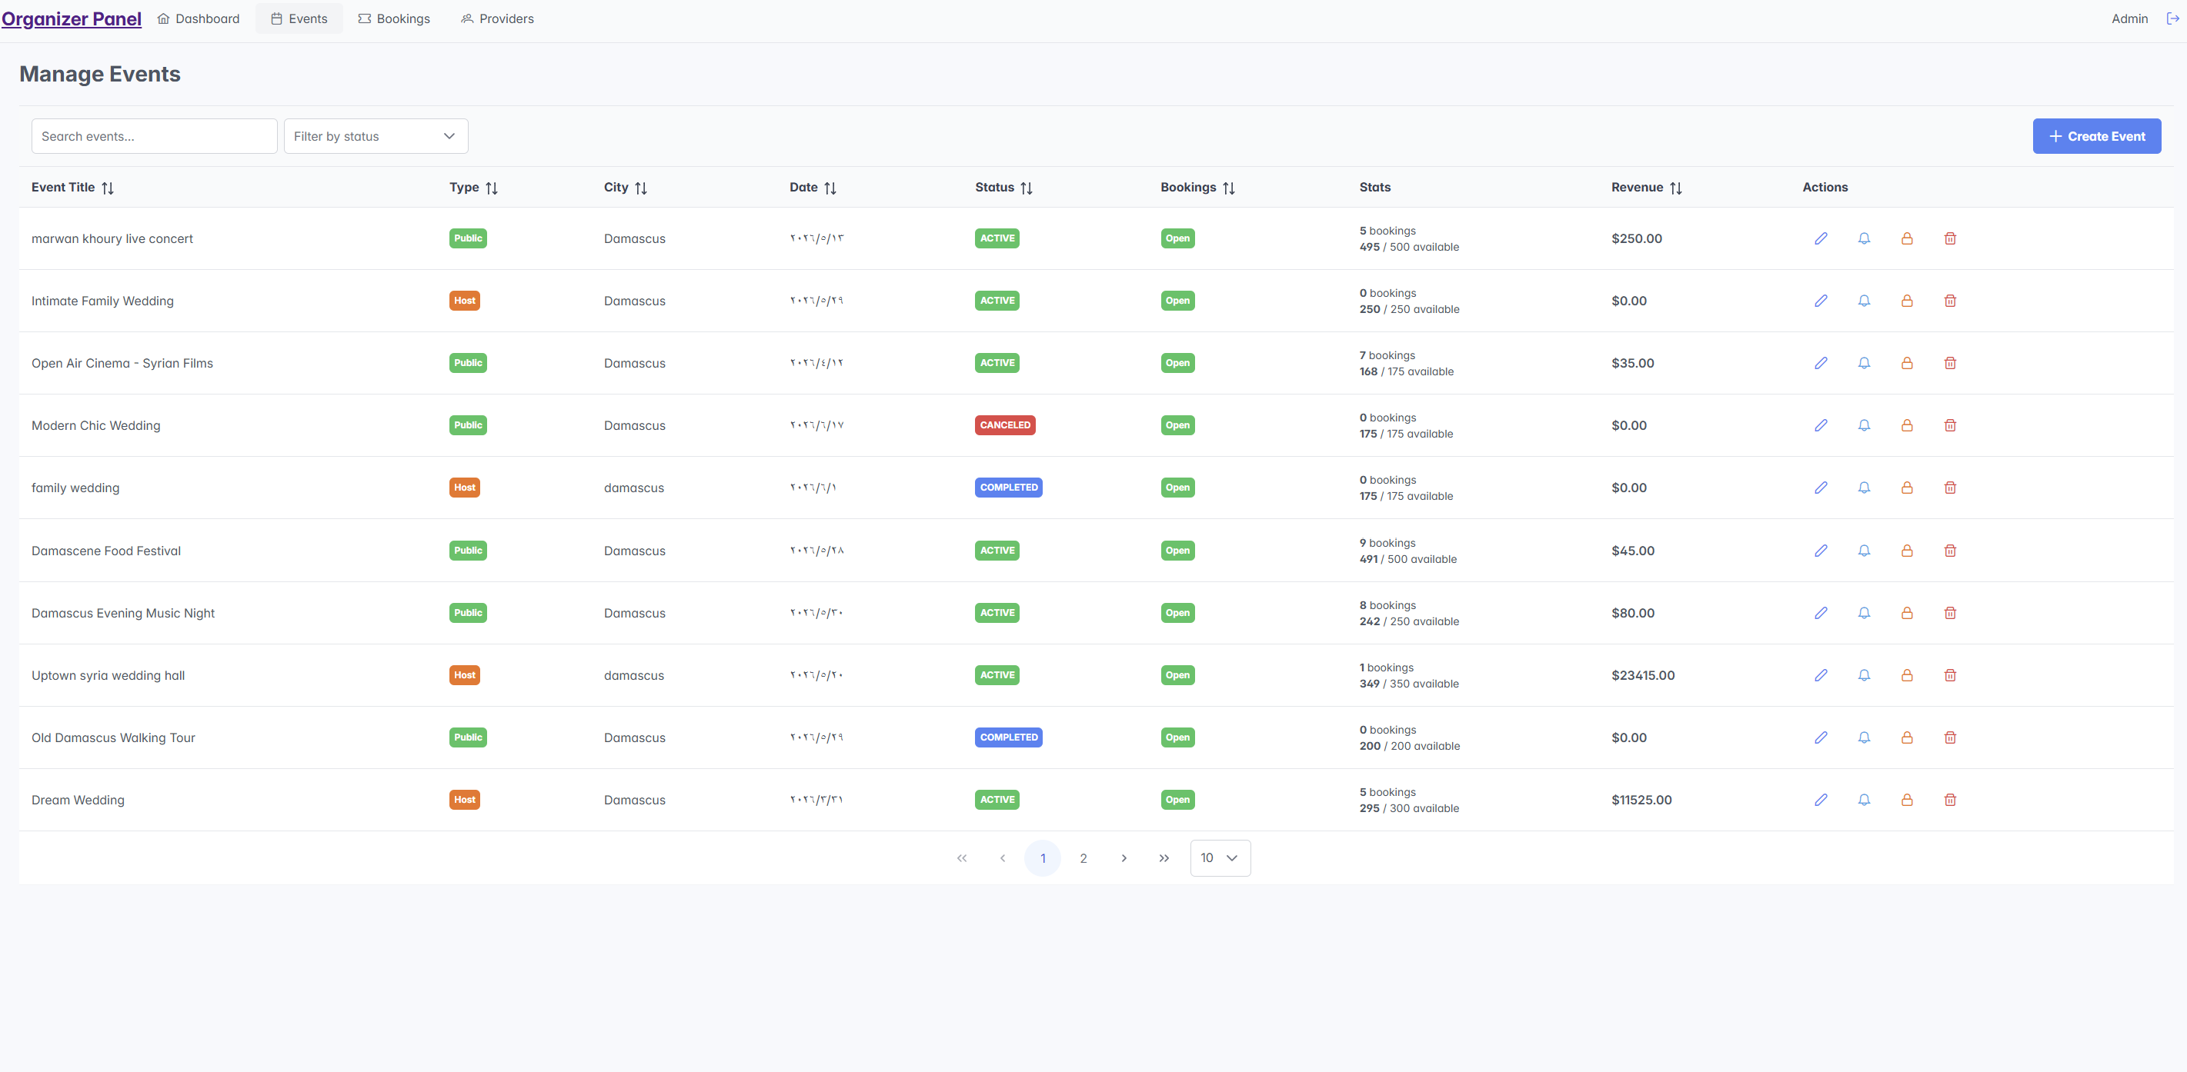
Figure 55: Manage Events Organizer Panel Interface

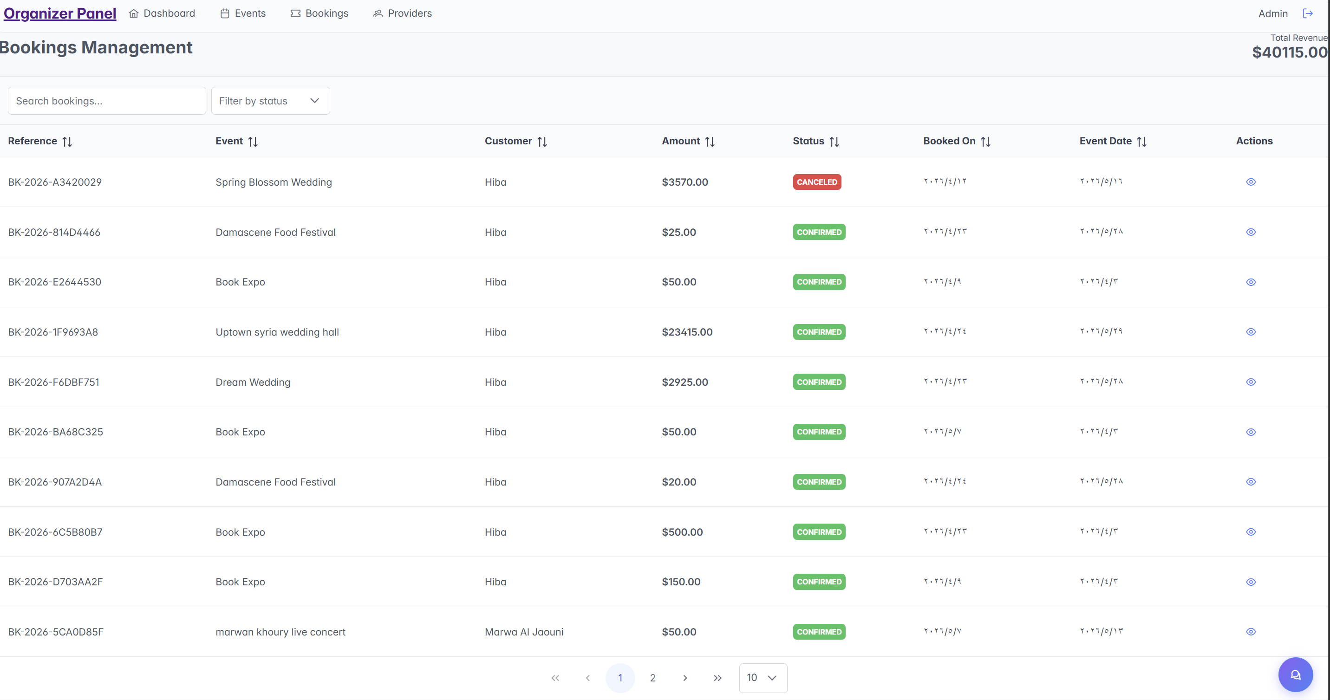
Figure 56:Bookings Management Organizer Panel Interface

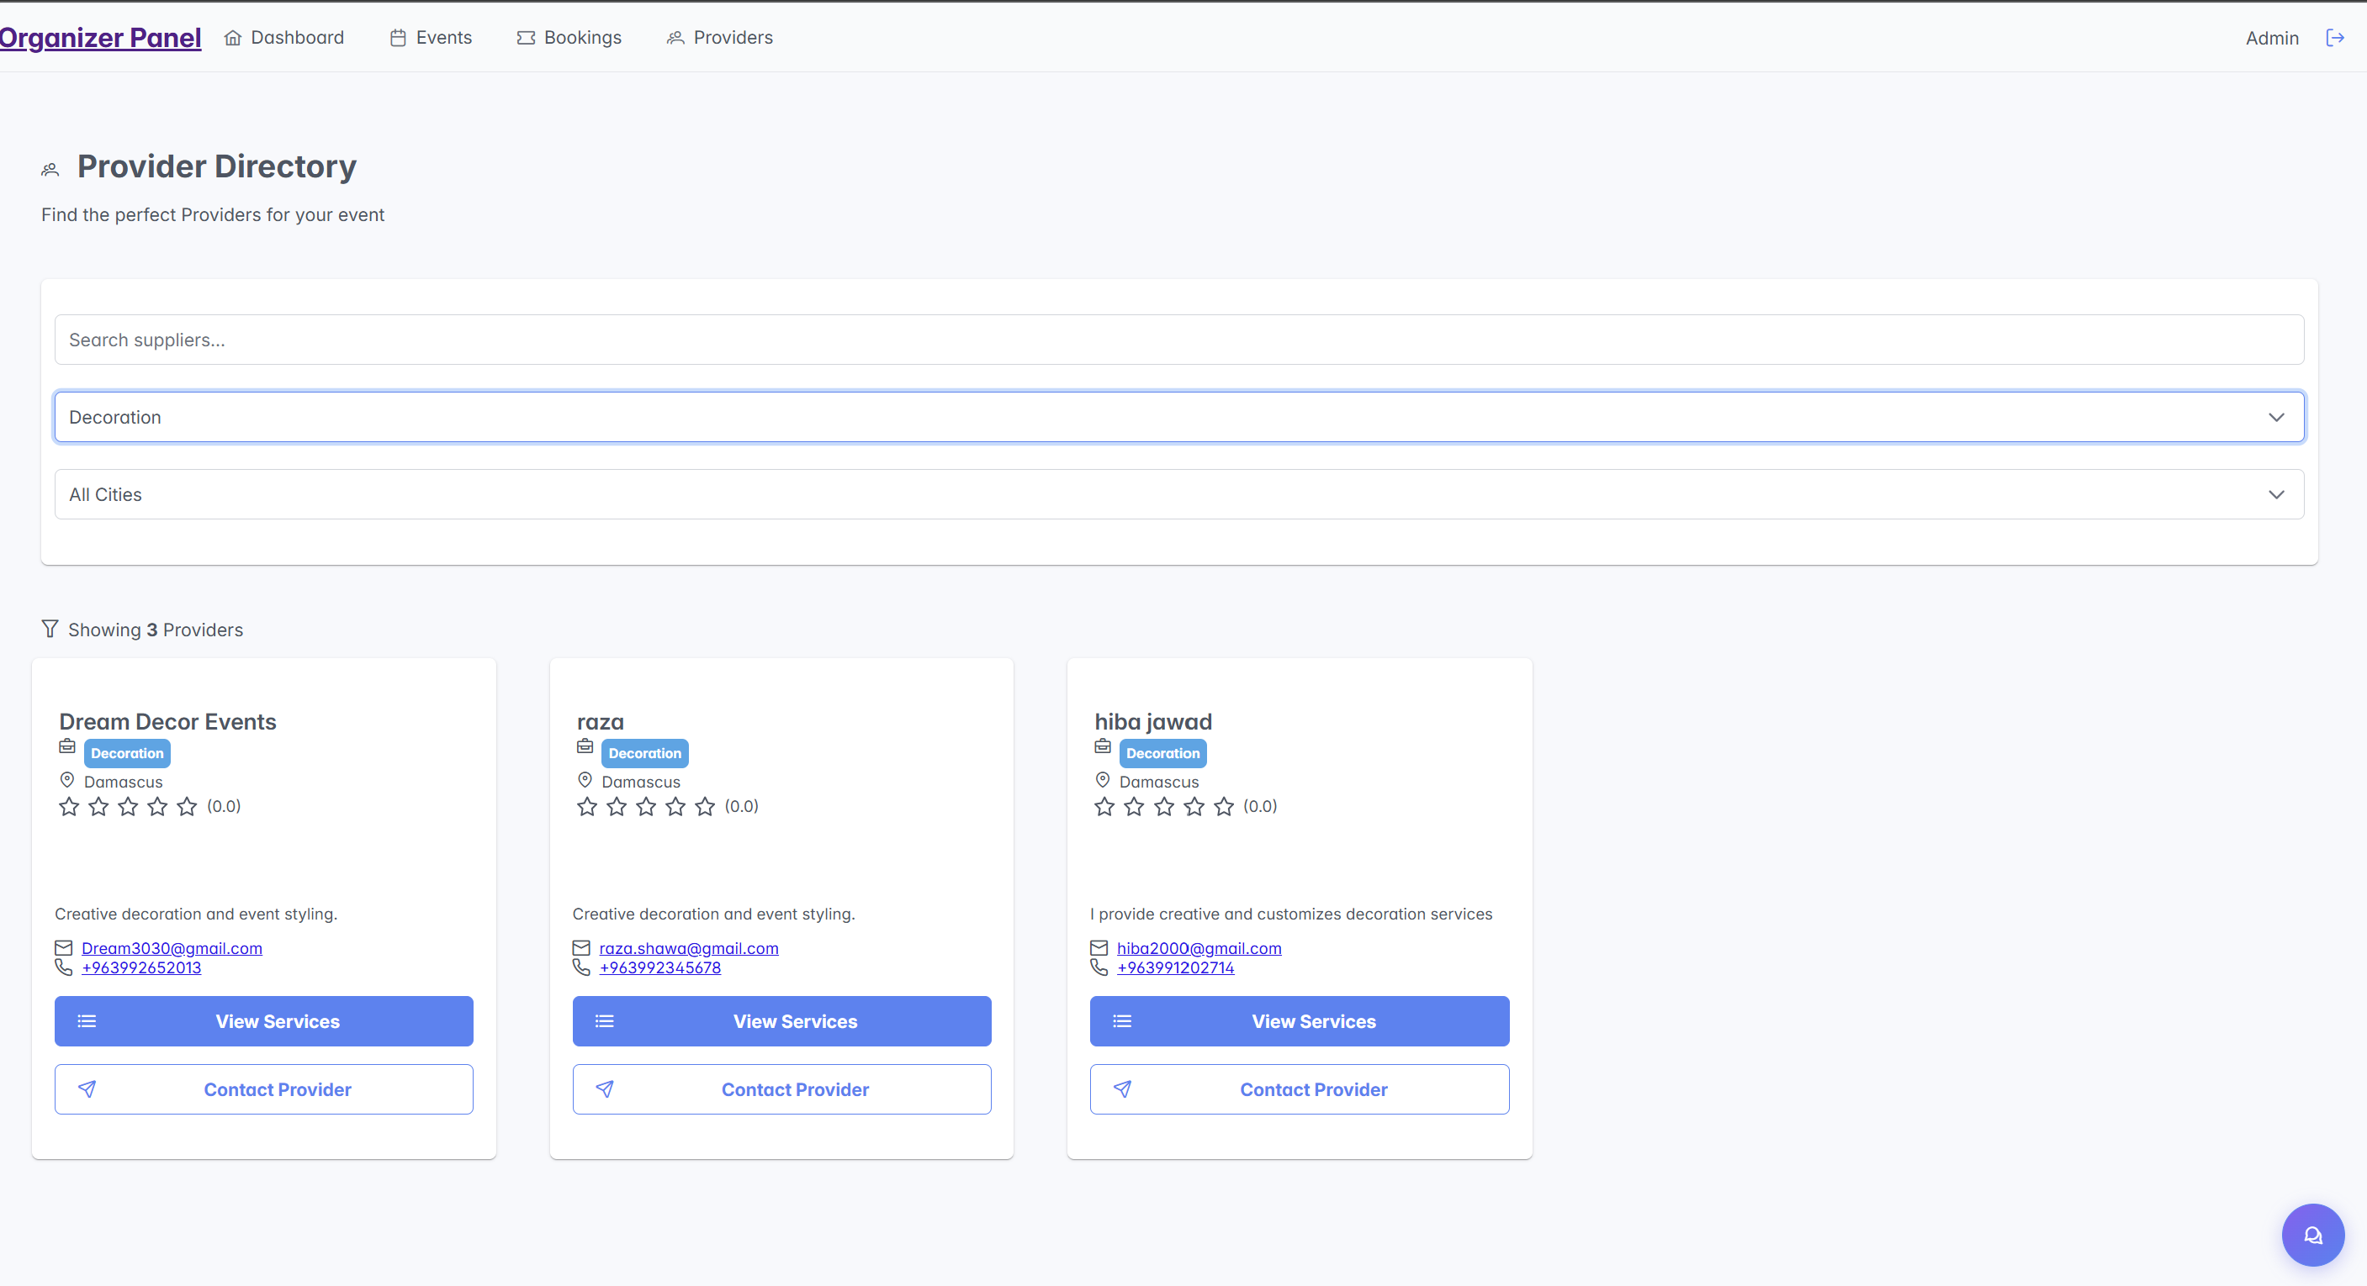
Figure 57:Provider Directory Interface2

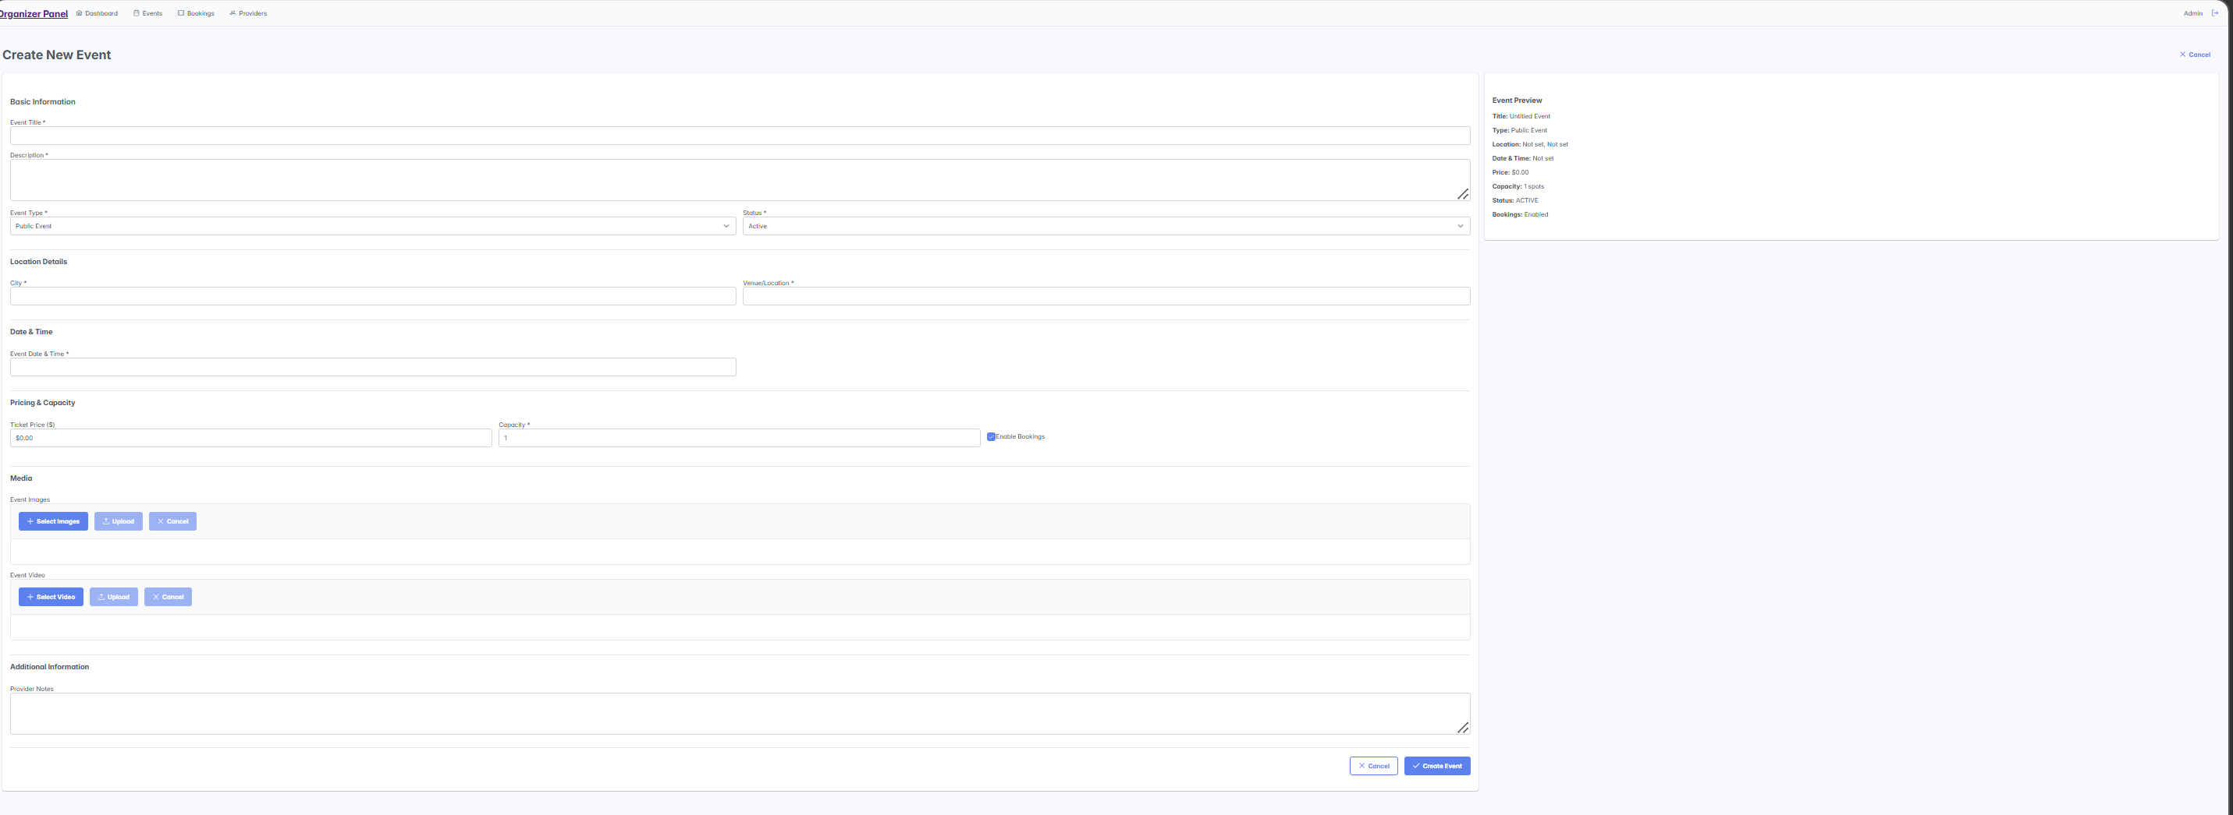
Figure 58:Provider Directory Interface3

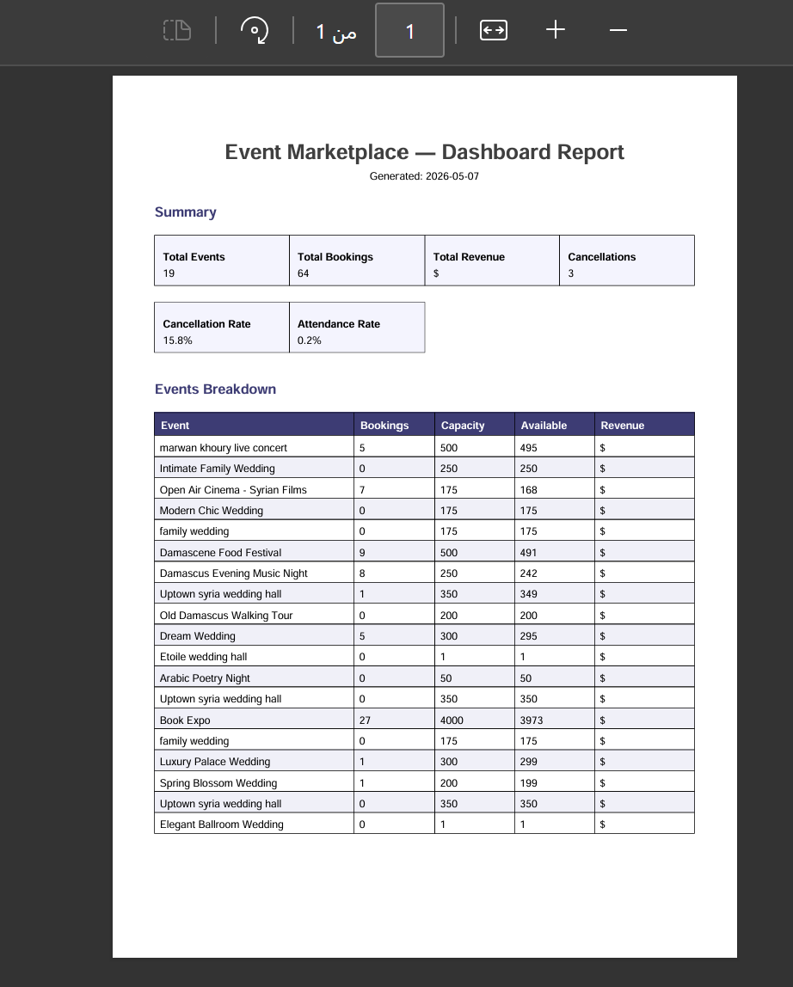
Figure 59:Dashboard Report Interface
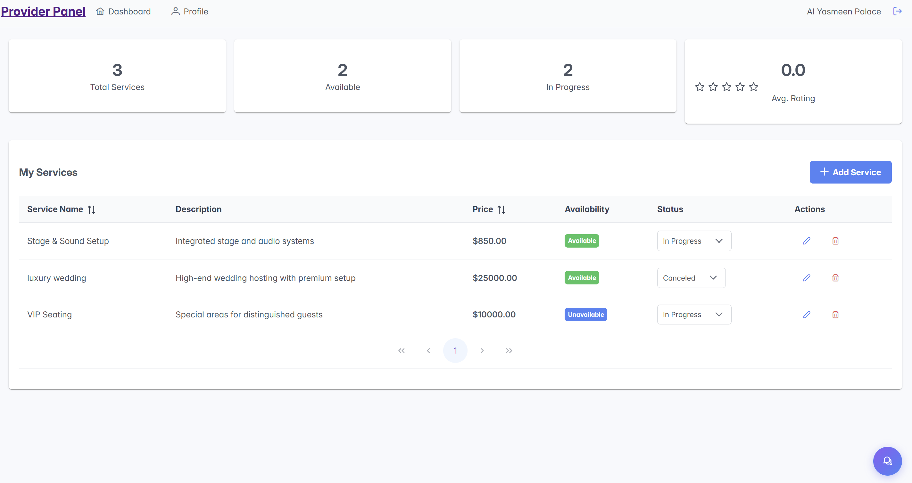
Figure 60:Provider Panel Interface

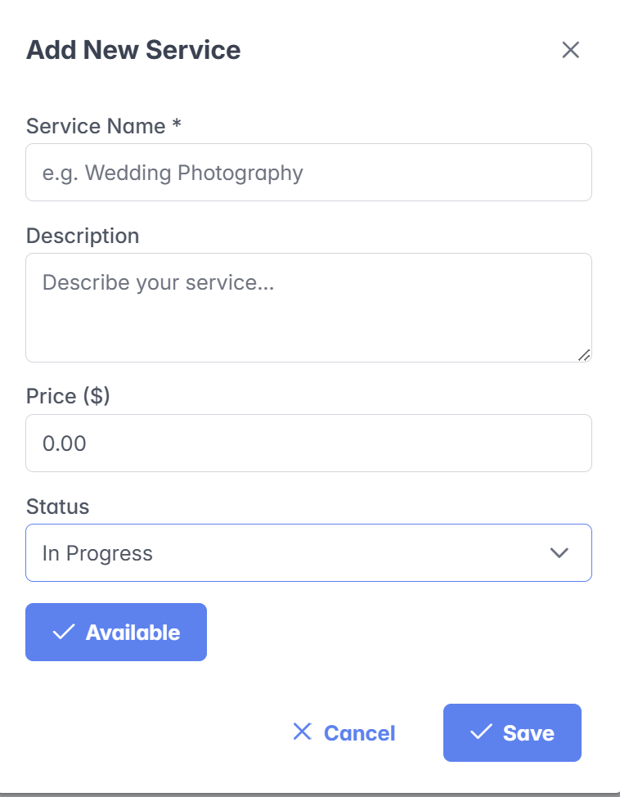
Figure 61:EventMarketPlace Assistant Interface
Figure 62:Add New Service Interface

Figure 63:AI Event Planner Interface

7-7 Smart Algorithms and ML Implementation
The system includes AI-powered features for recommendations and conversational interactions:
Example: AI-based Event Recommendations
public List<Event> getRecommendedEvents(User user) {
String prompt = buildPrompt(user.getPreferences());
String aiResponse = openRouterService.getAIResponse(prompt);
return parseEventsFromAI(aiResponse);
}
Notes:
- Text processing and AI response parsing extract structured recommendations.
- Models can be external APIs (OpenRouter) or internal ML models.
- Recommendations are verified before display to the user.

7.8 Summary
This chapter presents the EventMarketPlace software implementation, highlighting a layered architecture, key modules (events, users, bookings, dashboard, AI, notifications, reports), and technologies (Spring Boot, React, Firebase, OpenRouter API, PrimeReact, Chart.js, iText PDF). It also features AI recommendations, chat assistance, real-time notifications, and analytics. Full code is in the appendix. The chapter demonstrates clean, professional full-stack development.

Chapter 8:

Testing & Evaluation

Introduction
This chapter presents the testing and evaluation process conducted for the EventMarketPlace system. The purpose of testing is to verify that the system functions correctly, satisfies the specified functional requirements, and provides a stable and usable experience for users.
Several testing approaches were applied throughout the development process, including system testing, integration testing, usability evaluation, and compatibility testing. The testing phase also aimed to identify possible defects, evaluate system quality, and ensure that all major workflows operate as expected before final deployment and project submission.

8-1 Test Plan

8-1-1 Testing Objectives
The testing process was designed to achieve the following objectives:
- Verify that all functional requirements are correctly implemented.
- Ensure proper communication between frontend, backend, database, and external services.
- Validate the correctness of booking, event management, authentication, and AI functionalities.
- Evaluate the usability and responsiveness of the user interface.
- Detect and resolve defects before the final system delivery.
- Assess the overall reliability and stability of the system.

8-1-2 Scope of Testing
In Scope
The testing process included the following system components:
- Event Management Module
- Booking Management Module
- User Management and Authentication
- Supplier and Service Management
- Review and Rating System
- Analytics and Reporting
- Notification System
- AI Features and Recommendations
- Frontend user interfaces
- Backend REST APIs
- Firebase Firestore database operations
- External integrations such as Firebase Authentication and OpenRouter AI
Out of Scope
The following areas were not fully covered during testing:
- Automated unit testing
- Large-scale load testing
- Security penetration testing
- Production deployment testing

8-1-3 Testing Environment
The system was tested in a local development environment using the following technologies and tools:
Component | Environment
Frontend | React Application
Backend | Spring Boot
Database | Firebase Firestore
Authentication | Firebase Authentication
Storage | Firebase Storage
AI Integration | OpenRouter API
API Testing | Postman
Browser Testing | Chrome, Firefox, Edge, Safari
Table (82): Testing Environment

8-1-4 Testing Strategy
A manual testing approach was adopted throughout the project. Test cases were prepared according to the system requirements and executed to verify system behavior under different scenarios.
The testing process focused mainly on the core workflows of the platform, including:
- User registration and authentication
- Event creation and management
- Event booking and cancellation
- Payment processing
- Notifications and emails
- AI recommendations and chatbot interaction
Each test case was evaluated according to expected outputs and actual system behavior.

8-2 Types of Tests

8-2-1 Unit Testing
Unit testing aims to verify the correctness of individual components and functions independently.
The project includes the required testing infrastructure through Spring Boot Test for the backend and React Testing Library for the frontend. However, due to project scope and time limitations, the focus was placed mainly on functional and system-level testing rather than detailed unit testing.

8-2-2 Integration Testing
Integration testing was conducted to ensure that all system components communicate correctly with each other.
The following integrations were tested successfully:
- React frontend with Spring Boot backend APIs
- Spring Boot services with Firebase Firestore
- Firebase Authentication with protected APIs
- File uploads to Firebase Storage
- Email notifications through SMTP services
- AI communication through OpenRouter API
The testing confirmed that data flows correctly between all system layers.

8-2-3 System Testing
System testing was the primary testing method used in this project. The complete system was tested as an integrated application to verify that all functional requirements operate correctly.
All major user workflows were tested, including:
- User registration and login
- Event browsing and filtering
- Event booking and payment
- Event management by organizers
- Service management by providers
- Ratings and reviews
- AI recommendations and chatbot support
The results showed that the system performs correctly across all implemented modules.

8-2-4 Acceptance Testing
Acceptance testing was performed to verify that the system satisfies the project objectives and user requirements.
The system successfully demonstrated the following capabilities:
- Organizers can create and manage events.
- Users can browse and book events.
- Providers can offer additional services.
- Users can submit ratings and reviews.
- AI features provide intelligent recommendations and support.
The successful completion of these workflows indicates that the system satisfies its intended objectives.

8-2-5 Performance Testing
Basic performance observations were conducted during testing to evaluate system responsiveness.
The system demonstrated acceptable performance under normal usage conditions:
Operation | Average Response
Page Loading | 1–2 seconds
API Requests | Less than 150 sec
Image Upload | 2–5 seconds
PDF Generation | 1–3 seconds
AI Responses | 5–15 seconds
Table (83): Performance Testing

Overall, the system remained responsive and stable during testing.

8-2-6 Security Testing
Basic security mechanisms were implemented and tested within the system, including:
- Firebase Authentication
- Token-based authentication
- Input validation
- Database access restrictions
- CORS configuration
Although advanced penetration testing was not performed, the implemented security measures provide an acceptable level of protection for an academic project.

8-2-7 Usability Testing
Usability evaluation was conducted to assess the clarity and ease of use of the system interface.
The evaluation focused on:
- Simplicity of navigation
- Interface consistency
- Form validation clarity
- User feedback messages
- Mobile responsiveness
The system demonstrated a clean and user-friendly interface with responsive behavior across different screen sizes.

8-2-8 Compatibility Testing
The platform was tested on multiple browsers and screen sizes to ensure compatibility.
Browsers Tested
- Google Chrome
- Mozilla Firefox
- Microsoft Edge
- Safari
Devices Tested
- Desktop
- Tablet
- Mobile devices
The results confirmed that the system functions correctly across all tested environments.

8-3 Test Cases and Results

8-3-1 Test Case Structure
Each test case was designed using a structured format containing:
Field | Description
Test Case ID | Unique identifier
Requirement ID | Related requirement
Test Objective | Purpose of the test
Preconditions | Required setup
Test Steps | Execution steps
Expected Result | Expected system behavior
Actual Result | Observed output
Status | Pass or Fail

Table (84): Test Case Structure

8-3-2 Test Results Summary
The following table summarizes the final testing results:
Module | Total Tests | Passed | Failed
Event Management | 12 | 12 | 0
Booking Management | 15 | 15 | 0
User Management | 8 | 8 | 0
Supplier Management | 10 | 10 | 0
Review System | 9 | 9 | 0
Analytics & Reporting | 11 | 11 | 0
Notification System | 7 | 7 | 0
AI Integration | 5 | 5 | 0
Total | 77 | 77 | 0

Table (85): Test Results Summary
The results indicate that all tested functionalities operated successfully during the evaluation process.

8-4 Test Results and Analysis
The testing phase demonstrated that the EventMarketPlace system satisfies all major functional requirements and performs reliably across different modules.
Several minor issues were identified during testing, mainly related to interface behavior and notification handling. These issues were resolved successfully before the final evaluation phase.
The system showed the following strengths:
- Stable system behavior
- Correct business logic execution
- Successful integration between technologies
- Accurate booking and recommendation processes
- User-friendly interface and navigation
Overall, the system is considered functionally complete and suitable for academic demonstration and evaluation.

8-5 Quality Metrics
The following quality indicators were observed during testing:
Metric | Result
Requirement Coverage | 100%
Test Pass Rate | 100%
Critical Defects | 0
System Stability | Stable
Data Integrity | Verified
API Responsiveness | Good
Table (86): Quality Metrics
The system demonstrated good software quality and acceptable performance for the project scope.

8-6 Usability Evaluation
Formal usability studies with real users were not conducted due to time limitations. Instead, usability evaluation was performed through expert review and repeated practical testing.
The evaluation confirmed that the system provides:
- Clear navigation structure
- Consistent interface design
- Responsive layouts
- Simple booking workflows
- Easy interaction with AI features
Some future improvements may include:
- More advanced user guidance
- Enhanced accessibility support
- Additional interface customization options

Conclusion
The testing and evaluation process confirmed that the EventMarketPlace system successfully fulfills its intended objectives and functional requirements.
All core modules operated correctly during testing, and the integration between frontend, backend, database, and external services functioned reliably. The platform also demonstrated acceptable usability, responsiveness, and system stability.
Based on the obtained results, the system is considered suitable for academic evaluation and provides a solid foundation for future improvements and deployment.

Chapter 9:

Results and Analysis

Introduction
This chapter presents the practical results obtained after the development and implementation of the Event Marketplace system. It also includes an analysis of system performance and an evaluation of the extent to which the predefined objectives have been achieved. Furthermore, it compares the proposed system with traditional systems, analyzes strengths and weaknesses, and measures key performance indicators (KPIs).

9-1- Results of implementing the system:
The system relies on an integrated software architecture consisting of a front-end developed using React and PrimeReact, and a back-end developed using Spring Boot, with Firebase used for authentication, cloud storage, and data management.
The system also utilizes a RESTful API architecture to connect the front-end to back-end services, employing a Controller-Service-Repository (CPR) model to organize software processes and separate business logic from data access layers and The following functions are actually supported :
- Log in and create accounts via AuthController and AuthService using JWT with external authentication system integration.
- Manage events (create, edit, delete, view) via EventController and EventService.
- Electronic booking system via BookingController and BookingService.
- Manage service providers via SupplierController.
- Manage event-related services via ServiceController.
- Review and rating system via ReviewController.
- Dashboard control panel and statistics via DashboardController.
- Smart event planning support via AIController and AIService.
- Payment system and booking integration via PaymentService.
- Send emails and reminders via EmailService and EventReminderService.
- Manage storage via StorageService.
- Upload and link files to the system.
- The front-end integrates with these services via a REST API to provide an interactive user experience.

9-2 Comparative Analysis with Existing Systems:
A comparison was conducted between the Event Marketplace system and traditional event management systems to evaluate the efficiency of the proposed system and its contribution to improving user experience and operational processes.

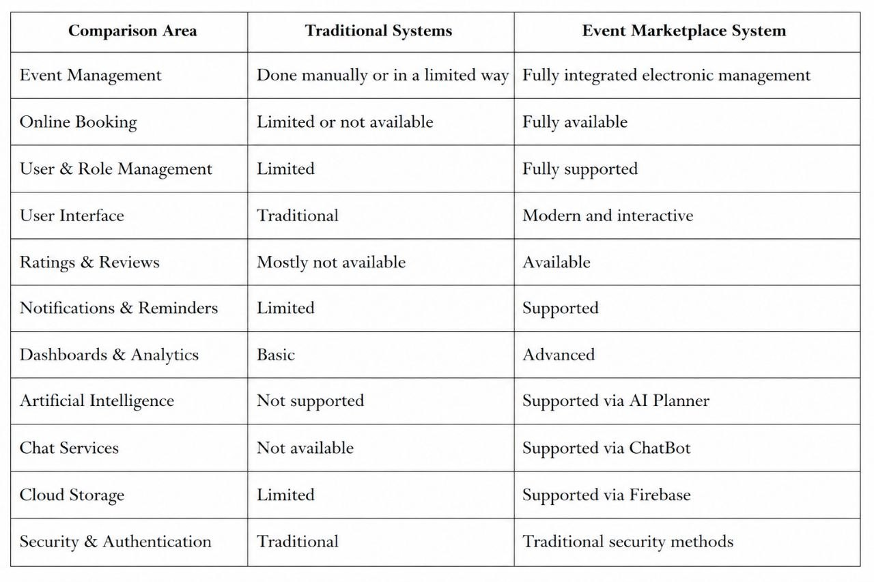
Table (87): Comparative Analysis with Existing Systems

From this comparison, it is clear that the proposed system provides a more advanced and flexible environment compared to traditional systems, particularly in automation, process management, and service integration.

9-3 Objectives Achievement:
The practical implementation results showed that the system successfully achieved its main objectives to a high degree, as follows:

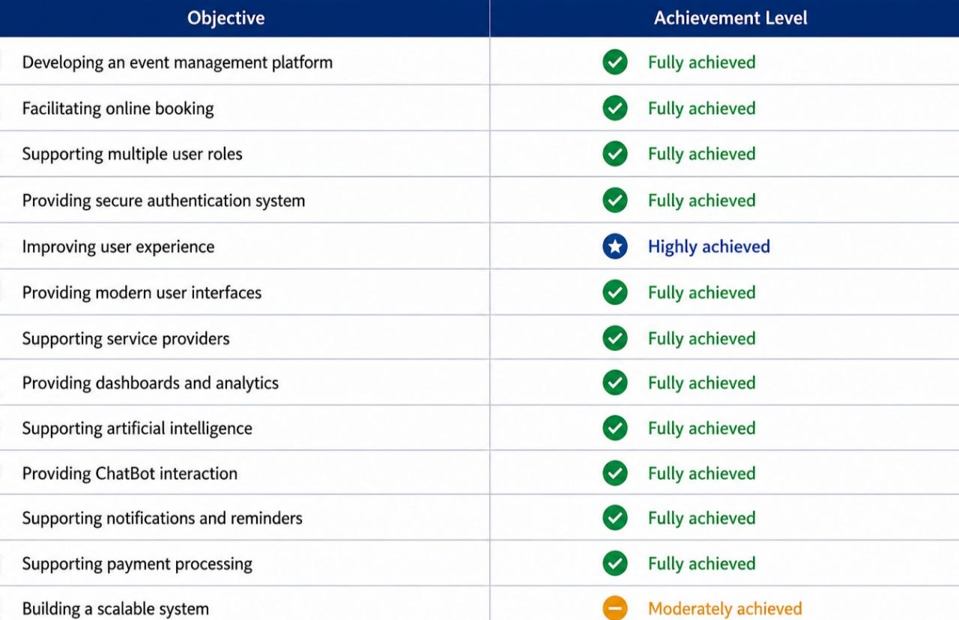
Table (88): Objectives Achievement

9-4 Strengths and Weaknesses Analysis
First: Strengths
The system has several strengths that enhance its efficiency and effectiveness, including:
- Use of RESTful API architecture for system communication.
- Application of the Controller-Service-Repository pattern.
- Support for multiple roles and permissions.
- Modern and interactive user interfaces.
- Integration of artificial intelligence via AI Planner.
- Availability of ChatBot interaction.
- Integrated booking system.
- Payment processing linked with bookings.
- Support for ratings and reviews.
- Advanced dashboards and analytics.
- Integration with Firebase for authentication and storage.
- Notifications and reminders for events.
- Ease of future scalability and maintenance.
Second: Weaknesses
Despite the success of the system in achieving its main objectives, some areas require future improvement:
- Performance optimization is needed when the number of users increases significantly.
- Lack of dedicated mobile applications.
- Limited real-time push notification support.
- AI algorithms need improvement for more accurate recommendations.
- Need for integration with real payment gateways.
- Dependence on external cloud services.

9-5 Key Performance Indicators (KPIs):
A set of key performance indicators was measured to evaluate system efficiency during operation, with the following results:

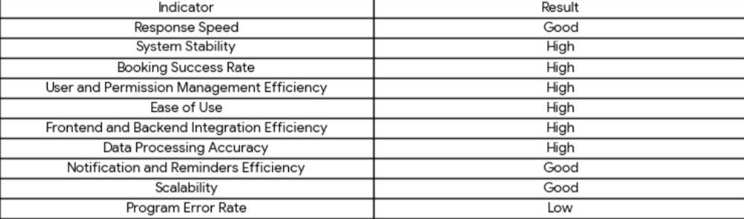Table (89): KPIs

The practical testing showed that the system is capable of executing core operations efficiently and stably, while providing a suitable user experience.

Chapter 10:

Conclusion & Recommendations

Introduction:
This chapter presents the final summary of the project, highlighting the key achievements during the analysis, design, and implementation phases. It also discusses the challenges encountered during development and provides future recommendations for improving and enhancing the system.

10-1 Project Summary and Main Achievements:
During this project, an integrated electronic event management system named Event Marketplace was developed. The system aims to facilitate event organization, booking processes, and communication between users, organizers, and service providers within a unified digital platform.
The system was developed using React and PrimeReact for the frontend, Spring Boot for the backend, and Firebase for authentication and cloud storage.
Key achievements include:
- Development of a secure authentication system using JWT and Firebase Authentication.
- Support for multiple user roles and permissions.
- Creation of a complete event and booking management system.
- Development of service provider and event-related service management modules.
- Implementation of payment processing integrated with bookings.
- Development of a review and rating system.
- Provision of dashboards and analytics for monitoring and management.
- Integration of AI-based smart event planning.
- Development of a ChatBot for user interaction.
- Support for notifications and event reminders.
- Building modern and interactive user interfaces.
The project contributed to providing a digital solution that improves event management, reduces manual processes, and enhances user experience efficiency and flexibility.

10-2 Challenges and Difficulties:
The development process faced several technical and organizational challenges, including:
- Difficulty in structuring the system architecture and organizing components.
- Challenges in integrating frontend and backend systems.
- Managing roles and access control.
- Working with REST APIs and ensuring stable data exchange.
- Integrating Firebase and cloud storage management.
- Developing and integrating the AI system.
- Building and connecting the ChatBot system.
- Managing payment processes and linking them with bookings.
- Testing various system scenarios.
- Performance optimization and response time improvements.
Despite these challenges, continuous development and testing phases led to a stable and usable system.

10-3 Future Development Suggestions:
The system can be further improved by adding the following features:.
- Real-time push notification support.
- Integration with real payment gateways such as Cham Cash.
- Enhancing AI algorithms for better recommendations.
- Advanced real-time communication between users and service providers.
- More detailed analytics and reporting systems.
- Multi-language support.
- Improved scalability and performance for large user bases.
- Integration of maps and geolocation for events.
- Use of Machine Learning techniques for user behavior analysis.

10-4 Recommendations:
Based on the project results and experience gained, the following recommendations are provided:
- Careful requirement analysis before development begins.
- Adoption of a well-structured architecture to ease maintenance and development.
- Focus on security and user data protection.
- Regular system testing to ensure stability.
- Continuous improvement of user experience and interfaces.
- Proper academic and technical documentation of the project.
- Use of modern technologies that support scalability.
- Leveraging cloud services for storage and data management.
- Monitoring and analyzing performance indicators regularly.
- Continuous system development according to user needs and technological advancements.

